Abstract

PLA and PETG applied to extrusion-based 3D printed snap-fit connections for product assembly

SANTANA, L1, ALVES, J L2, SABINO NETTO, AC 3,
1International CNPq fellow, Faculty of Engineering- University of Porto (FEUP), Porto, Portugal
2INEGI, Faculty of Engineering- University of Porto (FEUP), Porto, Portugal
3Federal Institute of Santa Catarina (IFSC), Florianópolis, Brazil.

Keywords: Assembly, Snap-fit, Low cost 3D printing, PLA, PETG

- Abstract
The goal of this work is to investigate the capabilities of low-cost extrusion-based 3D printing on building snap-fit connections to develop products for assembly. At first, we have conducted studies to recognize user-printing system relations, and to identify challenges when building parts with such connections [1] and the influence factors in the quality of the printed components [2]. The following step was planning the snap fit printing by selecting building materials, and analyzing de friction between surfaces, and the assembly force behavior after successive insertion/removal cycles. We have studied two polymers: Poly acid lactic (PLA) and Polyethyletherphthalate Glycol (PETG). Preliminary results show that the PETG elements, due to its flexibility, present better answers to cyclic loads, with long stages of assembly force stabilization, while the PLA parts, due to the greater stiffness and low deformation capacity of the material, present permanent damage in its structure. In product development, PETG offers advantages for applications where assembly and disassembly are required, and PLA, which has a higher mechanical strength, can be used in single assembly designs.

Image: electronic case, (a) sheet format and (b) assembled box (folded edges)

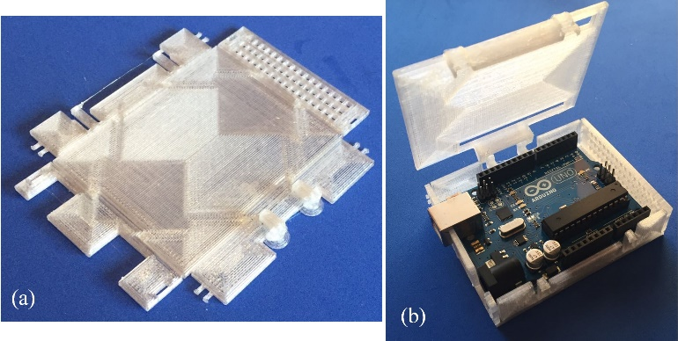
- Reference:

1. Santana, L., Alves, J. L., Sabino Netto, A. C., 2017. Aplicação da impressão 3D de baixo custo na fabricação de peças com conexões snap-fit. Anais do COBEF 2017.

- Santana, L., Alves, J. L., Sabino Netto, A. C., 2017. A study
of parametric calibration for low cost 3D printing: seeking improvement in dimensional quality. Materials and Design, 135: 159-172.

Biography:
Leonardo Santana is attending University of Porto (UP)'s School of Mechanical Engineering Doctorate Program with CNPq scholarship. Master by the Federal University of Santa Catarina (UFSC)'s School of Mechanical Engineering Graduation Program. Has six years of experience in open source 3D printing research. Jorge Lino Alves is an Associate Professor at the Faculty of Engineering of UP and Adjunct Director of the Master Program in Product and Industrial Design. Aurélio da Costa Sabino Netto has a Ph.D. from the Mechanical Engineering Graduation Program at UFSC. He is a Professor at the Federal Institute of Santa Catarina (IFSC).

Presenting author details

Leonardo Santana
Contact number: (+351) 936 275 297
CV: http://lattes.cnpq.br/5590318956612448
Category: e-poster

