Abstract

Title: Development of Management Information System for Process-Based Activity Based Costing System by Improving Lean Management Techniques and Processes in Newborn Unit of Hospitals and Application in Kahramanmaras Health Application and Research Hospital

Hikmet MARASLI1
1Department of Business Administration, Faculty of Economics and Administrative Sciences, Kahramanmaras Sutcu Imam University, Kahramanmaras, Turkey

Keywords: Lean hospital, Time-driven activity-based costing, lean accounting, web programming, mobile programming, management information system, 3D printer

- Abstract
The present study Lean Hospital, Patient and Employee safety is not neglected, Facility security is on the front panel, Preventing waste It is a philosophy aiming at continuous improvement and development, not leaving in scientific lines, using time well, producing quality work. Lean Manufacturing began to be implemented at the Toyota Motor Factory in the early 1950s, first under the leadership of Taiichi Ohno after World War II. In 1989, lean manufacturing techniques were implemented at the Virgina Mason Medical Center in the United States. Cost accounting systems are the central pillar of the operator as a source of information. The traditional cost system in hospital enterprises has been insufficient in the right distribution of increased indirect costs, in the evaluation of opportunities and in the provision of innovations. An activity-based costing system based on the application of lean techniques provides a more reliable and accurate cost management. The main purpose of this project is develop management information system and decision support information system by using information technologies, lean management techniques, lean accounting, process based activity costing, web based, and mobile based programming tools and methods.. In addition, to reduce waste in stock, development of a 3D Printer Kanban stock tracking system for drug. Applied in newborn unit of hospital. Providing managers with quick and accurate information will ensure better management of the institution.

Image:
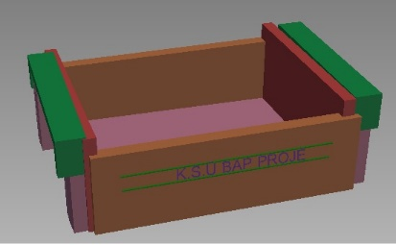
- Reference:

1 Walker, D., (2015), The Better Hospital, Zürich Switzerland.

- Jimmersson, C., (2007), A3 Problem Solving for Healtcare, A Practical Method for Eliminating Waste, CRC Press, United States of America

- Chen, Liang M. ve Chen, Kuang J. (2010), “Relationships among organizational innovation, learning and knowledge management in the information technology industry”, African Journal of Business Management Vol. 4(14): 3191-3200.

Biography:
21/02/1992 has completed his PhD at the age of 32 years from Cukurova University and Assistant Professor at Kahramanmaras Sutcu Imam University and Doctor of Business Administration and also Kanban Stock Control Digital information System Produced in 3D Printer, Turkey. He is kanban stock control digital information system produced in 3D printer. He has published more than 15 papers in reputed journals. He is developing lean healthcare management information system software.

Presenting author details

Hikmet MARASLI Gsm number:+905062393746
Session name/ number:
Category: (Oral presentation/ Poster presentation) Passport Number:

