3D Printing for Prototyping of special components in the Automotive Industry
Nicola Corsetto, Ph.D Student, University of Campania “Luigi Vanvitelli”, Italy.

Abstract (2000 word limit)

The evolution of innovative techniques in Industry 4.0 has characterized and defined the development of new materials for 3D printing, which have completely new properties, specifically new "material patterns." One of these is definitely TPU (thermoplastic polyurethane), the protagonist of an application for the following research in innovative Additive Manufacturing. This polymer has many advantages, such as high resistance to impact, wear, abrasion and cuts; moreover, it has a rather advanced adhesion of layers that allows for excellent mechanical homogeneity at the level of manufactured parts, making them isotropic. The proposed case study showed the results related to solving the problems caused by overheating of video devices used for test recordings and testing of racing vehicles, designing an innovative solution that can always be used while avoiding any kind of electrified technology to avoid an increase in failures and weight of the devices. A high level of attention was dedicated to respecting thermal stresses to bring the component to a high level of resistance to the high temperatures that are created in summer inside the cockpits exposed from the windshields to the sun. Important was the use of domestic 3D printers of low cost and performance with technical materials now also available at rather cheap prices. The tools used for the following research presents low-budget choices to take design to new levels of challenge in order to make 3D printing a usable tool for everyone to properly reproduce elements that cannot be mass-produced. The tools are: smartphones with high-resolution cameras, fluid-dynamic mechanical components, domestic 3D printers, TPU material spools, and computers with photogrammetry and 3D modeling software.

The procedure used involved the identification of an initial step, and specifically, that of surveying and three-dimensionally scanning the cooling grille of the car used for this test, (racing car Lamborghini Huracan), with simple photogrammetry techniques made possible due to the simple shape of the model in question. The digital survey phase by photogrammetry began by taking photos with different shots of the car's dashboard, to be then transferred to a digital medium that by means of software processed a well-defined image of the cooling grid, which was then brought to full size with the different patterns detected previously, for a correct interpretation of all the measurements necessary for the design. The procedure was then defined through the use of components already on the market, with the choice of a watertight modular fluid dynamics tube and universal modular joints of materials suitable for thermal stress, with careful positioning studies to identify the suitable location for the placement of the first mentioned components. The identification of a suitable dimensional framework allowed the correct mathematical design of a device suitable for the best convective optimization of airflow from the indoor air conditioning system. The desired goal was to take advantage of the vehicle cooling in order to cool the camera located on the windshield, with an element that was significantly reduced in weight, single-material, and would not suffer electrical or other failures and still be resistant to the high temperatures of the race tracks in summer.

The next steps were the three-dimensional modeling of the component directly on the grid element detected in a digital environment, using software such as Rhinoceros 3D, respecting all types of criteria required for the correct printing of the material in question, in fact the TPU requires minimum thicknesses for the right flexibility to be given to the model to obtain a correct airtight closure, once it is made to fit on the grid. Always using 3D modeling software, it was possible to place the component in a virtual environment for geometric and stylistic verifications and for a careful comparison with different drivers and technicians in the automotive field for the choice of the right aesthetic and functional component, with different physical tests of printed models with test material to physically understand the issues related to the application of the product inside the car interior. The crucial step

was definitely to respect the balance between stylistic form and correctly designed geometries for a clean and time-optimized printing without the aid of cantilever layer supports, a feature that was made possible thanks to a careful "stepped" design by placing the flat part of the prototype directly on the printing plate, thus achieving a model construction with increasing silhouettes, obtained by carefully managing the whole printing phase and properly maneuvering the different temperatures during the printing process during the printing of different hours. Various tests were conducted in order to study both the behavior of the material and the morphology of the designed model, in order to carry out different tests and refine its characteristics, with the use of different types of 3D TPU printing material to perform careful research related to the different behavior of different types of samples. The result was obtained through the validation of a final defined physical product, made without the need to create connection systems by gluing and/or threaded connections, in fact, the methodology used included avoiding glues of components aimed at the best product performance, that is, optimizing the cooling of the cameras in different positions of the cockpit, without causing damage to the expensive and technological dashboard of the car, making the designed component totally removable without leaving any trace of the attachment on the compressed carbon surface. This activity has confirmed the value of the aforementioned technologies, made more performant through proper technology transfer in order to be able to maximize the performance of products and components in any design and manufacturing need, managing special prototyping activities made hitherto unheard of due to the high costs of running 3D printers and industrial material supplies.

Image
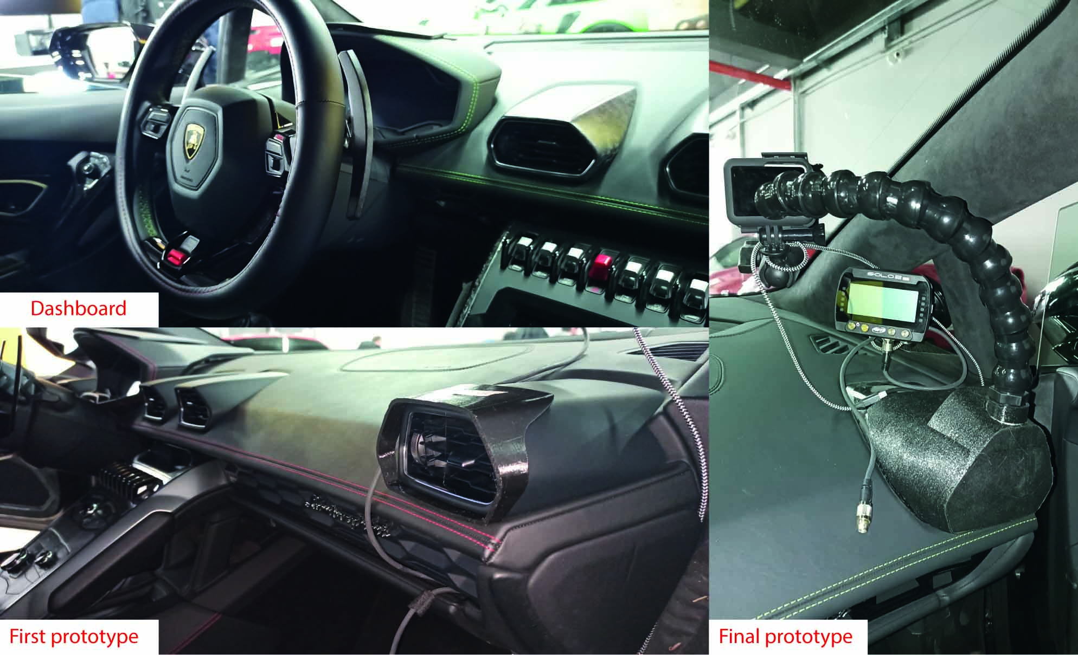
Recent Publications (minimum 5)
- Shahrubudin N.,Lee T.C., Ramlan R. (2019) An Overview on 3D Prinitng Technology:Technogolical, Materials, and Application. Procedia Manufacturing vol.35, p.1286-1296.
- Patton T.S., Chen C., Hu J., Grazulis L., Schrand A., Roy A.K. (2017) Characterization of Thermoplastic Polyurethane (TPU) and Ag-Carbon Black TPU Nanocomposite for Potential Application in Additive Manufacturing. Polymers, vol.9, p.6.
- Lecklider T., (2017) 3D printing drives automotive innovation. 33-3valuation Engineering, vol.56.
- Akyol O., Duran Z.,(2014). Low-Cost Laser Scanning System Design. Journal of Russian Laser Research, vol.35,p.244-251.
5. Savastano. M., Amendola C., D’Ascenzo F., Massaroni E., (2016) 3-D Printing in the Spare Parts Supply Chain: An Explorative Study in the Automotive Industry. Digitally Supported Innovation, p.153-170.

 Biography (150 word limit)
PhD student with a master's degree in industrial design and winner of a scholarship with a Transportation Design project. His passion for the automobile and modern technologies have led him to design innovative solutions that intertwine the two areas mentioned above, generating several activities also in the aeronautical and railway sectors with experimentation with new materials and hybrid methodologies for finishing surfaces produced through rapid prototyping. He is currently studying innovative technologies aimed at three-dimensional surveying and modeling.
Email: nicolacorsettoemail@gmail.com

Notes/Comments:

Presenting author details
Full name: Nicola Corsetto
Contact number: +39 389 9275632
Twitter account: none
Linked In account: Nicola Corsetto
Session name/ number: 3D printing in Automotive Industry
Category: Oral presentation/ Poster presentation

