Printing Parts and Models on a 3d Printer with flexible materials such as TPU
Yukun Wu
Owner of the online store on Amazon called “Mr. Wu’s 3d Printer Corner”

Additive Manufacturing devices, otherwise referred to as “3D Printers”, can make all kinds of parts and models limited only to the maker’s imaginations. The materials that make up these parts and models, of course, also comes in a wide variety. As far as FDM Fused Deposit Modelling Printers are concerned, the most commonly used materials are PLA PolyLactic Acid and ABS Acrylonitrile butadiene styrene. Also, FDM Fused Deposit Modelling Printers will go through a process of first melting the material that is fed into its extruder, and has this melted material instantly solidified as it is squeezed out of the extruder when the printers are making parts and models. This talk will focus on an overview of the actual process of making TPU into all kinds of exotic parts and models using FDM Fused Deposit Modelling printers.
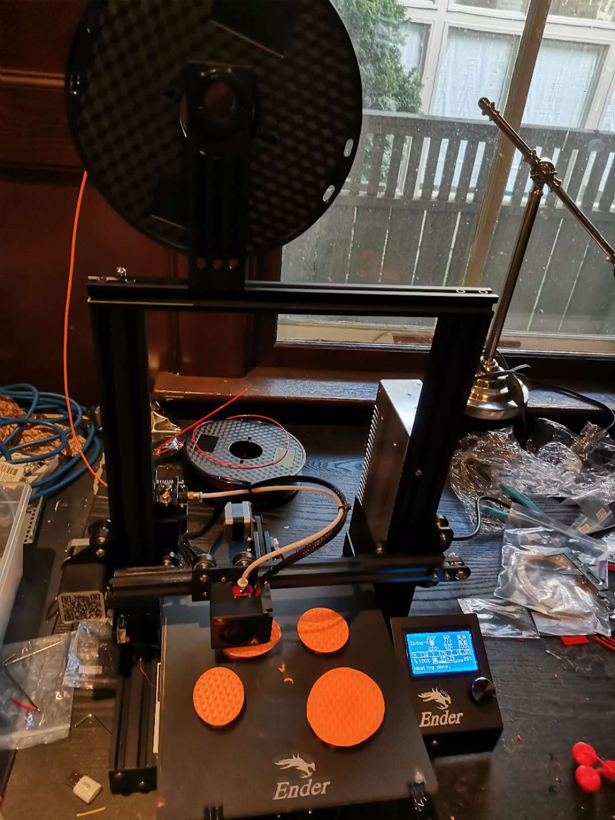
Fig 1. 3D Printer without the Auto-off Switcher
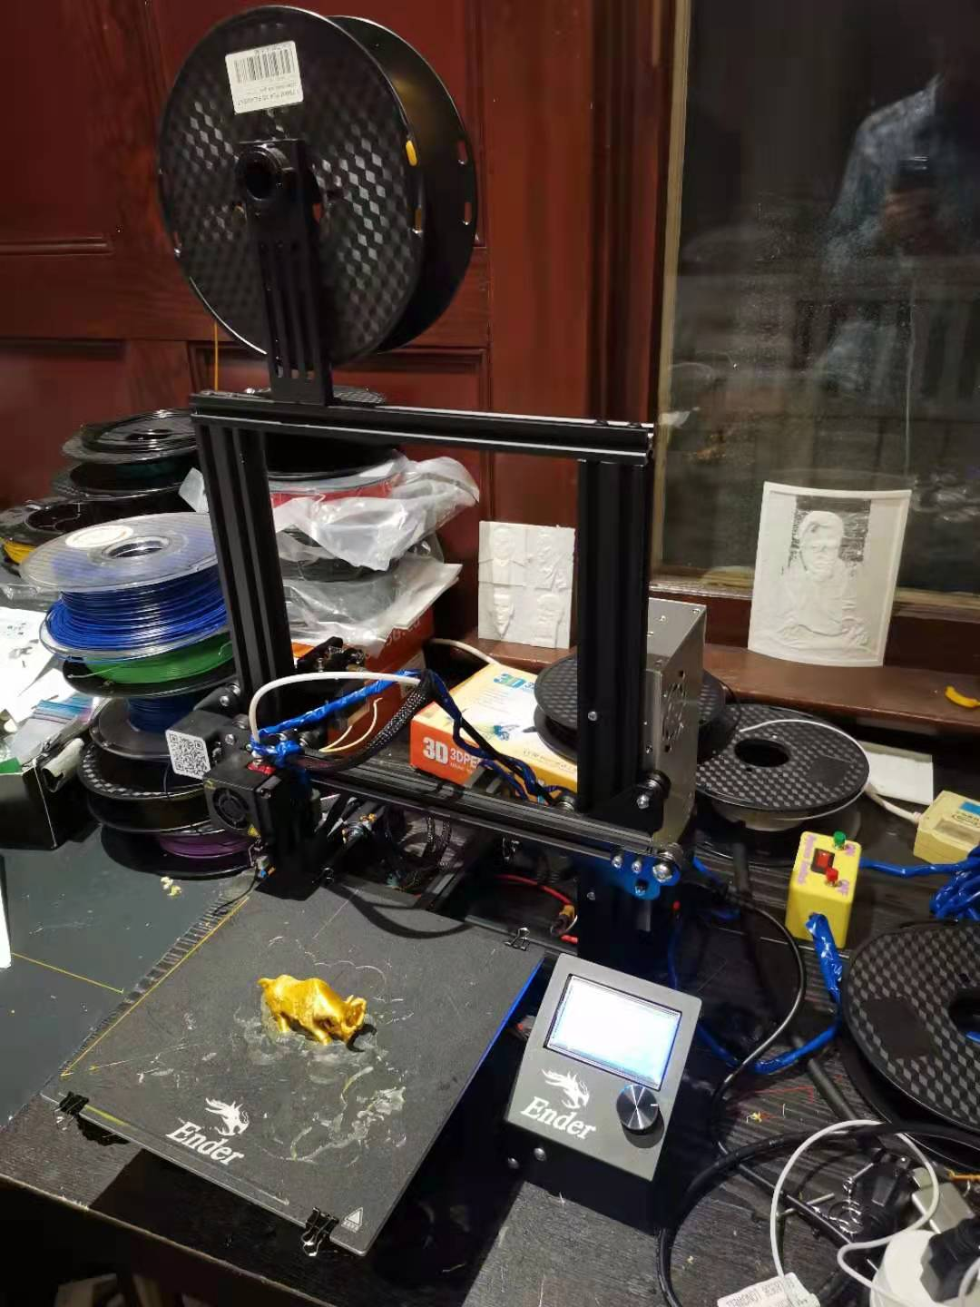
Fig 2. 3D Printer with the Auto-off Switcher

References:
- A kind of FDM type 3D printing platforms of ultrasonic wave added vibration.
Patent number: CN107042628A
- High strength polymer filament for FDM 3D printer including graphene coated metal nanoparticles, nanocarbons for 3D printer, and preparation method of the same
Patent number: US9745452B2
Yukun Wu is a 3d Printer Worker, a 3d Printer Reparing Man, a 3d Designer - including the design of mechanical parts, a 3d scanning technician and an Inventor of 3d Printer Parts and Accessories. This means that the technologies that he worked on most extensively so far are additive manufacturing technologies, or 3d printing technologies. He has quite a bit of experiences in 3d Printer Service Business. Of course, the earliest product that he invented, which is the 3d Printer's Auto-off Switcher, is the only product that he has a patent on. This is a device that switches 3d Printers off automatically once they finish printing.


Full Name: Yukun Wu
Contact number: 403 3122831
LinkedIn Account: https://www.linkedin.com/in/yukun-wu-3d-printer-parts-accessories-inventor/
Twitter account:
Session name/ number: PiezoElectric Material and 3D-Printing Session/
Category: Oral presentation

References:
- The Patent: Automatic power-off device suitable for 3D printer. Patent number: CN201922342898.

