Prototyping in automotive design: development of scale models with hybrid finishes and surfaces treatments.
Arch. Ph.D Francesco Fittipaldi
Dr. Nicola Corsetto

Abstract
The new digital vision typical of industry 4.0 offers the automotive sector new and advanced operational tools, functional to the best product/process system also for the prototype sector in the prototyping phase. Specifically, through a strong characterization on the use of new technologies, the "governance" of the processes linked to the creative phase of Concept Design will be increasingly manageable, where the flows of technical and stylistic information converge in the first physical identification of a new product. This operation is generally implemented through the creation of prototypes on a small scale, where the need to create new operational spaces is still governed by the ability of both the prototype maker and the performance of the hardware. In the specific, the need to create products using the new technologies attributable to the 3D printers typical of additive manufacturing, is confronted with the awareness that, in the panorama of 3D printers, the majority (85%) have operational performance limited by the extraction plate of about 300X400X400 mm. These dimensional limits in fact propose a use of printers with considerable limitations for prototypes that require development in scale with larger dimensions. The essay describes the methodology used which is based on the combined use of a careful 3D CAS modeling procedure functional to the modular rationalization of the pieces to be assembled in post-production and the hybrid techniques for the creation of the surface finishes to complete the physical prototype. This approach demonstrates the quality, technical sustainability, and inclusiveness of the digital approach as they are at the center of the project, proposing a case study of automotive design linked to a bus intelligent mobility, the result of a funded research project, IBIS, which has as its output the construction of a full-scale functioning demonstrator intended for urban mobility in an eco-regime.

Image
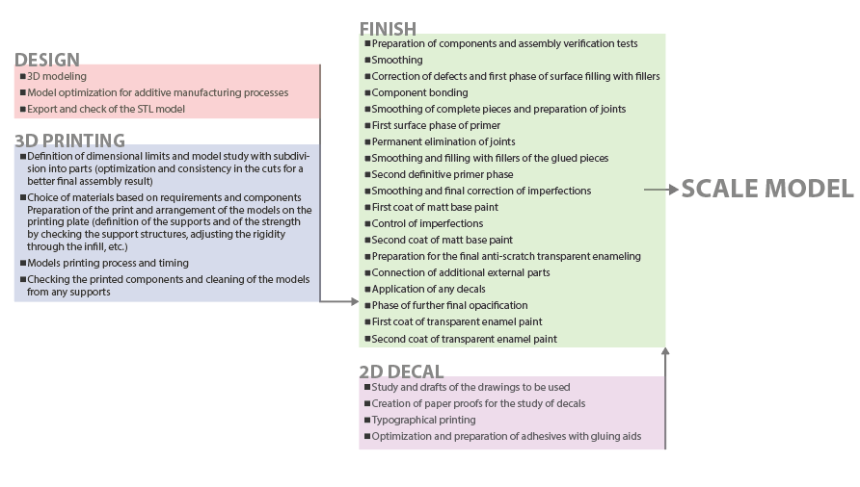
Recent Publications
- Yusheng Shi, Chunze Yan, Yan Zhou, Jiamin Wu, Yan Wang, Shengfu Yu, Chen Ying (2021) Materials for Additive Manufacturing, 1st edition. Academic Press, p.1-774, ISBN: 9780128193020.
- Daniel eyers (2020) Managing 3D Printing. Palgrave Macmillan, P.1-194, IBSN: 9783030233228.
- Martin Leary (2019) Design for Additive Manufacturing, 1st edition. Elsevier,p.4-358, IBSN: 9780128167212.
- Fittipaldi Francesco (2013) New concepts for urban mobility. Napoli: Luciano Editore, p.01-136, ISBN: 9788860261694.
- Kimio Toda, Abraham Salazar, Kozo Saito (2013) Automotive Painting Technology. Springer Netherlands, p.4-184, IBSN: 9789400750944.
- Fittipaldi Francesco (2011). Ergonomia, progettazione e sperimentazione virtuale. Napoli: Luciano Editore, p. 1-136, ISBN: 9788860261199.
- Stefano Turri (2007) Vernici, Materiali, tecnologie, proprietà.cea, P.1-448, IBSN: 8808181421.
- Fittipaldi Francesco (2004) Concept Design per la mobilità sostenibile. Napoli: Luciano Editore, p. 1-140, ISBN: 8888141693.

Arch. Ph.D Francesco Fittipaldi
Graduated in Architecture with a thesis on the project of an innovative city car, he obtained a PhD in Total Quality Management, at the Faculty of Engineering of the Federico II University of Naples. He attended the specialization courses in Statistics for Industrial Design and obtained the title of Bio-architecture.The research activity is characterized by the study of issues related to Transportation Design and in particular to Car design, Ergonomic Design and Sustainable Mobility, with operational methodologies for product development and experimentation in a virtual environment. He was adjunct professor of Design for sustainable mobility at Italian universities. Currently he collaborates with the University of Campania "Luigi Vanvitelli", for Transportation Design. He was Head of the Style Center at an engineering company, dealing with stylistic and ergonomic development for the railway, automotive and aeronautical sectors. In the field of land transport, he has designed several buses and microcars.
Email: francesco.fittipaldi@unicampania.it

Notes/Comments:

The group participating in the abstract it’s composed by: Arch. Ph.D Francesco Fittipaldi, Dr. Nicola Corsetto

