Use of robotic additive manufacturing for the shaping potentials lattice geometries from extruded biopolymers
César Bacca, MEng, Department of Mechanics and Mechatronics, Universidad Nacional de Colombia
Ernesto Córdoba Nieto, Prof., Department of Mechanics and Mechatronics, Universidad Nacional de Colombia,
Bibiana Vallejo, PhD, Prof. Department of Pharmacy, Universidad Nacional de Colombia

Abstract (300 word limit)
In the research carried out for the development of a robotic additive manufacturing process, rectangular prisms were manufactured from a biopolymer composed of water, glycerin and corn starch. In a first stage, experimental test benches were implemented to select the extruder components and also to define the raw material combination: starch percentage (15%, 20% and 25%) and glycerin percentage (0%, 15% and 30%). The material was extruded at two pressure levels and at five extruder speed levels, obtaining extrusion speed ranges, the rate of extruded material and the extrusion diameter of the material. In a second stage, these parameters were adapted to control the positioning of the extruded material by means of an 8DOF robotic platform, and thus define impressions with lattice-type shapes and topologies. Finally, when the manufactured parts were obtained, they were characterized dimensionally and mechanically by compression. The potential use of the strongest mixture, was selected to load a model active pharmaceutical ingredient, showing a low modification in the mechanical and geometrical effects of the final device.

Image
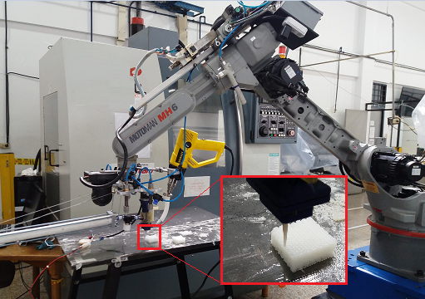
Figure 1: Adaptation of the robotic system for additive manufacturing by extrusion of biopolymers, and the construction of a device.

Recent Publications (minimum 5)
- Gibson, I., Rosen, D. W., & Stucker, B. (2015). Introduction and Basic Principles. In Additive Manufacturing Technologies: Rapid Prototyping to Direct Digital Manufacturing (pp. 1–18). Springer US. https://doi.org/10.1007/978-1-4419-1120-9_1.
- Koski, C., Onuike, B., Bandyopadhyay, A., & Bose, S. (2018). Starch-hydroxyapatite composite bone sca ff old fabrication utilizing a slurry extrusion-based solid freeform fabricator. Additive Manufacturing, 24(August), 47–59. https://doi.org/10.1016/j.addma.2018.08.030
- Li, X., Lian, Q., Li, D., Xin, H., & Jia, S. (2017). applied sciences Development of a Robotic Arm Based Hydrogel Additive Manufacturing System for In-Situ Printing. https://doi.org/10.3390/app7010073
- Ligon, S. C., Liska, R., Stampfl, J., Gurr, M., & Mülhaupt, R. (2017). Polymers for 3D Printing and Customized Additive Manufacturing. Chemical Reviews, 117(15), 10212–10290. https://doi.org/10.1021/acs.chemrev.7b00074
- Kuo, C., Liu, L., Teng, W., & Chang, H. (2016). Preparation of starch / acrylonitrile-butadiene-styrene copolymers ( ABS ) biomass alloys and their feasible evaluation for 3D printing applications. Composites Part B, 86, 36–39. https://doi.org/10.1016/j.compositesb.2015.10.005.
- Liu, J., Sun, L., Xu, W., Wang, Q., Yu, S., & Sun, J. (2019). Current advances and future perspectives of 3D printing natural-derived biopolymers. Carbohydrate Polymers, 207(June 2018), 297–316. https://doi.org/10.1016/j.carbpol.2018.11.077

 Biography (150 word limit)
César Bacca is a professional with projection in the use of agricultural resources as a sustainable source for obtaining materials, products and supplying energy demands. Master's degree and specialization studies focused on additive manufacturing, with biopolymers applied in the biomedical sector, use of polysaccharides to obtain packaging, alternative energies in agricultural centers, and mechanical design for food processing.
.
Email: cabaccag@unal.edu.co

Notes/Comments:

