Use of robotic additive manufacturing for the shaping of rectangular prisms of extruded biopolymers
César Bacca, MEng, Department of Mechanics and Mechatronics, Universidad Nacional de Colombia
Ernesto Córdoba Nieto, MEng, Department of Mechanics and Mechatronics, Universidad Nacional de Colombia,
Bibiana Vallejo, PhD, Department of Pharmacy, Universidad Nacional de Colombia

Abstract (300 word limit)
In the research carried out for the development of a robotic additive manufacturing process, it was possible to manufacture rectangular prisms from a biopolymer made of water, glycerin, corn starch. In a first stage, experimental test benches were implemented to select the extruder components for the best processing of the material. Also in this stage, the raw material mixtures were selected, such as: starch percentage (15%, 20% and 25%) and percentage of glycerin (0%, 15% and 30%). The material was extruded at two pressure levels and five extruder speed levels, obtaining the average value of the extrusion speed ranges, extruded material rate and material extrusion diameter. In a second stage, the obtained parts were characterized geometrically and mechanically. Finally, the potential use of a device (selected for the best mechanical resistance response).

Image
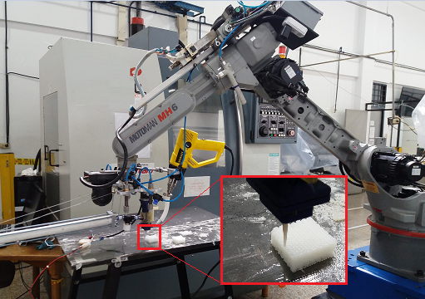
Figure 1: Adaptation of the robotic system for additive manufacturing by extrusion of biopolymers, and the construction of a rectangular prism.

Recent Publications (minimum 5)
- Gibson, I., Rosen, D. W., & Stucker, B. (2015). Introduction and Basic Principles. In Additive Manufacturing Technologies: Rapid Prototyping to Direct Digital Manufacturing (pp. 1–18). Springer US. https://doi.org/10.1007/978-1-4419-1120-9_1.
- Koski, C., Onuike, B., Bandyopadhyay, A., & Bose, S. (2018). Starch-hydroxyapatite composite bone sca ff old fabrication utilizing a slurry extrusion-based solid freeform fabricator. Additive Manufacturing, 24(August), 47–59. https://doi.org/10.1016/j.addma.2018.08.030
- Li, X., Lian, Q., Li, D., Xin, H., & Jia, S. (2017). applied sciences Development of a Robotic Arm Based Hydrogel Additive Manufacturing System for In-Situ Printing. https://doi.org/10.3390/app7010073
- Ligon, S. C., Liska, R., Stampfl, J., Gurr, M., & Mülhaupt, R. (2017). Polymers for 3D Printing and Customized Additive Manufacturing. Chemical Reviews, 117(15), 10212–10290. https://doi.org/10.1021/acs.chemrev.7b00074
- Kuo, C., Liu, L., Teng, W., & Chang, H. (2016). Preparation of starch / acrylonitrile-butadiene-styrene copolymers ( ABS ) biomass alloys and their feasible evaluation for 3D printing applications. Composites Part B, 86, 36–39. https://doi.org/10.1016/j.compositesb.2015.10.005.
- Liu, J., Sun, L., Xu, W., Wang, Q., Yu, S., & Sun, J. (2019). Current advances and future perspectives of 3D printing natural-derived biopolymers. Carbohydrate Polymers, 207(June 2018), 297–316. https://doi.org/10.1016/j.carbpol.2018.11.077

 Biography (150 word limit)
César Bacca is a professional with projection in the use of agricultural resources as a sustainable source for obtaining materials, products and supplying energy demands. Master's degree and specialization studies focused on additive manufacturing, with biopolymers applied in the biomedical sector, use of polysaccharides to obtain packaging, alternative energies in agricultural centers, and mechanical design for food processing. He is currently working as a PhD student, professor of Department of Mechanics and Mechatronics, and testing engineer at the Interfaculty Laboratory of Mechanical Testing - LABIEM, at the National University of Colombia - UNAL, evaluating different organic and composite materials.
.
Email: cabaccag@unal.edu.co

Notes/Comments:

