Abstract Template

Title: Quantum Dots Solar Cells and panels Additive Manufacturing by 3D printing ,
1Department of CAD, and 3D ENSTP Yaoundé Cameroon

Keywords: Shingwa Quantum Dots Cells (SQDC), Shingwa Quantum Dots panels(SQDP) 3D printing, Supersemiconductors

- Abstract Body (up to 250words)
SQS engineering researchers have designed Shingwa Quantum Dots Solar cells across the entire spectrum of visible light. Quantum dots are used in applications from solar energy harvesting to biological sensing and imaging to LED displays . The new 3D Printing and Additive Manufacturing system can be used to continuously manufacture high-quality quantum dots for it reduces the cost of production and increase its use in these applications. Shingwa Quantun Dot Cells and Panels with thin film technology would be the rising stars of the photovoltaic industry. They are cheap to produce, simple to manufacture and very efficient. They are also relatively new to the scene and offer the potential for more efficient solar cells and panels .Quantum dots (QDs) are a family of semiconductor materials with very interesting light-emitting properties, including the ability to tune what wavelengths light is emitted at. And more research and development is going on for super semiconductor materials with wavelength to be emitted at much longer wavelengths, reaching well into the infrared spectrum color. Currently, solar cells can only transform light emitted over a relatively narrow band of wavelengths. The fluorescence color of SQDC is a result of the chemical composition, the size, and the way the nanocrystals are processed. The 3D printing synthesis strategy utilized is would be allowed for the room temperature synthesis of Shingwa QDs, which are made using CesuimXxYy . SQS engineering starts with CesiumXxYy shingwa quantum dots(SQDC1) but then introduces various semiconductors to precisely tune their fluorescence color across the entire spectrum of visible light.

Image:
Name: NGUM SHINGWA MKONG BENJAMIN
Contact number: +237 678-833-418, +237 678852075
LinkedIn account: https://www.linkedin.com/in/ngum-shingwa-mkong-benjamin-95751967/
Twitter Account:
Category: Speaker
Passport number :0868184
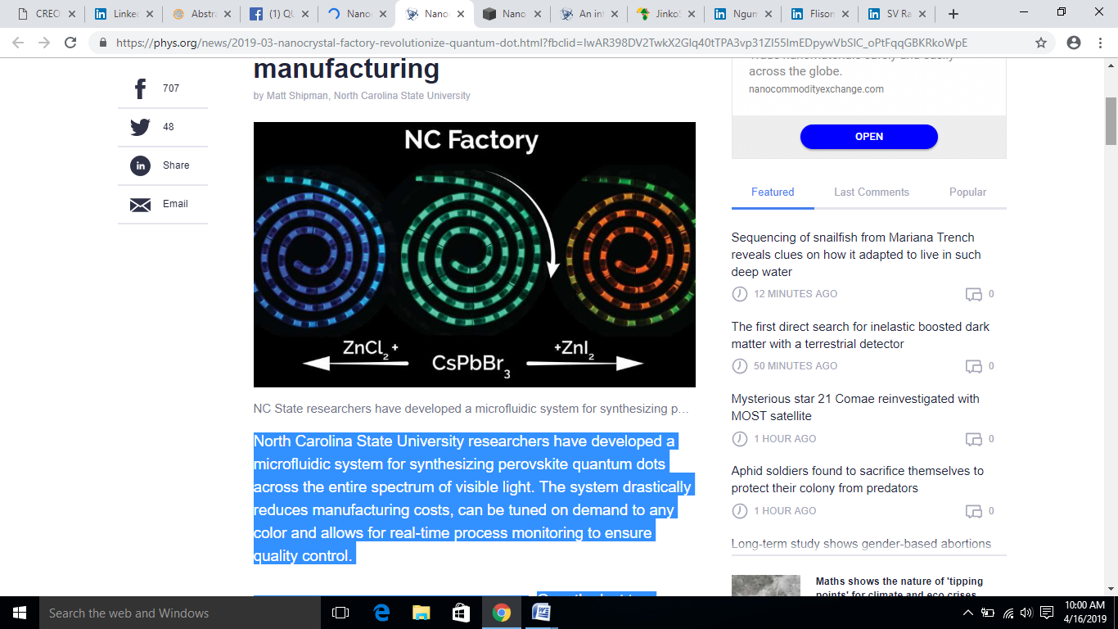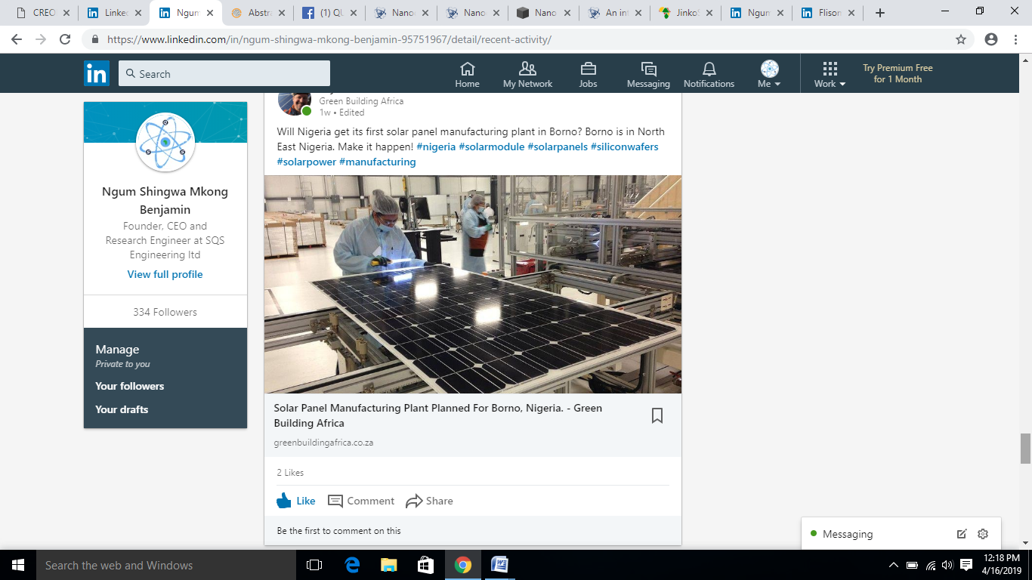
- Reference:

- Kameel Abdel-Latif et al Facile room temperature Anion Exchange reactions of inorganic perovskite Quantum Dots Enables by Modular Microfluidic Platform. Advanced Functional Materials(2019) D

- R. S. Sanchez et al. Tunable light emission by exciplex state formation between hybrid halide perovskite and core/shell quantum dots: Implications in advanced LEDs and photovoltaics, Science Advances (2016

Biography:
NGUM SHINGWA MKONG BENJAMIN has completed his M.eng at the age of 26 years from the University of Ngoundere National School of Agro-Industrial Sciences (ENSAI) from the Department of Industrial Maintenance and production Engineering Studies CAD and 3D printing in the University of Yaounde 1 (ENSTP) polythecnique., He as installed over 3MW of Off-grid solar stations in the rural commuiniteis in Cameroon for the past 3 years and now he is the Founder, CEO and Research and Developement Engineer at SQS engineering Ltd

Presenting authordetails



