Title: Personalized design and 3D printing for human total ankle prostheses: in-silico and in-vitro experimental evaluation

Belvedere C¹, Siegler S², Caravaggi P¹, Fortunato A³, Durante S⁴, Liverani E³, Ensini A¹, Tomesani L³, Leardini A¹
¹ Movement Analysis Laboratory, Istituto Ortopedico Rizzoli, Bologna, Italy
² Department of Mechanical Engineering and Mechanics, Drexel University, Philadelphia, PA, USA
³ Department of Industrial Engineering, Università di Bologna, Italy
⁴ Nursing, Technical and Rehabilitation Assistance Service, Istituto Ortopedico Rizzoli, Bologna, Italy

Keywords: Custom design, Total Joint Replacement, Additive manufacturing, Biomechanical models, Experiments in-vitro
- Abstract Body (up to 250 words)
Current total ankle prosthesis designs are based on cylindrical (CYL) or medially-oriented truncated-cone (TCM) geometries. A recent image-based morphological study demonstrated that natural ankle surfaces can be approximated by a laterally-oriented saddle-shaped skewed truncated-cone (SSCL) [1]. The aim of this study was to compare the three designs in terms of their efficacy in restoring natural ankle kinematics and flexibility.
Ten cadaveric lower-limbs underwent a validated process for custom designing of these geometries [2,3], including medical imaging, 3D-modeling and printing of the three relevant implantable sets of customized articular surfaces for tibiotalar replacement. Mechanical tests under cyclic loading were performed on each specimen, before and after the implantation of each of the three sets. Torques in out-of-sagittal plane directions were applied in neutral position and at joint flexion extremes. Corresponding in-silico simulations were also performed to estimate ligament strain/stress. The performances of custom-made artificial surfaces were compared with that of the natural joint surfaces.
SSCL surfaces replicated the physiological mechanical characteristics better than CYL and TCM, both at the ankle and subtalar joints, in all anatomical planes. In particular, in most of the specimens, SSCL was superior on a statistical basis compared to the other two surface approximations, especially for the responses in maximum dorsiflexion. In-silico evaluations confirmed more physiological ligament strain/stress patterns for SSCL surfaces.
All analyzed implant sets were originally designed to match the specific morphology of each tested specimen according to the three designing approaches. This study therefore represents well a possible future process of patient-specific ankle prosthesis designing and manufacturing.

- Image:
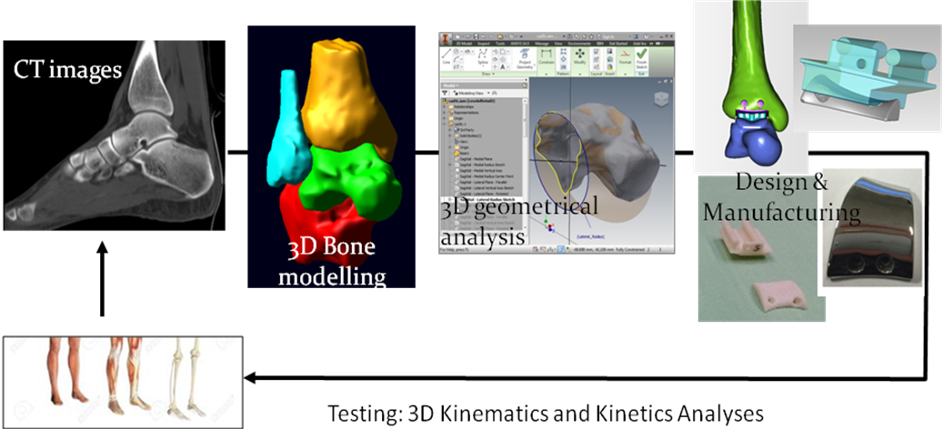

Flowchart of the study
- References:
- Siegler S, Toy J, Seale D, Pedowitz D, 2014. New observations on the morphology of the talar dome and its relationship to ankle kinematics, Clinical Biomechanics, 29(1): 1-6
- Belvedere C, Siegler S, Ensini A, Toy J, Caravaggi P, Namani R, Giannini G, Durante S, Leardini A, 2017. Experimental evaluation of a new morphological approximation of the articular surfaces of the ankle joint. J Biomech. 53:97-104
- Liverani E, Fortunato A, Leardini A, Belvedere C, Siegler S, Ceschini L, Ascari A, 2016. Fabrication of Co–Cr–Mo endoprosthetic ankle devices by means of Selective Laser Melting (SLM) Materials and Design 106: 60–68
- Biographies:
Claudio Belvedere has completed his PhD from University of Bologna, Biomedical Engineering. He has published about 40 papers has been serving as an editorial board member in a number of reputed international journals.
Alberto Leardini has completed his DPhil from University of Oxford, in Orthopedic Engineering. He is the Director of the Movement Analysis Lab, Istituto Ortopedico Rizzoli, Bologna, ITALY. He is in the Steering Group of the International Foot & Ankle Biomechanics community (i-FAB), in the Executive Council of the International Society of Biomechanics (ISB), and President of the IDBN.

- Presenting author details


Full Name: Claudio Belvedere
Contact number: +390516366570
Linked In account: belvedere@ior.it
Session name/ number:
Category: Oral presentation

