Abstract Template

Title: Visual Analysis of Surfactant solution flooding in Micro fluidic chip at different injection rates to optimize the Recovery

MUHAMMAD USMAN TAHIR¹, LIU WEI¹, ZHOU HONGTAO¹, IMRAN AKBAR¹, UBEDULLAH ANSARI¹, ASADULLAH MEMON¹, ATIF HUSSAIN¹
¹School of Petroleum Engineering, China University of Petroleum Huadong – Qingdao Campus, China

Keywords: Microfluidic Chip, Surfactant Flooding, Solution Flooding, EOR, Injection Rate

- Abstract Body (up to 250 words)
This paper presents the investigation of the surfactant solution flooding in cross capillary geometry using microfluidics devices in the framework of EOR (Enhanced Oil Recovery). As a matter of fact, the surfactant injected in reservoir to enhance the oil recovery causes blockage or flow deficiency due to incompatible flow in reservoir. Therefore, the objective of this study is to observe the flow efficiency of water/surfactant flow in these channels resulted improving in enhanced oil recovery. In this study, surfactant solution flooding experiments conducted at different injection rates. The first one relates to injection rate of 1 µl/min and second one corresponds to injection rate of 2µl/min. From this, it was revealed that at the flow of 1µl/min the surfactant solution reaches to junction point within 6 seconds and takes 13 seconds to achieve the full saturation in micro fluidic chip. Further, initial flow of surfactant is smooth and regular and then as it reaches at junction point its flow is declined by 7%. However at 2µl/min flow surfactant took 3 seconds to achieve saturation in microfluidic chip. Nevertheless, exactly half time was required for surfactant to reach junction point. Hence, higher injection rate are highly suitable for consolidated reservoir and surfactant require no alteration. The observations are key point for better understanding of the insinuated phenomena in EOR as to determine the applicable data to feed flow simulators.
- Image:

- Reference:
- N. Quennouz, M. Ryba, J.-F. Argillier, B. Herzhaft, Y. Peysson and N. Pannacci, 2014. Microfluidic Study of Foams Flow for Enhanced Oil Recovery (EOR). Oil & Gas Science and Technology – Rev. IFP Energies nouvelles, 69 (3): 457-466
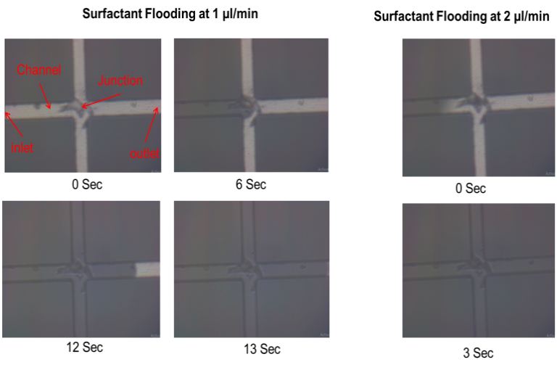
- J. Cui, and T. Babadagli, 2017. Use of new generation chemicals and nano materials in heavy-oil recovery: Visual analysis through micro fluidics experiments. Colloids and Surfaces, A 529, 346–355
- Biography:
I am Muhammad Usman Tahir doing his PhD at the age of 29 years from School of Petroleum Engineering, China University of Petroleum (East China). He is the 3rd year student
- Presenting author details


Full Name: Muhammad Usman Tahir
Contact number: 0086-15589841365
Twitter account: uzain83
Linked In account:
Session name/ number:
Category: (Oral presentation/ Poster presentation) Poster Presentation
Passport Number: CN7120831

