Passive microfluidic production of multiple emulsions

Adam S. Opalski¹, Karol Makuch¹, Ladislav Derzsi¹, Piotr Garstecki¹
¹ Institute of Physical Chemistry of Polish Academy of Sciences, Warsaw, Poland

Keywords: double emulsions, passive microfluidics, viscosity

- Abstract Body (up to 250 words)
Double emulsions (DE) are complex fluid systems, with a core droplet (e.g. aqueous) surrounded by a liquid shell (e.g. of oil) and suspended in an external phase (e.g. aqueous).¹ The thinner the shell is, the higher stability is shown by the DE. They found use in various fields of life sciences, from production of polymerosomes to screening rare cells via flow-cytometry.²
Microfluidic production of emulsions is thoroughly investigated, both single and complex emulsions. Double emulsions, however, are mainly produced by active methods, i.e. by shearing off a core droplet (creating feed, single emulsion) and shearing off the feed emulsion into double emulsion. Passive methods, such as step emulsification, offer higher level of monodispersity of produced emulsions as well as greater ease of use and parallelization than active methods.^{3,4}
Systematic investigation of the influence of feed emulsion parameters in the passive microfluidic system has never been carried out. We present a microfluidic system that allows production of monodisperse double emulsion (water-in-oil-in-water) with use of sequential step emulsification chips. We investigate the mechanism of double emulsion formation on the step, taking into consideration chip geometry and fluids parameters. We find that the crucial parameters in controlling the monodispersity, size, and shell thickness of the DE are the channels geometry, size of the cores in the feed emulsion and viscosities of used fluids.

- Image:

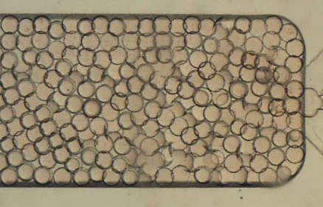
Figure 1 Thin-shelled water-in-oil-in-water double emulsions produced using step emulsification.

- Reference:
1 A. Ofner, I. Mattich, M. Hagander, A. Dutto, H. Seybold, P. A. Rühs and A. R. Studart, Adv. Funct. Mater., 2018, 1806821, 1806821.
2 G. T. Vladisavljević, R. Al Nuumani and S. Nabavi, Micromachines, 2017, 8, 75.
3 P. Zhu and L. Wang, Lab Chip, 2017, 17, 34–75.
4 A. S. Opalski, K. Makuch, Y.-K. Lai, L. Derzsi and P. Garstecki, Lab Chip, 2019.

- Biography:
Adam S. Opalski is last year graduate student at Institute of Physical Chemistry of Polish Academy of Sciences in group of prof. Garstecki. His research interests are passive droplet microfluidics and multiple emulsions. He is funded by National Centre of Science of Poland (DEC-2016/23/N/ ST4/01020).
- Presenting author details


Full Name: Adam S. Opalski
Contact number: +48223433247
Twitter account: -
Linked In account: -
Session name/ number: Microfluidic Research and Advances
Category: Oral presentation
Passport Number: why? -

