Title: Inertial Micromixing in Curved Serpentine Micromixers with Different Curvature Angles

Hossein Alijani ¹, Arzu Özbey ¹, Mehrdad Karimzadehkhouei ¹, Ali Koşar ^{1,2}

¹ Mechatronics Engineering Program, Faculty of Engineering and Natural Science, Sabanci University, Tuzla, Istanbul 34956, Turkey
² Center of Excellence for Functional Surfaces and Interfaces for Nano-Diagnostics (EFSUN), Sabanci University, Tuzla, Istanbul 34956, Turkey

Keywords: Inertial microfluidics, chaotic mixing, curved serpentine microchannel, Dean vortices

- Abstract Body
Micromixing is a crucial component of microfluidic systems which require mixing reagent molecules, fluids, or species for chemical reactions [1], which has applications in biomedical systems [2], chemical reactors [3], and polymerization [4]. In this study, three curved serpentine micromixers consisting of ten segments with curvature angles of 180°, 230°, and 280° were fabricated to investigate the effects of curvature angle on inertial micromixing of two fluids. In this regard, water and diluted Rhodamine B solution were pumped into the micromixers over flow rates of 400-3000μL/min. To characterize and compare the mixing performance of the micromixers and to understand the underlying mechanisms, fluorescent intensity maps and mixing indeces were utilized. According to the results, up to the Reynolds number of 150, the mixing performance of the micromixers with curvature angles of 180° and 230° was similar to each other. While the micromixer having segments with 280° curvature angle showed higher mixing index values and thus outperformed the other two micromixers. This was due to severe distortion of flow streamlines by Dean vortices and occurrence of chaotic advection. As a consequence, larger contact area was available for intermixing. Moreover, as the curvature angle of the mixing segments increased, the onset of chaotic advection took place at a lower Reynolds number, and the micromixer reached its ultimate mixing performance earlier. Above the Reynolds number of 170, no difference was observed in the mixing performance of the micromixers. In this range, the mixing index at the outlet of the micromixers had the asymptotic value of 0.93±0.02.
- Image:
Figure 1. The schematic of the micromixers (a) M180, (b) M230, and (c) M280 and locations of the inlets of water and 0.5mM Rhodamine B in water. Zoomed-in views show the channels width (in orange) and radius of curvature (in red). Green lines indicate the locations, at which mixing index is evaluated. All dimensions are in µm. Scale bar is 5mm.
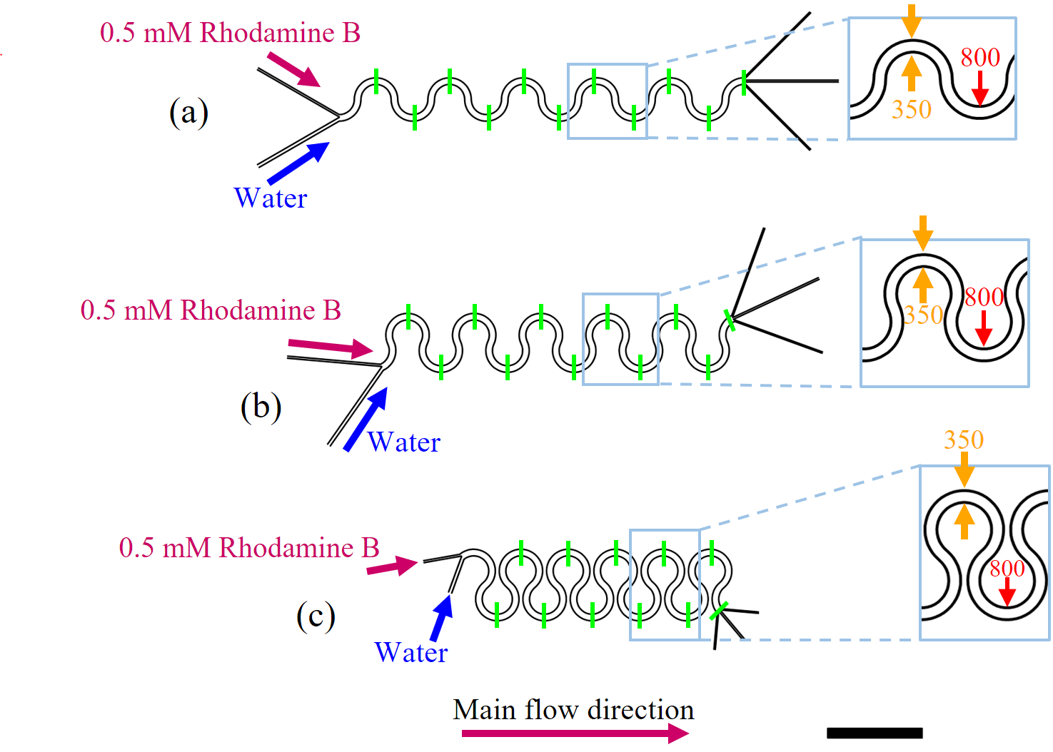
- Reference:
[1] L. Capretto, W. Cheng, M. Hill, and X. Zhang, "Micromixing within microfluidic devices," in Microfluidics: Springer, 2011, pp. 27-68.
[2] C.-Y. Lee and L.-M. Fu, "Recent Advances and Applications of Micromixers," Sensors and Actuators B: Chemical, 2017.
[3] Y.-T. Chen, K.-H. Chen, W.-F. Fang, S.-H. Tsai, J.-M. Fang, and J.-T. Yang, "Flash synthesis of carbohydrate derivatives in chaotic microreactors," Chemical engineering journal, vol. 174, no. 1, pp. 421-424, 2011.
[4] M. Ryu et al., "Infrared thermo-spectroscopic imaging of styrene radical polymerization in microfluidics," Chemical Engineering Journal, vol. 324, pp. 259-265, 2017.
- Biography:
Ali Kosar is one of pioneers in the design and development of new generation micro heat sinks and microfluidic devices. His research interests constitute a wide spectrum covering heat and fluid flow in micro/nano scale, forced convection, multi-phase flow, and cavitation. He aims at contributing to the literature by removing the lack of information about micro/nano scale heat transfer and fluid flow and providing experimental data and design guidelines for futuristic cooling and microfluidic system technologies. The results of his research have already generated more than 100 accepted/published journal research articles, which have been published in prestigious journals.

- Presenting author details


Full Name: Prof. Dr. Ali Koşar
Contact number: +90-216-4839621
Linked In account: https://tr.linkedin.com/in/ali-ko%C5%9Far-84462549
Session name/ number:
Category: Oral presentation

