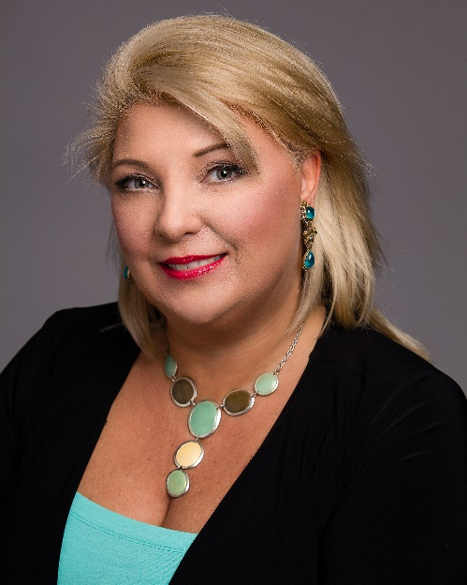
Cheryl Ivaniski, Dr. Ac., C.H., RDH

Cheryl Ivaniski is a Branded Wellness Authority and Thought Leader in the field of Diabetes. What is unique about Cheryl is her Holistic Approach to Diabetes Wellness which embraces Health, Healing and Hope. She focuses on giving her clients at the Academy of Holistic Diabetes Education, new leading edge solutions to prevent, restore and even reverse the complications of Diabetes where possible in a whole new way.
She is a Holistic Health Authority and a Dr. in Holistic Medicine - Acupuncture, with advanced training in Natural Nutrition, Kinesiology and Mind Body Medicine. Her clinical and research interests include transforming beliefs, attitudes and habits and integrating positive lifestyle changes to help normalize blood sugar levels naturally and to start Winning with Diabetes.
Cheryl has been teaching and has helped hundreds of people with her Holistic Living Prescription. Her clinical and research interests include nutrition and glycemic indices, natural solutions to normalize blood sugar levels, continuous glucose monitoring, mindset, sleep and stress management.

Cheryl is a Global Wellness Authority, Dr. Holistic Medicine-Acupuncture, 5 X International Best Selling Author, 2 X Global Award Winning Author, and winner of the prestigious Quilly Award.
She was recently inducted into the Academy of Best Selling Authors, Writers and Speakers.
Cheryl has been teaching and has helped hundreds of people with her Holistic Living Prescription. Her clinical and research interests include nutrition and glycemic indices, natural solutions to normalize blood sugar levels, continuous glucose monitoring, and sleep and stress management.
I've gone on to co-authoring books with some of the Top Thought Leaders in the World today, including Jack Canfield (New York Times Best Selling Author of Chicken Soup for the Soul Series), Les Brown, (World’s # 1 Motivational Speaker), Dr. John Gray (Men are Mars, Women are from Venus), Brian Tracey (Top 10 Business Guru) and others. My newest book, Having a Life of More was inspired by my 100-year-young grandpa and grandma who lost her life to Diabetes. It earned me International Status as a Global Award Winning Author in London, England.
I have been teaching and have helped hundreds of people with my Holistic Living Prescription. I've shared my message, mission and methods with over 1,500 audiences on stage, on television, on the radio, in podcasts, magazines, as a guest on many online and live shows. I love nothing more than spreading the methods I have used to live a life with Diabetes that I love for over 24 years!
As a licensed health care professional, professor and consultant in traditional medicine, combined with my Doctorate in Holistic Studies - Acupuncture, advanced training in Natural Nutrition, Certification in the Power of Mindset and Hypnotherapy, and treating and coaching clients for over 28 years, I deliver the newest leading-edge holistic tips and techniques to help you WIN over Diabetes!

