Complementary and alternative treatment for GERD
Hejazi z Pharm.D, Ahvaz Jundishapur university of medical sciences,IRAN

Abstract
Statement of the Problem: Gastroesophageal reflux disease (GERD), is a digestive disorder that affects the lower esophageal sphincter (LES), the ring of muscle between the esophagus and stomach. It complaint both in the primary care and hospital settings. Because of the possible serious adverse effects of the long-term use of common medicine for this problem (such as: Antacids, H2 blockers, Proton pump inhibitors, Prokinetics, Antibiotics, surgery) Complementary and alternative medicine (CAM) use is reported to be higher among patients with irritable bowel syndrome and inflammatory bowel disease. Methodology & Theoretical Orientation: Peer-reviewed publications were identified through searches in Scopus, science direct, Cochrane, PubMed, and also Google scholar by using the search terms “Gastroesophageal reflux disease,” “GERD,” “digestive disorder,” “CAM,” “phytotherapy,”“herbal medicine”. The search was completed through January 2020, and was limited to articles published in English. Relevant articles were identified based upon the expertise and clinical experience of the authors. Findings: We categorized our result in different categories including: Life style modifications (avoid cigarette and alcohol, exercise, small meals throughout a day, chew food slowly, sleep shoulders and head propped up, minimize caffeine and avoid lying down for at least 3 hours after a meal), supportive care: probiotics and prebiotics, treatments: synthetic (routine and newer options of anti-acid, h2 blockers, PPIs and surgical care) and natural Options (different Types of CAM including herbal medicines, yoga, acupuncture, massage therapy, chiropractic). Conclusion & Significance: In this case is better that Complementary medicine used together with mainstream medical care. To minimize the health risks of a non-mainstream treatment discuss it with your doctor. It might have side effects or interact with other medicines.

Image
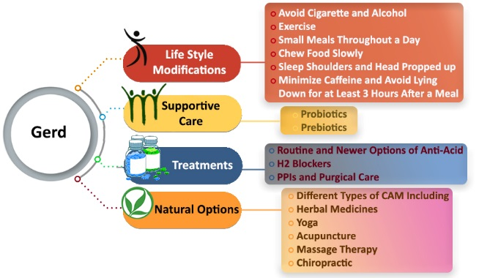
Fig 1. Approaches for Gastroesophageal reflux disease
Recent Publications

- Complementary and alternative medicine for osteoporosis, ZA Hejazi, F Namjooyan, M Khanifar, Iranian journal of medical sciences 41 (3 Suppl), S27, 2016
- Chemical and natural approach to vaginal atrophy, ZA Hejazi, F Namjoyan, Z Morshedi European Journal of Integrative Medicine 1 (8), 48, 2016
- Preparation and evaluation of vaginal cream containing extracts of Linum usitatissimum, Foeniculum Vulgare and Salvia officinalis, ZA Hejazi, F Namjoyan, MR Abbaspour, European Journal of Integrative Medicine 1 (8), 29

Biography
Zahra Sadat Hejazi has expertise in clinical research especially in Complementary and alternative medicine. She has search this topic because the number of patient who has this problem. She search about it for a year and complete it in January 2020. This article responsible to any question about this debase.

Email: z.s.hejazi@gmail.com

Notes/Comments:

