Spontaneous Rupture of Renal Pelvis in case of Sigmoid Volvulous
Bal Jaskaran Singh¹
Kasturi Sarathy²

Introduction: Spontaneous rupture of the renal pelvis is one of the rare complications and usually occurs due to obstructed distal ureteric calculus. Malignant ureteric obstruction and bladder outlet obstruction are few other causes that could lead to rupture of renal pelvis secondary to the back pressure changes. Pregnancy is one of the non-renal extra-luminal causes of the spontaneous renal fornix rupture.
Sigmoid volvulus is one of the common causes of intestinal obstruction accounting for 2 to 5% of emergency case load in the western world. The sigmoid colon twists around its own mesentery leading to intestinal obstruction and a compromised blood supply. ^{[1]}
In this case, the twisted sigmoid mesentery resulted in extrinsic compression of the distal ureter leading to spontaneous rupture at the Pelvic- Ureteric Junction (PUJ).
Case Presentation: A 57-year-old lady, with background of cerebral palsy and learning difficulties was admitted in emergency with abdominal pain and distension. The caretakers had noted progressive abdominal distension and no bowel movements for four days and hence subsequent surgical referral. National early warning score (NEWS) was 0. The abdomen was distended, tense and tender on palpation but no guarding or rigidity was elicited. Rectal examination showed an empty rectum. Patient responded well to initial resuscitation.
Investigations and Initial Management:
Blood investigations: Hb-137 g/L, WCC- 17.6 x 10⁹/L, CRP- 70, GFR- 82
Chest X- ray- NAD
Abdominal X-ray- classic coffee bean sign suggestive of a volvulus (Figure 1).
CT AP- confirmed the features of volvulus and no other bowel related pathology.
A rigid sigmoidoscopy with flatus tube insertion was performed to decompress the bowel.
The following day, patient appeared more distressed and complained of intermittent colic in the left flank, and increasing tenderness over abdomen.
Repeat blood investigations: CRP- 430mgL, GFR-32, Serum Creatinine 141umol/L.
Repeat CT AP- left sided hydronephrosis and hydroureter with active extravasation of contrast from the left renal pelvis into the retroperitoneum indicating a rupture (Figure 2). The dilatation of the ureter evident till the lower end where the root of the sigmoid mesentery is attached. No evidence of contrast in the distal ureter and the ureter is non-dilated beyond the transition point of extrinsic compression. The bowel wall of the sigmoid colon appeared non-enhancing suggesting ischemia.
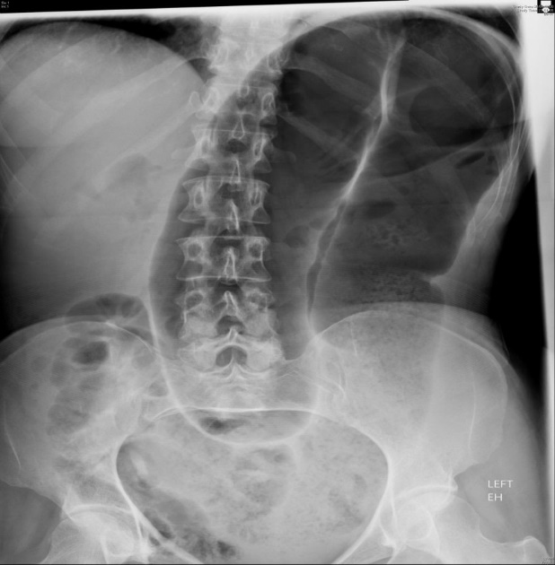
Figure 1

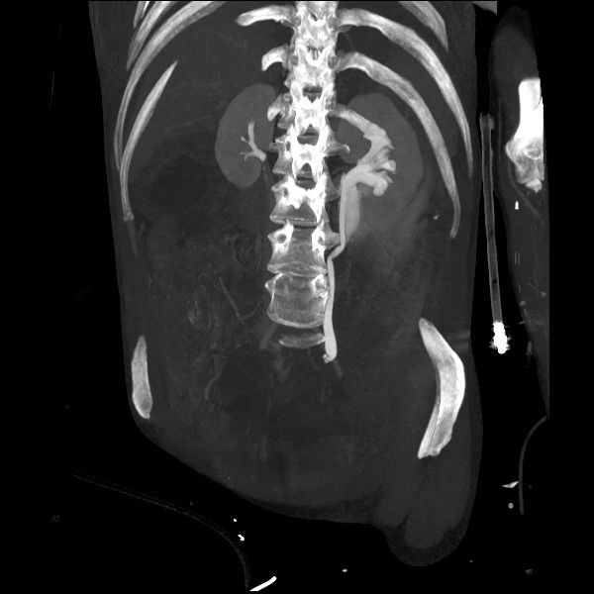
Figure 2
Treatment: After discussion with the urologist, a DJ stent was inserted in the left renal tract under fluoroscopic guidance (Figure 3). Subsequent laparotomy revealed a non-viable gangrenous segment of sigmoid colon. Sigmoid colectomy was performed with end colostomy. The patient made an uneventful recovery and was discharged 2 weeks following her admission. The urologists removed the stent after an interval of 3 months.

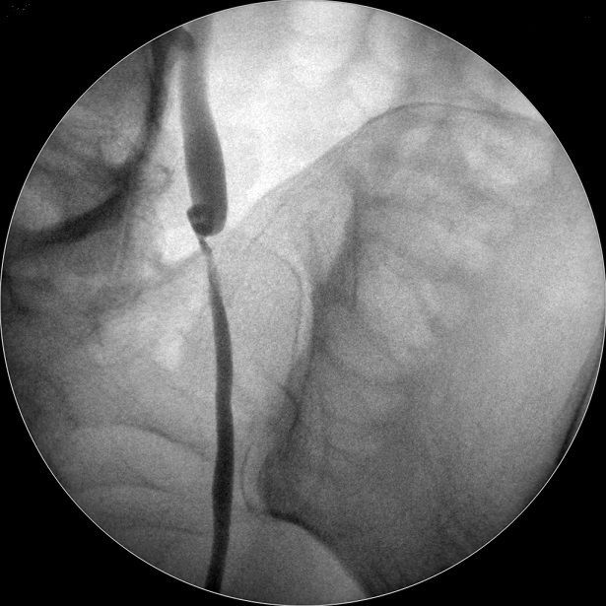
Figure 3

Discussion: Flank pain radiating to groin is most common clinical presentation of spontaneous rupture of renal pelvis (SRRP). SRRP is also associated with hematuria.^{[2]} Serial ultrasound examinations, Contrast enhanced CT scans and Intravenous Pyelogram are commonly employed imaging studies used for diagnosis of SRRP. Diversion of urine by means of a DJ-stent or a percutaneous nephrostomy are the treatment modality employed for small ruptures of renal pelvis.^{[3]}
In our patient, the rupture of renal pelvis could be secondary to back pressure changes that lead to high intra-ureteric pressure due to obstructed distal ureter.

References:
- Baiu I, Shelton A. Sigmoid Volvulus. JAMA. 2019;321(24):2478. doi:10.1001/jama.2019.2349.
- Te-Li Chen, Yu-Jang Su, Spontaneous Rupture of Renal Pelvis, International Journal of Gerontology, Volume 1, Issue 3, 2007, Pages 131-133, https://doi.org/10.1016/S1873- 9598(08)70034.
- Tuncay Tas, Basri Cakıroglu, Süleyman Hilmi Aksoy, "Spontaneous Renal Pelvis Rupture: Unexpected Complication of Urolithiasis Expected to Passage with Observation Therapy" , Case Reports in Urology, vol. 2013, Article ID 932529, 3 pages, 2013. https://doi.org/10.1155/2013/932529.

