Are Patients Admitted With Gallstone Pancreatitis Being Treated as per the Current UK Guidelines?

Introduction
Gallstone disease is the leading risk factor for pancreatitis, an inflammatory condition wherein the exocrine pancreas releases its enzymes prematurely, leading to auto-digestion. Guidelines updated by the British Society of Gastroenterology (BSG) in 2005 state all patients with biliary pancreatitis should undergo definitive management of gallstones with cholecystectomy/ERCP and sphincterotomy during the same admission unless clear treatment within the next two weeks is planned. In severe acute pancreatitis, this should be delayed until signs of systemic disturbance have resolved. This audit aimed to establish if national guidelines had been met at Birmingham Heartlands Hospital, and to identify any steps that can be taken to improve adherence to the guidelines.

Methods
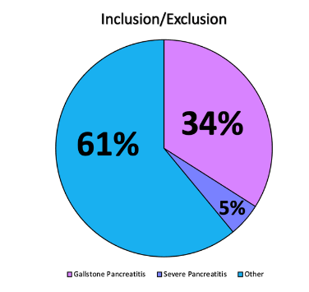
Data was collected on patients admitted to the general surgery ward from January 1st 2023 to June 30th 2023 and diagnosed with gallstone pancreatitis (approximately 100 patients) to ascertain if they received definitive treatment for their gallstones as indicated by guidelines. If they had not been treated according to the guidelines, the patients were followed up for 3 months to see if they developed complications or were re-admitted. Data was collected for different variables such as: time to diagnosis, diagnostic investigations, risk stratification, length and complications during the stay, mode of nutrition, and deaths reported. Microsoft Excel was used to collect the data and calibrate the results.

Results
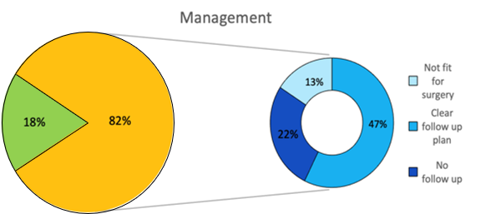
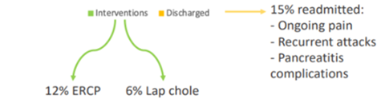
In total, 47% of patients did not receive an appropriate intervention according to the BSG guidelines. Severity score was also found to be poorly documented, with only 20% of patients having had their score noted. 59% of patients received antibiotics, and only 27% of these had a clear indication documented for receiving them. Nutrition was managed well, with all patients receiving IV fluids and having an enteral mode of nutrition established. 9% were to receive a laparoscopic cholecystectomy via the HTC pathway and 29% via the inpatient waiting list. As the dataset was limited and based only on one single secondary care setting, this reduces the generalisability of our results. However, the dataset was very recent and so would be representative of the current practices in the trust.

Conclusions
Adequate documentation of severity score is key in ensuring the guidelines are followed. The ability of scoring systems to accurately predict pancreatitis outcomes is evident from the literature. Antibiotic use must also be justified as regular use is not endorsed by the literature, and more detailed noting of this is required. There is also an urgent need for all patients to receive clear follow-up plan from discharge to reduce the risk of readmission. In order to improve documentation in the future, introducing a pro-forma for the management of patients with gallstone pancreatitis may be of benefit. The pro-forma would be based on the guideline and therefore improve adherence. It is also important to reaudit annually to assess improvement and adherence to the guideline.

