Differentiative trajectory of hippocampal neural stem cells and interneurons by snRNA-and scRNA-sequencing
Tingting Sun PhD, Zaozhuang Key Laboratory of Research in Neurodegenerative Diseases and Development of Neuropharmaceuticals, Zaozhuang University

Abstract (300 word limit)

Alzheimer’s disease (AD) is a normal degenerative disease with deficit in adult neurogenesis. However, there is a severe conflict in adult AD neurogenesis. To draw the panoramic view of adult neurogenesis in the process, and to reveal the effect of adult neurogenesis on AD process, we traced the neuronal progenitors, neuroblast and neural stem cell (NSC) pool from postnatal 17 to 12 months of APP/PS1 transgenic mice. NSC differentiative trajectory was depicted based on single cell sequencing, which included five sequential stages from quiescent to activation. Further, we found an obvious alteration of topologic-specific cell diversity and gene expression in hippocampus, and based on these, we found significant changes in interneurons diversity, especially in hippocampal dentate gyrus and CA3 regions. The further gene set enrichment analysis, qRT-PCR, immunofluorescence and immunoprecipitation detected the significant expression alteration of proliferation-related and cytoskeleton-related genes during AD process. These indicated the proliferation and cytoskeleton-related factors probably participate in the NSC and interneuron differentiation process and involved in the disease process.

Image
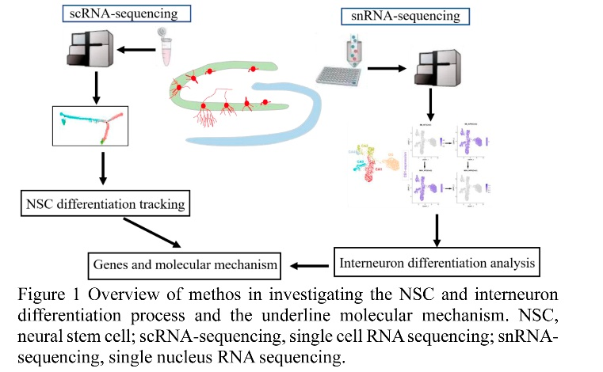
Recent Publications (minimum 5)
- Li T, Dong Sh, He Ch, Yang J, Li W, Li Sh, Li J, Du X, Hou Zh, Li L, Li S, Huang Zh, Sun T (2022) Apoptosis, rather than neurogenesis, induces significant hippocampal-dependent learning and memory impairment in chronic low Cd ²⁺ exposure. Environ Toxicol, doi: 10.1002/tox.23445.
- Sun T, Li T, Yi K, Yan G, Gao X (2021) Fluorescent protein variant generated by reassembly between skeleton and chromophore. ACS Omega 6(4):2925-2933.
- Sun T, Li T, Yi K, Gao X (2020) Structure-guided evolution of Green2 toward photostability and quantum yield enhancement by F145Y substitution. Protein Sci 29:1964-1974.
- Sun T, Li W, Ling Sh(2016)miR-30c and semaphorin 3A determine adult neurogenesis by regulating proliferation and differentiation of stem cells in the subventricular zones of mouse. Cell Prolif. 49(3):270-280.
- Sun T,Li T,Davies H, Li W, Yang J, Li Sh, Ling Sh(2016) Altered Morphologies and Functions of the Olfactory Bulb and Hippocampus Induced by miR-30c.Front Neurosci 10：207.

Biography (150 word limit)

Dr. Tingting Sun has been engaged in the research on the mechanism of neurodegenerative diseases and neurogenesis. In the past five years, she has presided over one youth project of the National Natural Science Foundation of China, one key project of the natural science foundation of Shandong Province, participated in three projects of the National Natural Science Foundation of China, and applied for one international PCT and one domestic invention patent. She is a communication review expert of the National Natural Science foundation of China, Expert of science and technology expert database of Shandong Province and Guangdong Province, special commissioner of science and technology of Shandong Province.

Email: suntingting@uzz.edu.cn

Notes/Comments:

Presenting author details
Full name: Tingting Sun
Contact number: +86-0632-3786399
Mail id: suntingting@uzz.edu.cn
Category: (Oral presentation/ √Poster presentation)

