Abstract Title: Evaluation of Posterior Cervical Foraminotomy in Management of Cervical Disc Disease.
Esam Eldin Gaber Saleh MD¹, Awatef Elsayed Farghaly MD²,
Hossam AbdElhakim Elnoamany MD³, Tamer Ahmed Elsaadany M.B.B.CH⁴
¹ MD Department of Neurosurgery, Faculty of Medicine (University of Menoufia, Egypt)
² MD Department of General surgery, Faculty of Medicine (University of Menoufia, Egypt)
³ MD Department of Neurosurgery, Faculty of Medicine (University of Menoufia, Egypt)
⁴ M.B.B.CH Department of Neurosurgery, Faculty of Medicine (University of Tanta, Egypt)

Abstract:
Background: Posterior cervical procedure was the first method for management of cervical disc disease until the appearance of anterior cervical discectomy and fusion but in recent years posterior cervical foraminotomy has a comeback as it doesn't entail fusion.
Methods: Thirty patients suffering from cervical polyradiculopathy were operated through posterior cervical foraminotomy in a prospective study.. The study was conducted on patients presented to Neurosurgery Department of Qabbary General Hospital and Menuofia University hospitals in the period from March 2017 to October 2019.
Result: A total of 73 spinal levels were operated, the most common level affected in this series was c5/c6 presented in 23 cases (31.5%), followed by c6/c7 level presented in 21 cases (28.7%),15 cases with c4/c5 (20.5%) and 14 cases with c3/c4 affection (19.2%).Three patients of the 30 cases (10%) in the series had four level affection, Eleven patients(36.7%) had three level affection, Twelve patients (40%) had double level affection, Four cases(13.3%) had a single level operation. In this study; 26 cases (86 %) had Excellent and good outcomes according to Odom’s criteria of outcome grading, while 4 cases had a fair outcome.
Conclusion: Posterior cervical foraminotomy is a safe and effective motion preserving approach for treatment of cervical radiculopathy in well selected cases. It has comparable outcomes to the Anterior Cervical Discectomy and Fusion (ACDF) approach with avoidance of possible complications associated with anterior approaches.
Key Words: Cervical Disc; Foraminotomy; Posterior Cervical.

Professional Biography :

Tamer Ahmed Elsaadany has completed his M.B.B.CH degree at the age of 23 years from School of Medicine, Tanta University, Egypt. He is a resident neurosurgeon at the department of neurosurgery at Qabbary Teaching hospital,Egypt. He is a candidate at the Egyptian fellowship Board of Neurosurgery.He has published more than10 papers in reputed journals and has been serving as an editorial board member of repute.

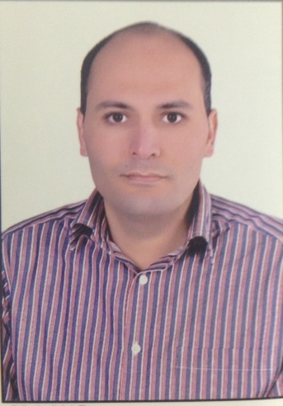
Tamer Elsaadany

Email Id: tamer_elsaadany@yahoo.com

Any Comments:

