CRISPR-Cas technology: emerging applications in clinical microbiology and infectious diseases
Sahar Serajian, Ehsan Ahmadpour, Sonia M. Rodrigues Oliveira, Maria de Lourdes Pereira and Siamak Heidarzadeh
¹ Department of Molecular Systems Biology, Cell Science Research Center, Royan Institute for Stem Cell Biology and Technology, ACECR, Tehran, Iran.
² Infectious and Tropical Diseases Research Center, Tabriz University of Medical Sciences, Tabriz, Iran.
³ Immunology Research Center, Tabriz University of Medical Sciences, Tabriz, Iran
⁴ CICECO - Aveiro Institute of Materials, University of Aveiro, 3810-193 Aveiro, Portugal
⁵ Hunter Medical Research Institute, New Lambton, NSW 2305, Australia
⁶ Department of Medical Sciences, University of Aveiro, 3810-193 Aveiro, Portugal
⁷ Department of Microbiology and Virology, School of Medicine, Zanjan University of Medical Sciences, Zanjan, Iran

Abstract (300 word limit)
Through the years, many promising tools for gene editing have been developed including zinc-finger nucleases (ZFNs), transcription activator-like effector nucleases (TALENs), CRISPR-associated protein 9 (Cas9), and homing endonucleases (HEs). These novel technologies are now leading new scientific advancements and practical applications at an inimitable speed. While most work has been performed in eukaryotes, CRISPR systems also enable tools to understand and engineer bacteria. The increase in the number of multi-drug resistant strains highlights a necessity for more innovative approaches to the diagnosis and treatment of infections. CRISPR has given scientists a glimmer of hope in this area that can provide a novel tool to fight against antimicrobial resistance. This system can provide useful information about the functions of genes and aid us to find potential targets for antimicrobials. In this way, several obstacles such as the efficiency of CRISPR- Cas systems delivery, developing resistance against CRISPR-Cas, and Legislation of CRISPR-Cas-Based Antimicrobials are still major concerns.
This paper discusses the emerging use of CRISPR-Cas systems in the fields of clinical microbiology and infectious diseases with a particular emphasis on future prospects.

Image

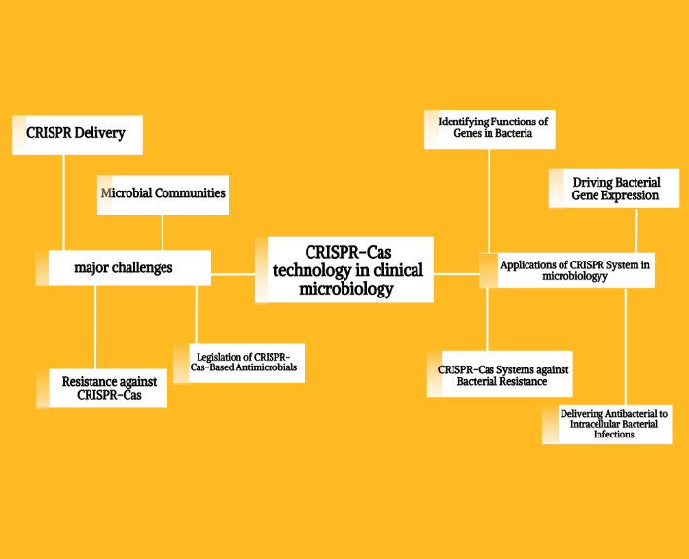

Recent Publication
- Serajian S, Ahmadpour E, Oliveira SMR, Pereira ML, Heidarzadeh S. CRISPR-Cas Technology: Emerging Applications in Clinical Microbiology and Infectious Diseases. Pharmaceuticals (Basel). 2021 Nov 17;14(11):1171.
- Serajian S, mohyeddin kazemeini m, Heidarzadeh S. Epidemiology of urinary tract infection and antibiotic resistance pattern of E. coli in patients referred to Shahid Beheshti hospital in Zanjan, Iran. 20th International Congress of Microbiology of Iran
- Soleimani Sasani, M., Heidarzadeh, S., Zolfaghari, M.R., Soleimani, M., Serajian, S. (2020). High potential of tellurite bioremediation by moderately halophilic Staphylococcus xylosus.
- zanjani M, Amanloo S, kakavand F, Serajian S, Ahmadi F, kakavand F. Genotype analysis of Candida albicans isolates using ALT repeat sequences obtained from patients with vulvovaginal candidiasis from Zanjan, Iran. 20th International Congress of Microbiology of Iran


Biography

Sahar Serajian has a major in medical laboratory sciences and works in Royan Institute for Stem Cell Biology and Technology and participates as a tech-team in SYNAPSE accelerator which is expertise in In Vitro Diagnostics technologies. She has several years of experience in a clinical laboratory in a hospital and many collaborations with the microbiology department of Zanjan medical university. she is passionate about health and innovations. Her vision is to find links between existing science knowledge and public health challenges. Her research is toward cutting-edge sciences which can solve future health problems and develop innovative platforms to detect and prevent diseases.

Email: Sahar.serajian95@gmail.com

