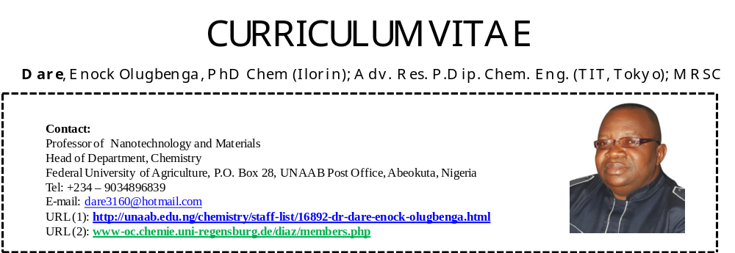
Novel Dansyl Fluorescently Labeled Octasilsesquioxane Nanohybrids II for Latent fingerprinting Detection
Dare Enock O^{*ab}., Diaz Diaz David^{*b},
ª Department of Chemistry, Federal University of Agriculture, Abeokuta, Nigeria
^{b} Institute of Organic Chemistry, Faculty of Chemistry and Pharmacy, Regensburg University, Regensburg
*Corresponding authors

Two novel dansyl fluorescently labeled POSS nanohybrids, POSS-PD and POSS-S-PD, have been facilely synthesized by CuAAc “click” and sequential thiol/CuAAc “click” chemistry respectively. The FLMs have been characterized by NMR, FTIR, UV-vis, elemental analysis and photophysical evaluation. POSS anchoring triazole ring has different influence on the absorption and fluorescence transition of both POSS-PD and POSS-S-PD, which however depends on their relative architectural design. By virtue of the extremely high є (58,848) , POSS-PD is much more favorably disposed to absorption transition probability whereas POSS-S-PD in its high ɸ_{fl} (100%) and large stoke’s shift (9956) has a transcending propensity for a stronger emission transition probability. Both FLMs are highly photostable retaining fluorescent emission > 80% after 60 h monochromatic irradiation. The two FLMs adequately detect latent fingerprints on glassy surface in good legibility.

Biography:
Enock Olugenga Dare is a Professor of Materials and Nanotechnology of the Federal University of Agric. Abeokuta. He did his postdoctoral at Princeton University, NJ, USA. He is an Alexander von Humboldt Fellow. He has published over 100 research articles, including patent. He has also supervised 9 Ph.D projects successfully.

