Smart Properties of Co-doped (Bi³⁺ & Zr⁴⁺) Potassium Sodium Niobate (K_{0.50}Na_{0.50}NbO₃) Based Piezoelectric Ceramics
Fayaz Hussain, PhD, Department of Materials Engineering, NED University of Engineering & Technology, Pakistan.

Abstract

Co-doped compositions based on (1-x)(K_{0.50}Na_{0.5})NbO₃ – x(Bi_{0.50}Na_{0.50})ZrO₃ (KNN-BNZ) have been studied, where 0.01 ≤ x ≤0.06. The grain morphology through SEM analysis of KNN-NBZ remained similar in all compositions and revealed densely packed arrangement of grains consistent with a relative density >95% of the theoretical. The XRD result of sintered samples showed single phase perovskite in the range of 2θ=15° to 80°. The best relative permittivity (ε_{r}) of the composition of 0.05 ≤ x ≤ 0.06 observed form LCR data. In addition to this, the dielectric loss (Tanδ) is <0.05 in all compounds up to the Curie point (T_{C}). Most noteworthy ferroelectric-hysteresis-loop is that the ceramics with x = 0.52 saturate at the lowest applied-electric-field (20kV/cm). In stark contrast to all KNN-BNZ compositions, a huge enhancement in piezoelectric activity obtained with an optimum of d₃₃=315pC/N and k_{p} =0.45 for the composition with x = 0.052. Nevertheless, the formulations above x=0.52 showed relaxor type behaviour which should be applicable for inverse piezoelectric-effect applications.

Image
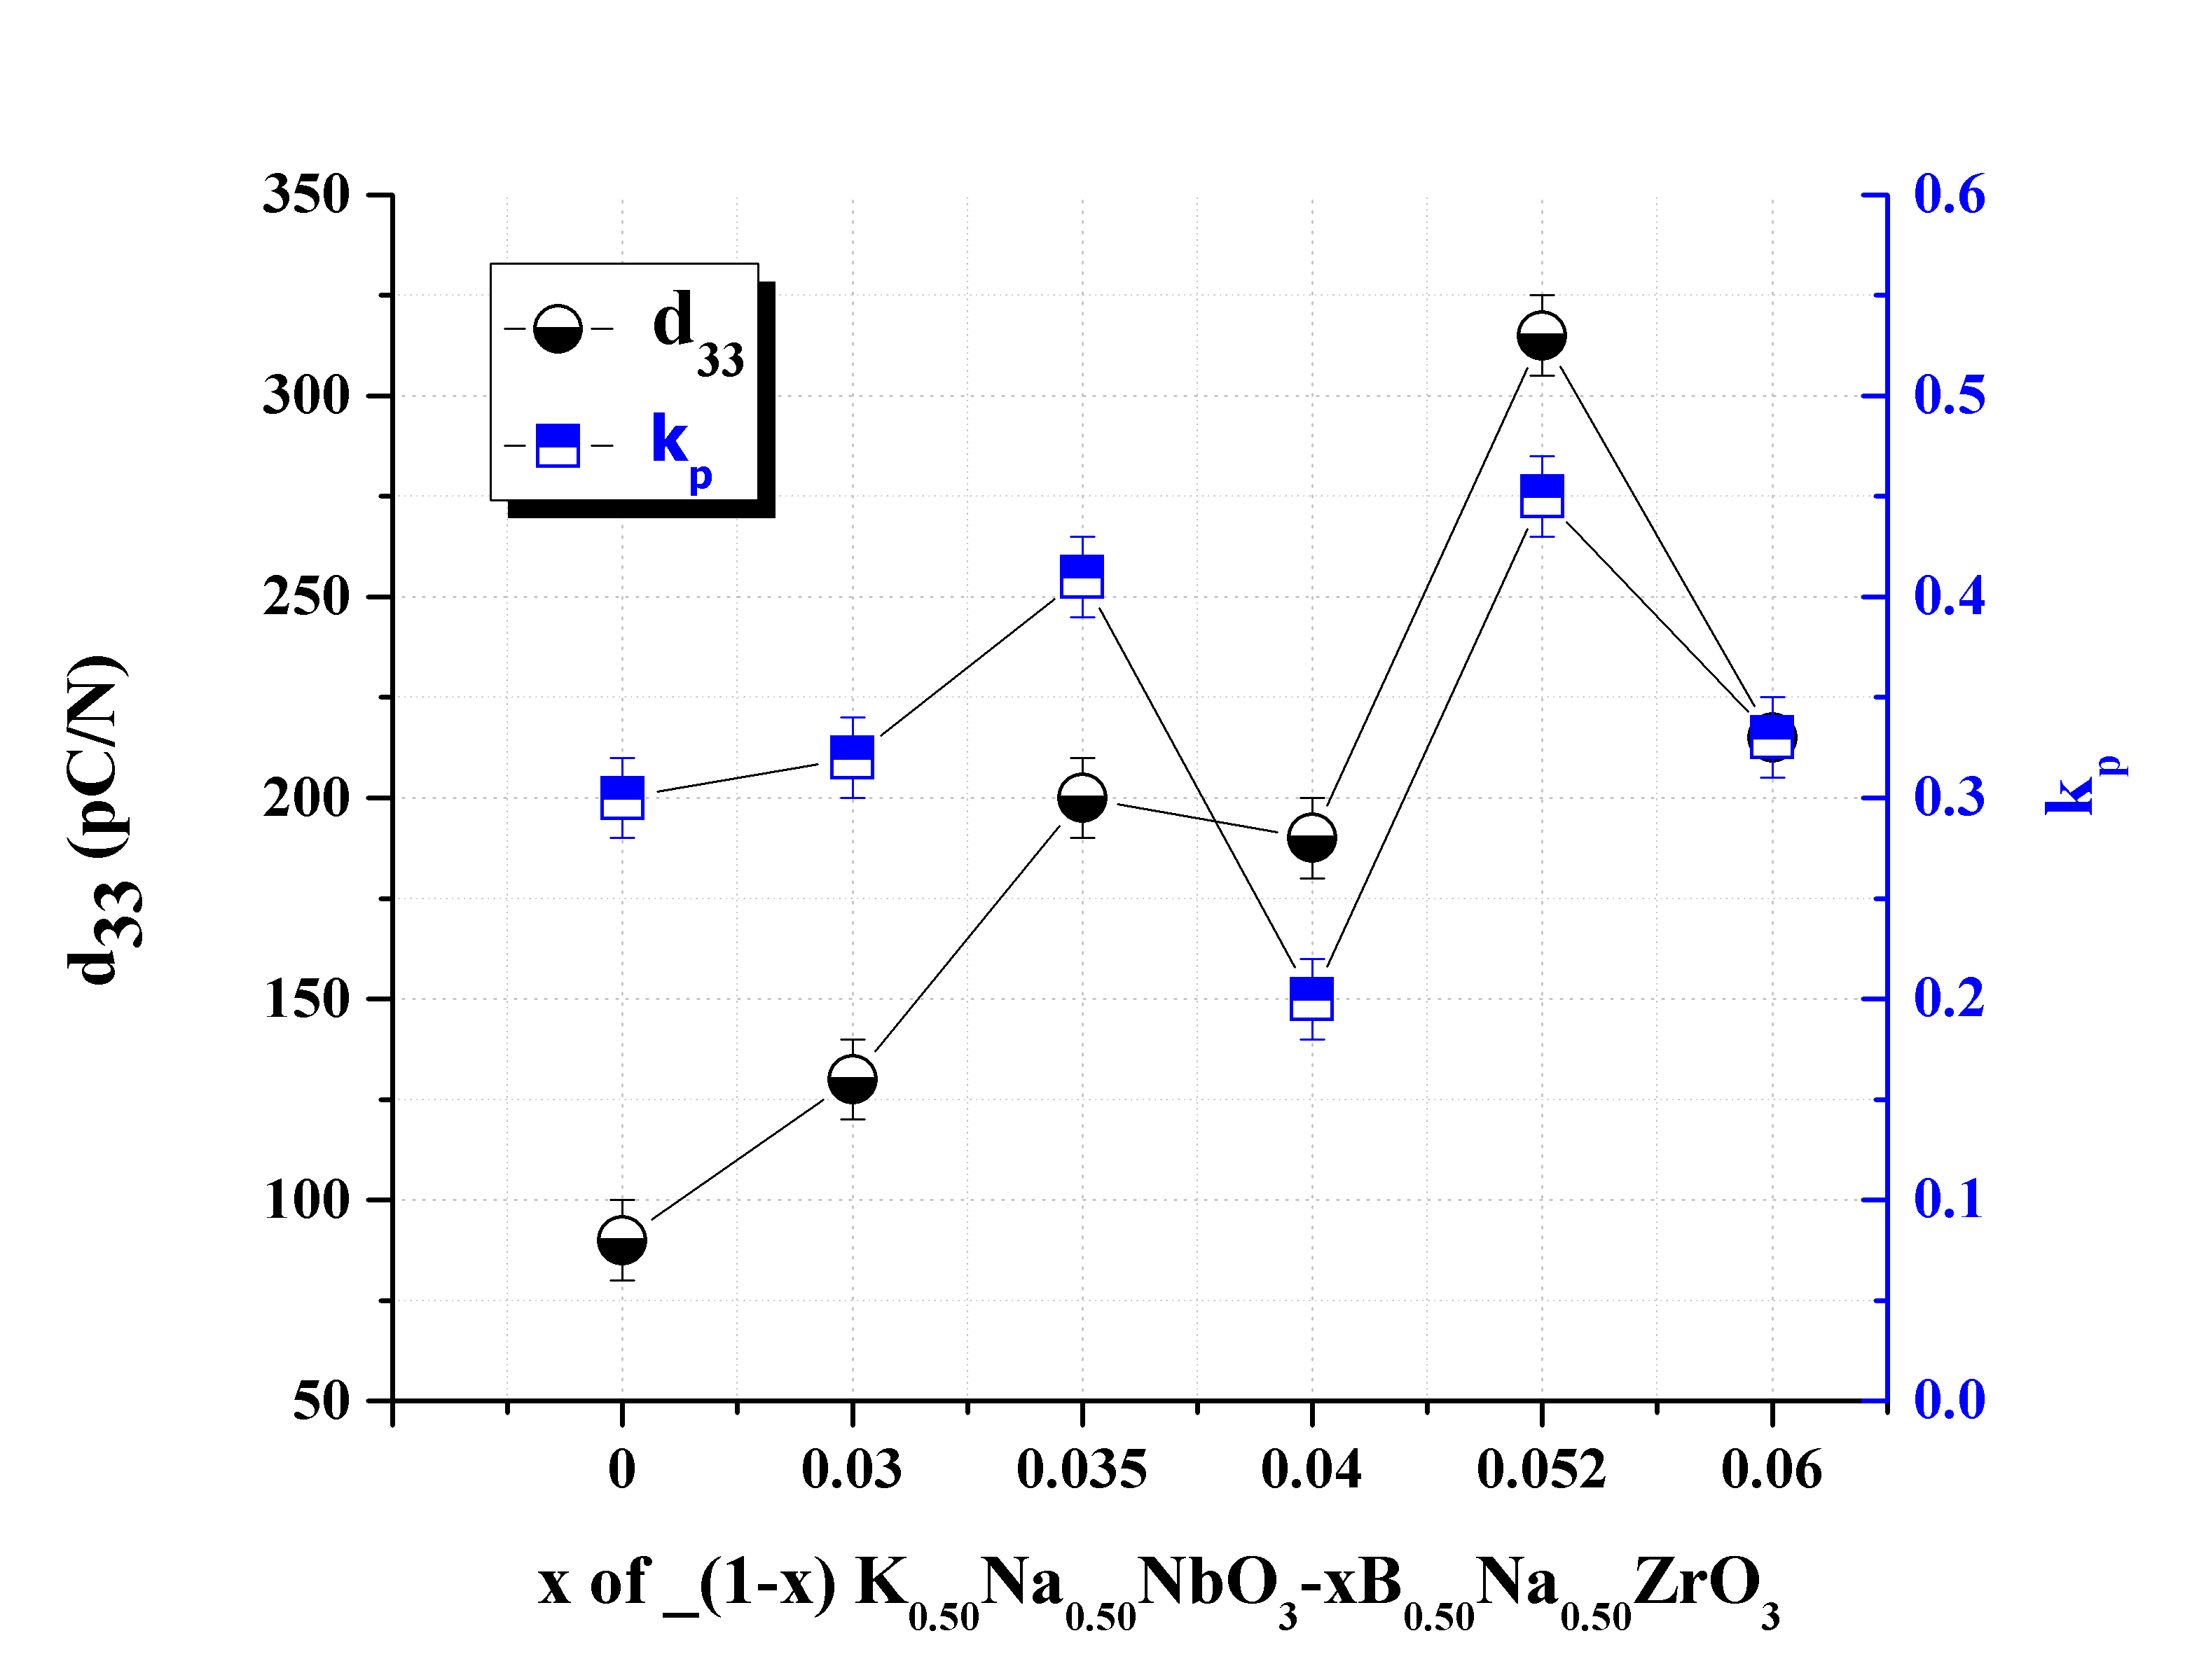
Figure 1 Piezoelectric coefficient and coupling factor versus addition of BNZ in KNN-50/50
Recent Publications
1-Amir Khesro, Dawei Wang, Fayaz Hussain, Raz Muhammad, Antonio Feteira and Ian Reaney, “Temperature dependent piezoelectric properties of lead-free (1-x)K0.6Na0.4NbO3–xBiFeO3 ceramics”, Frontiers in Materials: Ceramics and Glass, under review, March-2020.
2-Fayaz HUSSAIN, Amir Khesro, Zhilun Lu, Ge Wang and Dawei Wang “Lead Free Multilayer Piezoelectric Actuators by Economically New Approach”, Frontiers in Materials: Ceramics and Glass, accepted, March-2020 .
3- Dandan Han, Changhao Wang, Dayong Lu, Fayaz Hussain, Dawei Wang, Fanling Meng, “A temperature stable (Ba1-xCex)(Ti1-x/2Mgx/2)O3 lead-free ceramic for X4D capacitors”, Journal of Alloys and Compounds, Available online 23 December 2019.
4-Fayaz Hussain, Amir Khesro, Raz Muhammad, Dawei Wang, “Effect of Ta-doping on functional properties of K0.51Na0.49NbO3”, Materials Research Express. (IF=1.449), published (Dated 22-08-2019).
5-Muhammad Raz; Khan Sohail; Hussain Fayaz; Khesro Amir, “Phase evolution and microwave dielectric properties of (Ca/Sr)Nd4Ti5O17–based ceramic systems”, Materials Research Express, (IF= 1.449), (September, 2019)
6- Hussain F., et al., p-Type/n-type behaviour and functional properties of KxNa(1-x)NbO3 (0.49≤x≤0.51) sintered in air and N2, Journal of the European Ceramic Society (2018), https://doi.org/10.1016/j.jeurceramsoc.2018.03.013,IF=3.794
7-Kausar Harun, Fayaz Hussain, et al., Sol–gel synthesized ZnO for optoelectronics applications: a characterization review, Materials Research Express, 2017.04(12).
8-Wang, D., Hussain F, Khesro, A, et al., Composition and temperature dependence of piezoelectricity in (1-x)(K1-yNay)NbO3-x(Bi1/2Na1/2)ZrO3 lead-free ceramics. American Ceramic Society, 2016: p. 1-9
9-Khesro, A., Wang, D, Hussain, F, et al., Temperature Stable and Fatigue Resistant Lead-free Ceramics for actuators, Applied Physics Letters, 2016.109(14).
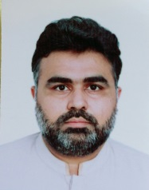

Biography
Dr Fayaz Hussain (Assistant Professor at NED University) has completed his PhD on ‘KNN based lead-oxide free piezoelectric ceramics’ have been studied from the perspective of optimising their performance for multilayer actuators potentially for energy harvesting applications under the supervision of Professor Ian Reaney at the University of Sheffield, UK in the year 2017. To fabricate the multilayers, a novel Wet-Multilayer-Method (WMM) was also developed to overcome the issues of delamination during firing of multilayers actuators. I have authored/co-authored publications around 16 papers including key articles on piezoelectric ceramics in bulk and multilayers with ¬100-citations. This work is mainly from my PhD data.

Email: fhussain@neduet.edu.pk
engrfayazned@gmail.com

Notes/Comments:

