Effect of Covid-19 pandemic imposed lockdown on Internet Addiction
Dr Bhakti Murkey¹, Dr Sureshkumar Mehta²

¹Assistant Professor, Department of Psychiatry, Pacific Medical College and Hospital, Udaipur, Rajasthan, India
²Professor, Department of Psychiatry, Pacific Medical College and Hospital, Udaipur, Rajasthan, India

ABSTRACT:
Introduction: Covid-19 pandemic has compelled many nations to impose strict social isolation guidelines as infection control measures. In India, a nation-wide lockdown was imposed in order to prevent community spread of the virus. This has initiated a surge in emotional and psychological distress, along with excessive reliance on internet use to cope with the same. This study aims at assessing the effect of lockdown on internet use. Methodology: A semi-structured proforma circulated as a Google Form was used to collect the demographics and assess the severity of internet use in 200 participants, both prior to and during lockdown. Problematic and Risky Internet Use Screening Scale (PRIUSS) was used as the assessment tool. Results: Mean age of the participant group was 38.42 years. Most of the participants used their cell phones (mobile devices) to access the internet and mostly for the purpose of online socializing. One third of the population spent more than 4 hours online/day besides academic or work purpose. Up to 70% of the population reported to have experienced benefits of online surfing, while around 30% reported an experience of harmful effects. 62% of the population felt that the lockdown had significantly affected their pattern of internet use. Severity of internet use was found to be significantly higher in all the individual factors under PRIUSS during lockdown, as compared to prior to lockdown (p<0.001). Conclusion: Social isolation created under lockdown situation during the pandemic has significantly increased internet use among users in India.

Keywords: Covid-19, Internet Addiction, Lockdown, Problematic Internet Use

PROFESSIONAL BIOGRAPHY:
Dr Bhakti Murkey has completed her Masters Degree in Psychiatry from SMS Medical College, Jaipur. She has worked at the Department of Child and Adolescent Psychiatry at NIMHANS, Bangalore and is also a certified REBT therapist. She takes keen interest in both academics and research activities and has published about a dozen articles in the field of mental health so far.
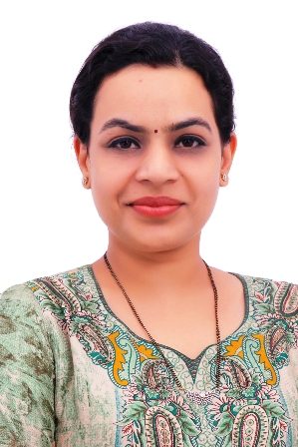
Presenting Author:
Full name: Dr Bhakti Murkey
Contact number: +919799206939
Email id: doctor.bhaktii@gmail.com
Category: Oral paper presentation

