Photograph
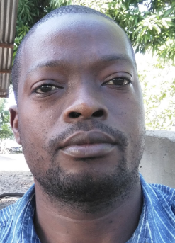

Title of the Abstract: Polymer Fonts of CO₂ and CH₄ Emission From Incineration Practices in Quelimane City in Mozambique
Author Name: Lucio Jose Tomas Jasse
Affiliation: University
University: UniLicungo
Country: Mozambique

Abstract:
Nowadays the Polymer Chemistry production and plastics products has increased explosively. In undeveloped countries your consumption causes problem for the environment, in some cases it damages more than the total existents industries. Quelimane in particularly is a small City in Mozambique with 246915 people and 117 km², and produce more than 90 tons of garbage a day, mostly made of polymers PE, PP, PS, PVC and PET, which can be founded in: plastic bag; bottles for drinks; cosmetics and cleaning product; disposable packaging back sheet of sanitary, napkins and diapers, etc. The plastic and their products are very cheaper, not durable and is widely used at parties and restaurant in the form of disposable materials, therefore, everyday are produced excessively garbage mixed with other domestic biodegradable and several heaps of solid hospital waste which are deposited in container distributed along the city's cement and then are collected to burn in open dumps, releasing immeasurable amounts of CH₄, HCl, NH₃ and CO₂. The majority of people leaves in suburb area, it is a swampy area and part of the non-combustible garbage is used as rubble, accelerating the state of degradation of garbage and contributes a lot for methane’s production and daily polymer are burned at home to reduce the amount of garbage or for light a fire to cook, this contributes for CO₂ production. The problem is that is not possible to quantify the quantity of the polymers produced, burned and the quantity of the pollutants released. But the total quantity is industrial equivalent to the large industries.

Biography:

Dr. Lucio is a Teacher of Analytical, General, Inorganic, physics chemistry and Spectroscopy in UniLicungo, Eduardo Mondlane and Catholic Universities in Mozambique. He has a master degree of science in chemistry teaching. Is a researcher of low cost materials working at producing chemicals and equipment for chemistry’s education experiments and health, and has participated in Internationals and nacional conferences.

Research Interests: environment chemistry

References: Prof. Dr Michel Schallies, University of Education/PH Heidelberg, Im Neuenheimer Feld 561 D-69121 Heidelberg, in German
Mail Id: luciojasse@gmail.com
Contact Number: +258 877456200

