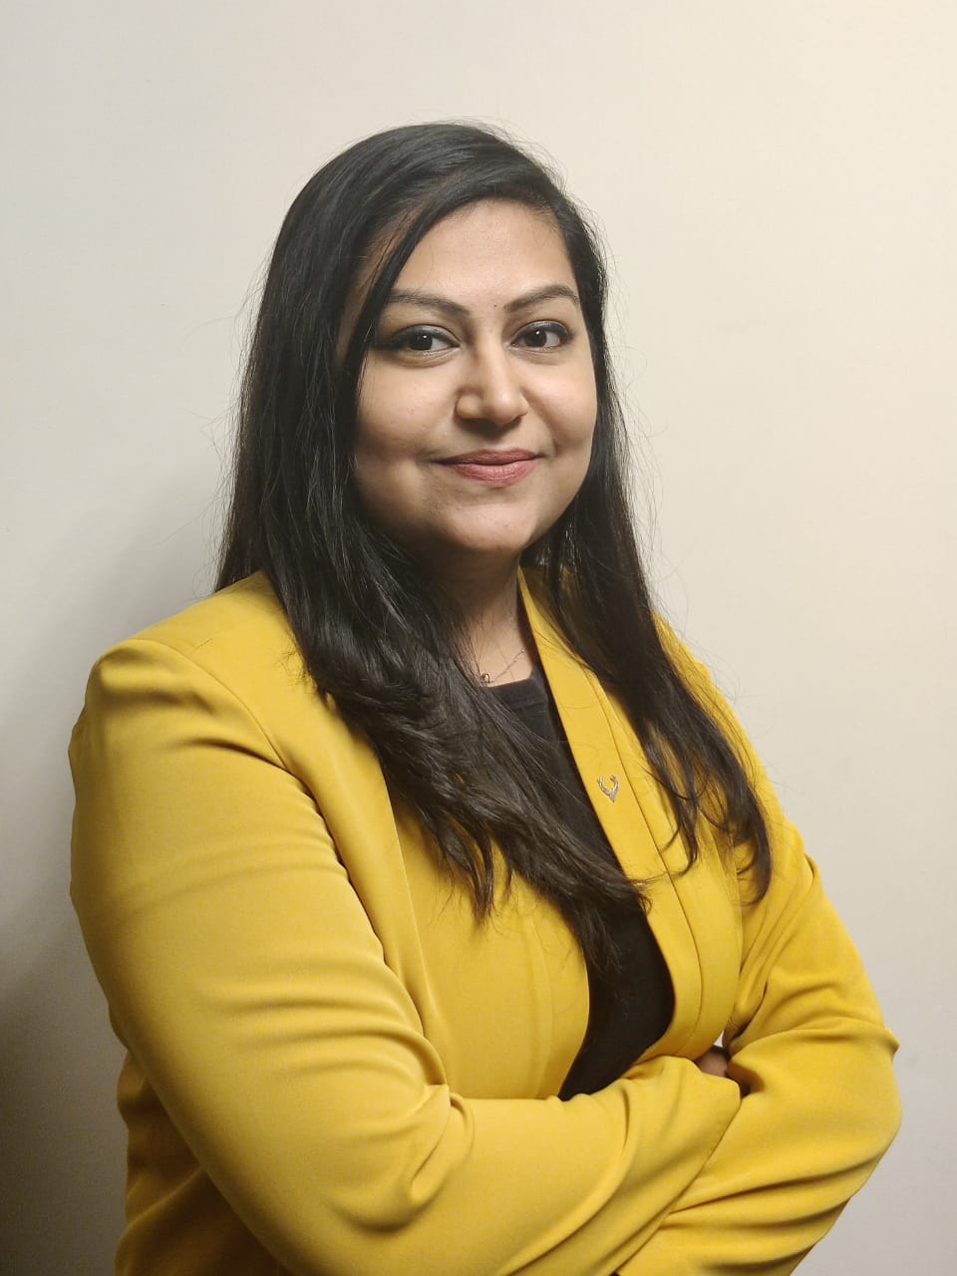


Title: De-epithelialized Perforator Based Turnover Flap for Reconstruction of Lower Limb Defects
Dr Kena Patel, Smt. NHL Municipal Medical College, SVPIMSR, Ahmedabad, Gujarat, India
Dr Vijay Bhatia, Professor and Head of Department; Plastic and Reconstructive Surgery, Smt. NHL Municipal Medical College, SVPIMSR , Ahmedabad, Gujarat, India

ABSTRACT:
Lower limbs defects provide us with a unique challenge in terms of soft tissue coverage. The definitive decision for flap coverage ultimately requires sound knowledge about the vascular anatomy of lower limb vessels, their branches and perforator vessels. Lower limb is supplied by perforator vessels forming a rich anastomotic network in the deep fascia. We have explored here the utility of deepithelialized perforator based turnover flap, based on the perforator vessels, in coverage of leg defects.
First use of turnover random pattern flap was described by Dr. Thatte RL in 19811. These flaps, as described, were originally random pattern flaps with limited length to breadth ratio. Taking into knowledge the perforator anatomy of lower limb and the concept of this turnover flap, we have designed a de-epithelialized perforator based turnover flap which provides us with a flap having good vascularity and better chance at survival than traditional random pattern turnover flap. This flap provides an additional advantage with no limitations of its length to breadth ratio and low risk of necrosis of these flaps as compared to their random pattern turnover flap counterparts.
Author hereby presents a case series of 20 patients with lower limb defects treated with perforator based turnover flap over the span of 3 years; describing the methodology, flap design, surgical technique, outcomes and complications encountered.

Biography:
Myself, Dr Kena Patel; am a young and budding plastic surgeon from SVPIMSR, Ahmedabad, India. I have co-authored and published 8 papers in reputed National and International journals. I was selected for trialect scholarship program and have completed fellowship in the department of Hand and Plastic surgery, University Hospital, Zurich, Switzerland. Always thriving for excellence, I have attended various National and Internaltional conferences and workshops.

Dr Vijay Y. Bhatia is a Professor and Head of Department of Plastic and Reconstructive Surgery at SVPIMSR, Ahemdabad, India. He has over 30 years of teaching experience and has authored 21 papers in reputed National and International journals. He is a reviewer for many International journals as well. He has Co-published a chapter on Facial injuries in book of Brain protection and neural trauma published by Narosa publishing House; New Delhi and a chapter on Facial trauma, Current concepts in management and principle.

Presenting author details
Full name: Dr Kena Patel
Contact number: +91 9998930520
Email id: drkena29@gmail.com
Category: (Oral presentation/ Poster presentation) : Oral paper presentation
Session name: Track 20 Reconstructive surgery [De-epithelialized Perforator Based Turnover Flap for Reconstruction of Lower Limb Defects.]
Research interest: Breast Reconstruction.
Post bariatric body contouring.
Fat grafting.

