‘To freeze or not to freeze, that is the question’
A case of septic arthritis in a finger resulting from cryotherapy for viral warts

Authors:
M Kandil¹ - Clinical Fellow, Plastic Surgery MBChB
U Sarwar¹ - Specialty Registrar, Plastic Surgery MBChB, MRCS, MSc, DIC
Z Shariff¹ - Consultant Plastic and Hand Surgeon FRCS (Plast) Dip Hand Surg

Correspondence address:
¹Department of Plastic and Hand Surgery
Bradford Royal Infirmary
Duckworth Lane
Bradford
BD9 6RJ

Corresponding author:
M Kandil
Department of Plastic and Hand Surgery
Bradford Royal Infirmary
Duckworth Lane
Bradford
BD9 6RJ

drkandil91@gmail.com

Introduction:
Cryotherapy is a common treatment for a variety of skin conditions and lesions¹ including viral warts, a benign condition commonly associated with human papilloma virus. Cryotherapy works through a cycle of freezing and thawing destroying tissues by causing ice crystals to form within the cells¹. However, cryotherapy has to be performed with care due to the risks of burns², damage to healthy tissue and scarring and pigmentation. We report on the first case of septic arthritis developing post cryotherapy to a digit.

Case report:
A 56yr-old female retired podiatrist who five days prior received cryotherapy, by a Dermatologist, for a long standing presumed viral wart over the dorsum of the distal interphalangeal joint (DIPJ) of the right middle finger (Figure 1), was referred to the local Plastic Surgery service with a painful, swollen right digit (Figure 2).
On examination, she was febrile with a discharging collection around the DIPJ (Figure 2) along with cellulitis along the finger. She had a normal white cell count but raised C-reactive protein level of 48mg/L (normal 0-12mg/L). An x-ray showed soft tissue swelling with no bony changes (Figure 2). A formal debridement of the collection under local anaesthetic the following day demonstrated a small communication of the wound into the joint. Microbiological analysis of the tissue revealed a staphylococcus aureus infection. She was commenced on oral antibiotics for the septic arthritis and seen again four days later in clinic. Further examination revealed a fusiform swelling of the finger from the tip of the finger to the proximal interphalangeal joint. A further debridement was performed along with washout of the joint and flexor sheath and the commencement of intravenous antibiotics. She was discharged home two days post-operatively with a course of oral antibiotics and followed up in outpatient clinic. Subsequent reviews a month later revealed loss of soft tissue over the dorsal DIPJ extending into the exposed unstable joint with loss of the terminal extensor resulting in a mallet deformity. She subsequently required fusion of her DIPJ with metalwork for her previous septic arthritis.

Conclusion:
Cryotherapy is a versatile technique to deal with a number of common dermatological ailments. However, it also carries risk for the untrained individual. The delicate skin and tissues of the dorsum of the fingers can result in significant trauma and care must be exercised in these areas to prevent full thickness wounds that involve the joint and result in septic arthritis and functional disability.

References:
1. http://www.bad.org.uk - accessed on 29th January 2020
2. Sarwar U, Tickunas T. Frostbite developing secondary to cryotherapy for viral warts. Br J Gen Pract. 2013 May;63(610):239–40

Figure 1. Picture of viral wart over right middle finger pre cryotherapy

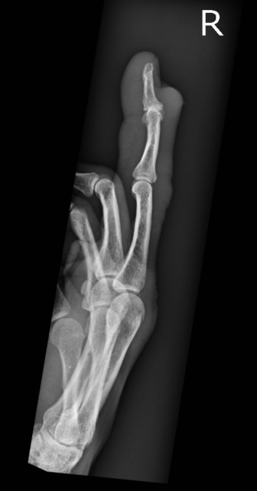

Figure 2. Right middle finger infection first presentation

