Prolonged use of permanent synthetic hair dyeing formulation may induce hepatocellular carcinoma.
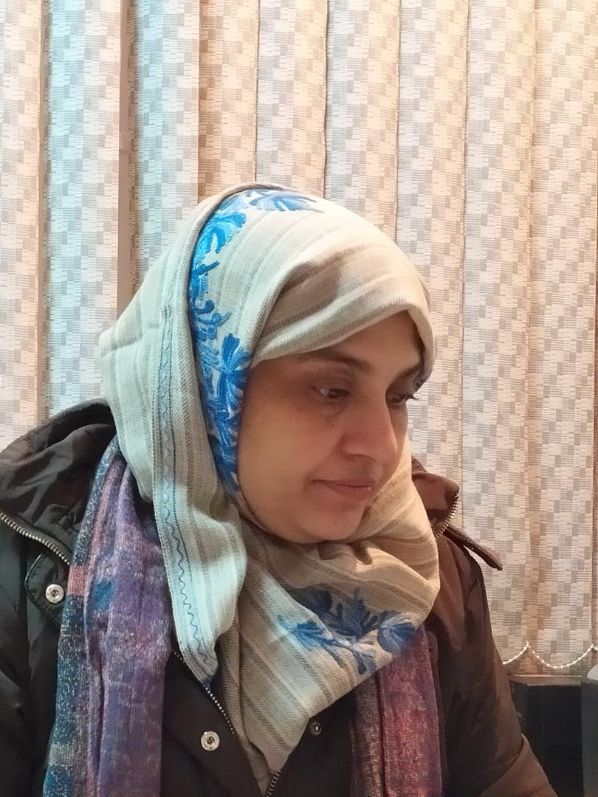

Safia Habib*, Shifa Khan, Asif Ali, Moinuddin, and Shahid Ali Siddiqui
*Department of Biochemistry, Faculty of medicine,
Aligarh Muslim University, 202002. UP. INDIA

Abstract
There has been an increasing trend in the use of synthetic hair colouring products in recent years. Both the sexes of all the income groups prefer to use these colourants. This has led to an increase in the annual turnover of the cosmetic industry to around 17 billion dollars. An increase in the incidence of cancers has been reported in long term hair dye users.
The study aims to probe hair dye-induced carcinogenesis in human subjects. Through these studies, we can conclude that there appears a direct association between hepatocellular carcinoma in synthetic hair dye users. We also report that the mechanism of carcinogenic progression is through immunological triggers. The prolonged use of these formulations needs monitoring in the interest of public health.

Biography

Dr Safia Habib is currently working as an Assistant Professor in the Department of Biochemistry, Jawaharlal Nehru Medical College. Aligarh Muslim University, India. She is PhD in Biochemistry and her area of research mainly includes the role of biological macromolecules in health and diseases. She has attended many national and international conferences. She has also participated in academic and faculty development programs and has published 40 research papers in national and international journals.

Importance of Research and Development

There is increasing use of hair dyeing products specifically oxidative hair dyes. This rising trend of hair dye use has put human health at risk. Most epidemiological studies support the association between the use of hair dye ad the risk of developing cancers. Still, since the evidence appears to be weak further investigations are required. The present study reports the acquired antigenicity of DNA exposed to one of the hair dyeing pigments 4-chloro-orythophenylenediamine (4-Cl-OPD) that could lead to immune stimulation. Authors also report that the long-term use of synthetic hair dye (≥5 years) formulations could induce hepatocellular carcinomas. Direct binding and inhibition ELISAs confirm the presence of cancer antibodies in patients (anti 4-Cl-OPD- modified human DNA) with a history of synthetic hair dye use and histologically confirmed hepatocellular carcinoma.
The findings of this study could help in the screening and early detection of carcinogenesis in individuals who are exposed to these formulations either personally or occupationally.

About the university

Aligarh Muslim University (AMU) is situated at a distance of 130 Km South-East of Delhi. It was established in 1920 and evolved out of the Muhammadan Anglo-Oriental College (MAO College) which was first set up in 1877 by the great visionary and social reformer, Sir Syed Ahmad Khan. It draws students from all states of India and different countries. The university is open to all irrespective of caste, creed, religion and gender. AMU has more than 30000 students, 1400 teachers and 6000 non-teaching staff. The university comprises a wide spectrum of academic disciplines and now has 13 faculties comprising 107 departments of studies, 7 colleges, 19 centres, 3 institutes, 2 polytechnics, 10 schools and 3 off-campus centres. A special feature of the university is its residential character with most of the students residing on campus. There are 19 halls of residence for students with 80 hostels. AMU has regularly been ranked among Athe top Indian Universities in recent years.

Recent publications

- Khan, S., Ali, A., Moinuddin, Mir, A. R., Khan, R. H., Alhumaydhi, F. A., & Habib, S. (2021). 4-Chloro-orthophenylenediamine alters DNA integrity and affects cell survival: inferences from a computational, biophysical/biochemical, microscopic and cell-based study. Journal of Biomolecular Structure and Dynamics, 1-12.
- Mustafa, M., Ali, A., Siddiqui, S. A., Mir, A. R., Kausar, T., Nayeem, S. M., ... & Habib, S. (2021). Biophysical characterization of structural and conformational changes in methylmethane sulfonate modified DNA leading to the frizzled backbone structure and strand breaks in DNA. Journal of Biomolecular Structure and Dynamics, 1-14.
- Talha, M., Mir, A. R., Habib, S., Abidi, M., Warsi, M. S., & Islam, S. (2021). Hydroxyl radical induced structural perturbations make insulin highly immunogenic and generate an auto-immune response in type 2 diabetes mellitus. Spectrochimica Acta Part A: Molecular and Biomolecular Spectroscopy, 255, 119640.
- Warsi, M. S., Habib, S., Talha, M., Mir, A. R., Alam, K., & Ali, A. (2021). Characterization of human serum albumin modified by hair dye component, 4-chloro-1, 2-phenylenediamine: Role in protein aggregation, redox biology and cytotoxicity. Journal of Molecular Liquids, 331, 115731.
- Mir, A. R., Habib, S., & Uddin, M. (2021). Recent advances in histone glycation: emerging role in diabetes and cancer. Glycobiology, 31(9), 1072-1079.
- Rizwee, M. M., Abidi, M., Habib, S., Mir, A. R., Ali, A., & Uddin, M. (2021). Characterization of Glyoxal Modified LDL: Role in the Generation of Circulating Autoantibodies in Type 2 Diabetes Mellitus and Coronary Artery Disease. Current Drug Delivery, 18(7), 1027-1040.

References

- Ames, B. N., Kammen, H. O., & Yamasaki, E. (1975). Hair dyes are mutagenic: identification of a variety of mutagenic ingredients. Proceedings of the National Academy of Sciences, 72(6), 2423-2427.
- Maibach, H. I., Leaffer, M. A., & Skinner, W. A. (1975). Percutaneous penetration following use of hair dyes. Archives of Dermatology, 111(11), 1444-1445.
- Habib, S., & Ali, A. (2020). Increasing use of hair dye and associated genotoxicity needs to be probed. Indian Journal of Clinical Biochemistry, 35(2), 133-134.
- Lademann, J., Richter, H., Jacobi, U., Patzelt, A., Hueber-Becker, F., Ribaud, C., ... & Nohynek, G. J. (2008). Human percutaneous absorption of a direct hair dye comparing in vitro and in vivo results: implications for safety assessment and animal testing. Food and chemical toxicology, 46(6), 2214-2223.
- Saitta, P., Cook, C. E., Messina, J. L., Brancaccio, R., Wu, B. C., Grekin, S. K., & Holland, J. (2013). Is There a true concern regarding the use of hair dye and malignancy development?: A review of the epidemiological evidence relating personal hair dye use to the risk of malignancy. The Journal of clinical and aesthetic dermatology, 6(1), 39.
- Zhang, Y., Hughes, K. J., Zahm, S. H., Zhang, Y., Holford, T. R., Dai, L., ... & Zheng, T. (2009). Genetic variations in xenobiotic metabolic pathway genes, personal hair dye use, and risk of non-Hodgkin lymphoma. American journal of epidemiology, 170(10), 1222-1230.
- Heikkinen, S., Pitkäniemi, J., Sarkeala, T., Malila, N., & Koskenvuo, M. (2015). Does hair dye use increase the risk of breast cancer? A population-based case-control study of Finnish women. PloS one, 10(8), e0135190.
- Ahmad, I., & Ahmad, M. (2015). Dacarbazine as a minor groove binder of DNA: Spectroscopic, biophysical and molecular docking studies. International journal of biological macromolecules, 79, 193-200.
- Ahmad, S., Shahab, U., Habib, S., Salman Khan, M., Alam, K., & Ali, A. (2014). Glycoxidative damage to human DNA: Neo-antigenic epitopes on DNA molecule could be a possible reason for autoimmune response in type 1 diabetes. Glycobiology, 24(3), 281-291.
- Alniss, H. Y. (2018). Thermodynamics of DNA minor groove binders: perspective. Journal of Medicinal Chemistry, 62(2), 385-402.

