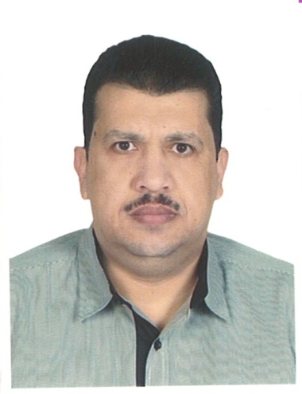

Biography
Professor Dr Ibrahim El- Bayoumy holds bachelor of medicine and surgery (Tanta faculty of medicine-Egypt,1989), then he earned his master degree in public health, preventive and social medicine (Tanta faculty of medicine-Egypt1996),and MD,PhD in public health ,preventive and social medicine 2003 from Tanta faculty of medicine-Egypt and McGill faculty of medicine –Montreal -Canada in division of clinical epidemiology in Royal Victoria hospital through double channel system as scholarship from ministry of education-Egypt. He is Full professor of public health and community medicine in Tanta faculty of medicine-Egypt since November 2016 . Now he is working in ministry of health in Kuwait as consultant of public health and preventive medicine.
He has obtained post-graduate Master degree is diabetes care and education-Dundee faculty of medicine-Scotland –UK October 2015.He was invited speaker in many international conferences in China. South Korea .Japan and Hong Kong Kuwait about diabetes and obesity.

Abstract title:
Effect of sleeve gastrectomy on metabolic status in type 2 obese diabetics

Professor Dr Ibrahim El Bayoumy
MBBCh,MPH,(MD,PhD) Public health and preventive medicine
MSC. diabetes care and education Dundee faculty of medicine-UK
Professor of public health and community medicine-Tanta faculty of medicine-Egypt
Email ibrahim.elbayoumy@med.tanta.edu.eg
Background: Limited data are available about evaluation of the effects of sleeve gastrectomy on the glycaemic control on diabetes mellitus. The objective of this study is to evaluate the effectiveness of sleeve gastrectomy in improving the control of glycemic status in obese diabetic patients
Patients and methods: This is retrospective cross sectional study to review the maintained data base collected between May 2018 to April 2021 in department of laparoscopic surgery in Farwaniya hospital-Kuwait.
A total 120 patients with diabetes mellitus who had undergone laparoscopic sleeve gastrectomy were studied.at 3 months and 6 months of follow up visits, collected data about variation in Body Mass Index (BMI). And glycosylated hemoglobin (HbA1c),and fasting blood glucose were analyzed.
Results: Of the 120 diabetic patients with≥ 6 months post-operative follow up 72 diabetic patients (60%) are still taking medications for diabetes mellitus and 48 diabetic patients (40%) are resolved at 3 months and 6 months of follow up. HbA1c has decreased from 9.22±1.36 (n=18) preoperatively to 6.02±0.22 after 3 months of surgery and 30 diabetic patients ,HbA1c become 5.88±0.22 after 6 months
Body Mass Index (BMI) has decreased from 47.43±11.33 kg/m²in the sample of the study(120 diabetic patients )preoperatively to 37.82±6.80 at 3 months and to 33.25±3.12 Kg/m after 6 months of surgery
Patients with short duration of diabetes less than 5 years have had better weight loss after surgery and achieved greater resolution rates
(euglycemic state).
^{Conclusion}
Sleeve gastrectomy has improved the glycemic control in obese diabetic patients in the for of improvement and resolution and also succeeded in reduction of the body weight in the sample of the study

