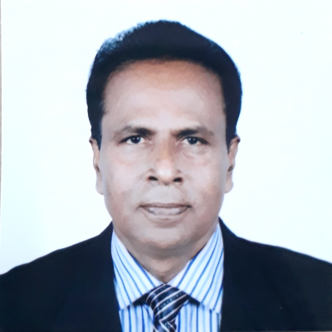

C.V of Haragobinda Baidya
Mothers Name: SARALAMAYE BAIDYA, Fathers Name: HARIPADA BAIDYA
Date of Birth: 03-07-1961,
Marital Status: Married with one male issue. Religion: Hindu,
NID Number: 770709458, Passport Number: 0912122 (Issue Date: 20 Sep 2016 and Date of Expiry: 19 Sep 2021)
Permanent Address: Village- Latenga, P O- Vangerhat, U/Z- Kotalipara, District: Gopalganj, Country- Bangladesh

About Organization
Name of working NGO: Minority Self-Empowerment Foundation (MSEF)
Working employee performance: As an Executive Director from 1995 till to date with excellent performance and well reputation in the nonprofit global leaderships in the human development sector. As a founder executive of the MSEF NGO to develop the poor community stakeholders overall the developing country of Bangladesh. The MSEF NGO is non profitable, non-political, non-business oriented and women empowerment institution in Bangladesh. We are working in community services health development program.

