Metabolic basis for the development of metabolic diseases
Emil Mukhamejanov, DM Professor, Kazakhstan

Abstract (300 word limit)
The pathogenesis of the development of chronic non-communicable diseases has not been elucidated. The main reason for their development is a violation of glucose homeostasis. We have developed a metabolic model of the relationship between the metabolism of proteins, fats and carbohydrates using exogenous or endogenous food flows. The model allowed us to take a fresh look at the mechanism of development of obesity and diabetes, which opens up new opportunities in the development of technologies for their prevention and treatment. In the center of the model are proteins that coordinate the metabolism of carbohydrates and fats. Violation of protein metabolism activates the process of lipogenesis when using exogenous food flow and reduces the amount of gluconeogenesis, which leads to a decrease in the amount of fat oxidation and the development of obesity. A decrease in the amount of protein synthesis leads to a decrease in the energy requirement of glucose, which is the most important reason for the development of insulin resistance. This indicates that protein metabolism plays a key role in the mechanism of diabetes development. Thus, a violation of the relationship between the metabolism of proteins, fats and carbohydrates can occur both when using exogenous and endogenous food flows, which requires changing our understanding of approaches to the prevention and treatment of metabolic diseases.
Image
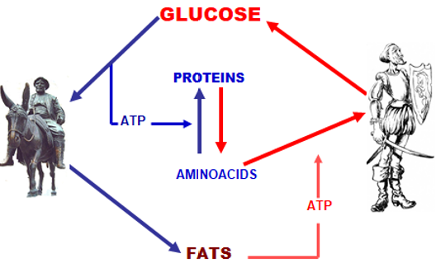
Fig 1. Model of the relationship between the metabolism of proteins, fats and carbohydrates using exogenous and endogenous food flow to maintain glucose homeostasis
Recent Publications (minimum 5)
- E.Muchamejanov, A.Kirgizbaeva, E.Muhamadieva, S.Erjanova, V.Mizin, D.Shakenov. 2019. “Metabolic sindrome: pathogenesis, prevention and treatment”, International Journal of Development Research, 10, (05), 27173-27178.
- E.Mukhamejanov, M.Balabekova, G.Kairanbayeva (2019) The More You Eat, The Less Your Weight-Nutritional Basis for Treatment of Obesity Nutri Food Sci Int J 9(2): 1-6
- E.Mukhamedzhanov, A.Kulnasarov,S.Erdjanova “Two Pyramids - Two Products Phase Nutrition - New Model Nutrition of Humans”. EC Nutrition 14.1 (2019): 114-119
- E.Mukhamejanov, S.Erjanova Obesity and Protein Metabolism Journal of Pharmacy and Pharmacology 6 (2018) 956-964
- E.Mukhamejanov, N.Ibragimova, A.Aitynova. (2020). Metabolic blocks and insulin resistance. World Journal of Advanced Research and Reviews, 6(2), 95-102.
- E.Mukhamedzhanov, O.Esyrev, N.Nakisbekov, Insulin Resistance - Pathogenesis of Prevention and Treatment. Diabetes Complications. 2018; 2(4): 1-4.


Biography (150 word limit)
Emil Mukhamejanov doctor of medical sciences, professor. In 1964-1972, he worked in the Institute of Physiology, responsible for the regulation of muscle contraction. In 1974-1991, he worked in the Institute of nutrition, responsible for the regulation of energy metabolism and metabolic diseases. Developed metabolic model of balanced diet coupled with effects of toxic compounds, physical activity and dietary factors. Has developed specialized nutrition products for athletes and for the prevention and treatment of metabolic diseases. Currently working in the national scientific and practical center of physical culture.
Email: labpharma@mail.ru

