Specialized products to improve the performance of athletes
Emil Mukhamejanov, DM Professor, Kazakhstan

Abstract (300 word limit)
The main task of nutrition for athletes is to create an apparatus for movement (muscles) and provide them with an energy reserve (glycogen). These processes occur during the absorptive period. In our report, we will focus on the energy supply of physical activity. The performance of intensive physical work is carried out due to the energy of glucose, the reserves of which are limited. With the depletion of glycogen reserves, further provision of physical activity is carried out due to its endogenous synthesis. But amino acids are used as a substrate or catabolism of functional proteins, primarily muscle proteins, occurs, which leads to the development of muscle weakness.

We have developed a specialized Top Energy product, which contains ingredients to ensure the process of gluconeogenesis. The intake of such a product before the training or competitive process preserves functional proteins, which helps to increase the athlete's performance. To improve the process of energy generation, we have developed a specialized product Fuco-Bar, which, when taken, increases the efficiency of the energy generation process. The product was tested on athletes and showed high efficiency. The main amount of energy is formed under aerobic conditions in the process of biological oxidation. Therefore, we have created a product with the inclusion of water-soluble coenzyme Q10. This helped to improve the efficiency of the energy generation process. These products have been developed in Kazakhstan and commercial production has begun.
Image
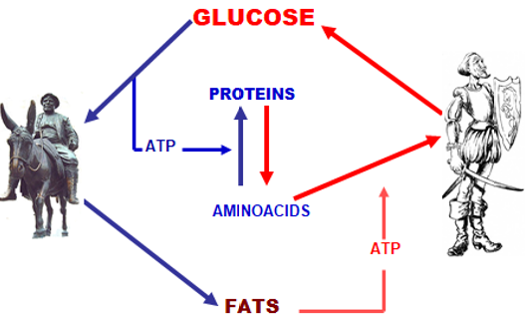
Fig 1. Model of the relationship between the metabolism of proteins, fats and carbohydrates using exogenous and endogenous food flow to maintain glucose homeostasis
Recent Publications (minimum 5)
- E.Muchamejanov, A.Kulnasarov, S.Karakov, D.Shakenov, V.Belyavskaya. (2020). Nutrition base of the anti-doping products development for the athletes working efficiency encreasment. World Journal of Advanced Research and Reviews, 6(1), 218-232.
- E.Mukhamejanov, M.Nurumov, D.Shakenov, Z.Anayatova “Fuco-Bar” - A product that improves an Athlete’s performance J Nutr Food Sci 2019, Volume 9 Page 27
- E.Mukhamedzhanov, S.S.Erdzhanova, O.V.Esurev,
A.K.Kulnazarov THE ALGORITHM OF FOOD IN THE PROCESS OF EXTREME ACTIVITIES Science and world. 2013. № 3 (3). 45-49

- EK Mukhamejanov., et al. “Two Pyramids - Two Products Phase Nutrition - New Model Nutrition of Humans”. EC Nutrition 14.1 (2019): 114-119
- E.Mukhamejanov, V.Kurilenko. (2020). Fucoidan: A nutraceutical for metabolic and regulatory systems homeostasis maintenance. World Journal of Advanced Research and Reviews, 6(1), 255-264

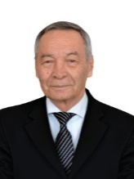
Biography (150 word limit)
Emil Mukhamejanov doctor of medical sciences, professor. In 1964-1972, he worked in the Institute of Physiology, responsible for the regulation of muscle contraction. In 1974-1991, he worked in the Institute of nutrition, responsible for the regulation of energy metabolism and metabolic diseases. Developed metabolic model of balanced diet coupled with effects of toxic compounds, physical activity and dietary factors. Has developed specialized nutrition products for athletes and for the prevention and treatment of metabolic diseases. Currently working in the national scientific and practical center of physical culture.
Email: labpharma@mail.ru

