IMPROVING PATIENT EDUCATION, CARE AND OUTCOMES
AbdelGhaffar Mohamed M, Egypt,Bahrain

ABSTRACT
INTRODUCTION:
No doubt that proper patient education is a very important part of patient care and has its impact on the outcomes of treatment whether medical or surgical.

ITEMS TO BE DISCUSSED :
- In this topic we will discuss the importance of patient education and its perception by professional nurses.

It will also discuss the initiatives and different ways to improve patient education by clinical nurses

the topic will also discuss the different strategies for providing effective patient education

models of my own experience will be used to support the topic

all information will be supported by recent references, research and tutorials.

RECOMMENDATIONS:
What’s needed to improve patient eduction will be also discussed.

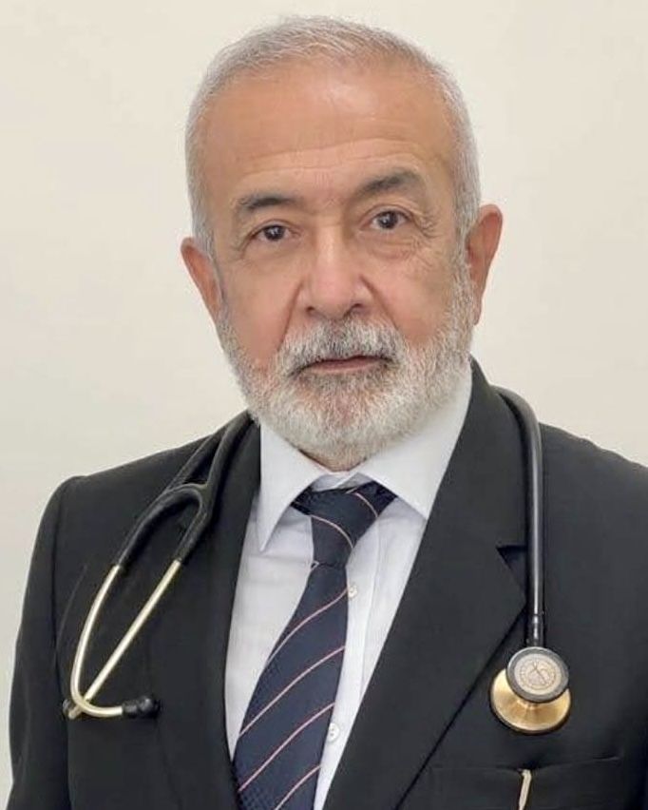
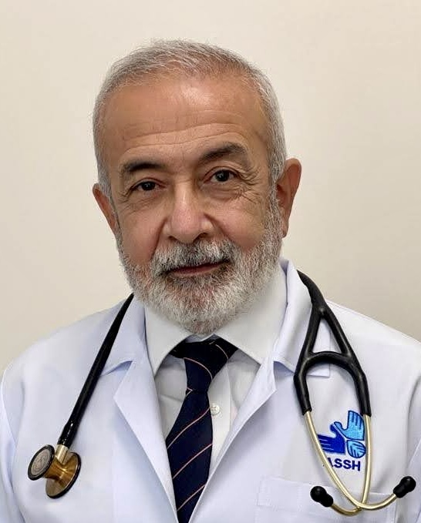

Biography
Mohamed is a professor of pulmonary medicine since 1999 as affiliated in Menofia university and then Arab Gulf University 2015. He got his doctorate degree 1987 from Cairo University
He played a remarkable role in the eduction process in these universities and hospitals he worked in. He has special interests in intervention and critical respiratory care

Name:Prof Mohamed Mohmoud AbdelGhaffar
Affiliation: professor and senior consultant ASSH,AKMC
UNIVERSITY: Cairo,Menofia and AGU
COUNTRY: Egypt and Bahrain
Email: prof_ghaffar2@hotmail.com
Tel: +97337278882
+201090404777

