SAT-002 THE DISEASE-SPECIFIC ASSOCIATION OF INCIDENT GLOMERULONEPHRITIS WITH SOCIOECONOMIC STATUS
A.Sahota¹ M.Canney²³ D.Induruwage³ S.Barbour^{*23}
¹
University of British Columbia, Department of Medicine, Vancouver, Canada
²
University of British Columbia, Division of Nephrology, Vancouver, Canada
³
Provincial Health Services Authority, British Columbia Provincial Renal Agency, Vancouver, Canada

Introduction
The population-level incidence and epidemiology of glomerulonephritis (GN) is not well studied. Although the incidence of all-cause chronic kidney disease is associated with lower socioeconomic (SES) status, it is currently not known if this also applies to specific types of GN. We therefore investigated the relationship between SES and the population-level incidence of membranous nephropathy (MN), IgA nephropathy (IgAN), focal segmental glomerulosclerosis (FSGS), ANCA-related GN and lupus nephritis (LN) in a large Canadian province.

Methods
A provincial renal pathology database was used to capture all incident cases of biopsy-proven MN (N= 392), IgAN (N= 818), FSGS (N= 375), ANCA-GN (N= 387) and LN (N= 389) from 2000 to 2012 in British Columbia, Canada. Secondary causes of GN were excluded. Patient SES was based on postal code level quintiles of household income from the Canadian Census, standardized to regional averages to account for differences in the cost of living. Incident rates were direct standardized based age and sex to the 2006 provincial population. For LN, direct standardization based on age was done separately in men versus women due to the female predominance in disease.

Results
Patient characteristics at the time of biopsy are shown in Table 1. For each type of GN, there was no significant difference in the age, estimated GFR or proteinuria at biopsy across quintiles of SES (p≥0.1), suggesting similar access to renal biopsy healthcare services. The age and sex standardized incident rates for each GN are shown in Table 2. A significant increase in disease incidence with lower SES was seen in LN and ANCA-GN (both p<0.05), with standardized rate ratios of 1.5-1.7 in the lowest SES quintile. There was no association between SES and the incidence of FSGS (p=0.09), IgAN (p= 0.09) or MN (p=0.2).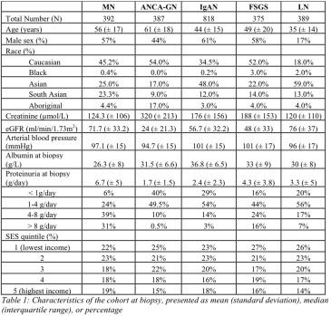
- Download : Download high-res image (439KB)
- Download : Download full-size image
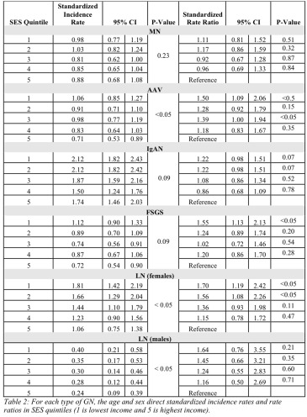

Conclusions
Using population-level data in a universal healthcare system with similar access to renal biopsy diagnosis, we have demonstrated that lower SES is associated with a 50-70% increase in the incidence of LN and ANCA-GN, but not with the incidence of IgAN, MN or FSGS. This is the first description of the age and sex adjusted incidence of GN associated with SES, and provides previously unknown and novel information regarding the epidemiology of glomerular diseases. Further research is needed to determine if the increased incidence is due to unmeasured confounders such as race or disease-specific environmental exposures that are associated with SES.

