Design and synthesis of new vinyl amide, imidazolone, and triazinone linked -combretastatin analogues packed on diamond nanoparticles as a panel for boosted solubility and antiproliferative activity.
Botros Y. Beshay, PhD, College of Pharmacy, AASTMT, Egypt.

Abstract
A group of new analogues of combretastatin A-4, which are linked with vinyl amide, imidazolone, and triazinone, were designed and synthesized. The cytotoxic activity of these compounds was tested against MDA-MB-231 breast cancer cells. The triazinone-linked analogues (6 and 12) displayed the strongest cytotoxic activity at sub-micromolar concentrations compared to combretastatin A-4, which served as the reference standard. The ability to inhibit b-tubulin polymerization was found to correspond with the results of the b tubulin polymerization inhibition assay. Moreover, the cell cycle aspects and apoptosis induction were evaluated through biological assays for these compounds. Additionally, the most potent compound 6 was loaded onto PEG-PCL modified diamond nanoparticles (PEG-PCL-NDs), and F4 was determined to be the best formula, as it exhibited superior solubility and release compared to the drug suspension. In comparative cytotoxicity testing, PEG-PCL modified F4 reduced the IC50 by around 2.89 times compared to nude F4 and 3.48 times compared to the non-formulated compound 6.

Image
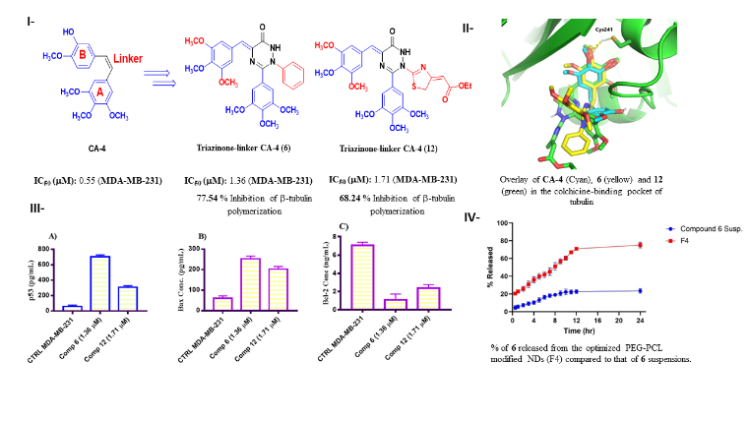
I &III- Cytotoxic activity against breast MDA-MB-231 cell line and In vitro Tubulin polymerization assay II- Molecular modeling of compounds 6 and 12 in 6 (yellow) and 12 (green) in the colchicine-binding pocket of tubulin. IV-% of 6 released from the optimized PEG-PCL modified NDs (F4) compared to that of 6 suspensions.
Recent Publications (minimum 5)
- Mohamed Y. Zakaria, Shady M. Abd El-Halim, Botros Y. Beshay, Islam Zaki & Mohammed A.S Abourehab, "Poly phenolic phytoceutical loaded nanobilosomes for enhanced caco-2 cell permeability and SARS-CoV 2 antiviral activity’: in-vitro and insilico study" , Drug Delivery, 30:1 , 2023.
- Anwer, K.E. El-Sattar, N.E.A.A. Shamaa, M.M. Zakaria, M.Y. Beshay, B.Y., "Design, Green Synthesis and Tailoring of Vitamin E TPGS Augmented Niosomal Nano-Carrier of Pyrazolopyrimidines as Potential Anti-Liver and Breast Cancer Agents with Accentuated Oral Bioavailability" , Pharmaceuticals 2022, 15, 330 , 2022.

- Islam Zaki, Amal M. Y. Moustafa, Botros Y. Beshay, Reham E. Masoud, Mohammed A. I. Elbastawesy, Mohammed A. S. Abourehab, and Mohamed Y. Zakaria, "Design and synthesis of new trimethoxylphenyl-linked combretastatin analogues loaded on diamond nanoparticles as a panel for ameliorated solubility and antiproliferative activity" , OURNAL OF ENZYME INHIBITION and MEDICINAL CHEMISTRY 2022, VOL. 37, NO. 1, 2679–2701 (2022) .
- Girma Worku Seifu, Yihenew Simegniew Birhan, Botros Youssef Beshay, Ariaya Hymete and Adnan Ahmed Bekhit, "Synthesis, antimalarial, antileishmanial evaluation, and molecular docking study of some 3-aryl-2-styryl substituted-4(3H)-quinazolinone derivatives" , BMC Chemistry 16, 107 (2022) , 2022.
- Botros Y. Beshay, Amira A. Abdellatef, Yasser M. Loksha, Salwa M. Fahmy d, Nargues S. Habib, Alaa El-Din. Bekhit, Paris E. Georghiou, Yoshihiro Hayakawa, Adnan A. Bekhitd., "Design and synthesis of 2-Substituted-4-benzyl-5-methylimidazoles as new potential Anti-breast cancer agents to inhibit oncogenic STAT3 functions" , Biorganic Chemistry Journal,113, 105033 , 2021.
- Paris E. Georghiou, Joseph H. Banoub and Botros Y. Beshay , "Inclusion of a Phytomedicinal Flavonoid in Biocompatible Surface-Modified Chylomicron Mimic Nanovesicles with Improved Oral Bioavailability and Virucidal Activity: Molecular Modeling and Pharmacodynamic Studies" , Pharmaceutics 2022, 14, 905 , 2022.
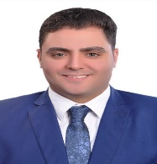

Biography
Botros Y. Beshay is a young researcher who is currently an assistant professor of Medicinal Chemistry, college of pharmacy, AAST. He has started his academic career as an Organic Chemistry demonstrator at Faculty of Pharmacy, Sinai University since 2009. He has obtained his Ph.D. degree in Pharmaceutical Chemistry in September, 2019, from the Faculty of Pharmacy, faculty of Pharmacy, Alexandria University. He graduated at Jun. 2008 from Faculty of Pharmacy, Asyut University with a general grade “excellent with honor and ranked 9th” He is interested in Drug design and discovery fields where he has Designed novel ligands with promising biological activity as anticancer, antibacterial, antifungal and anti HIV agents using different molecular modelling techniques. He has a good experience on handling with different drug design software such as Discovery Studio, SYBYL, MOE, GOLD, PYMOL and Autodock
Email: botros_beshay@aast.edu

Notes/Comments:

Presenting author details
Full name: Botros Youssef Gaballah Beshay
Contact number: +2 01007650839
Twitter account: -
Linked In account: -
Session name/ number:
Category: (Oral presentation/ Poster presentation)

