Study of energy transfer processes in aluminates based phosphors

Suresh Puppalwar, Kamla Nehru Mahavidyalaya, Nagpur, India

Abstract
Materials that absorb light and emit it at other wavelength are known as light emitting materials and also referred as phosphors. Phosphors are used in many applications such as lighting, displays, lasers and scintillators. Lanthanide group ions are usually used as luminescent centers. Energy transfer can play an important role in phosphors in the optical properties of luminescent materials both from theoretical and practical points of view. The luminescence efficiency of a phosphor can be enhanced by co-doping with a second kind of dopant (donor) as a result of energy transfer from the donor to the acceptor. Rare earth doped aluminates have emerged as a new class of luminescence materials. Tb³⁺/Eu³⁺ co-doped CaLaAlO₄ (CLA) and Tb³⁺/Sm³⁺ co-doped LaMgAl₁₁O₁₉ (LMA) phosphors were successfully prepared by solution combustion route. The sample shows single tetragonal structure. CLA: Tb³⁺, Eu³⁺ phosphors exhibited green emission corresponding to the f–f transition of Tb³⁺ ions and red emission bands corresponding to the f–f transition of Eu³⁺ ions, respectively. Commission International del'Eclairage (CIE) chromaticity coordinates are found to be x = 0.3277 and y = 0.3370, which is close to the standard white-light color (x = 0.333 and y = 0.333), demonstrating potentials phosphors for white light emission. The mechanism of energy transfer (ET) from Tb³⁺ to Sm3+ was seen as the dipole–dipole interaction. The ET efficiency was observed 78.28% which is efficient ET from Tb³⁺ to Sm³⁺ions in LMA host.
Conclusion & Significance: CLA: 0.01 Tb³⁺, 0.02 Eu³⁺ assemblies has CIE chromaticity coordinates are close to the standard white-light color, demonstrating its great potential as single-component phosphor for

white-light emission. The LMA: Tb³⁺, Sm³⁺ phosphors exhibited the emission peaks in the blue, green and orange-red regions, which reveal that it, could be a potential multicolor emitting phosphor.
Keywords: Aluminates phosphors; rare earths; Energy transfer; Luminescence.

Recent Publications

S.P. Puppalwar, M.S. Mendhe and S.J. Dhoble, Novel single-component CaLaAlO₄:Tb³⁺, Eu³⁺ phosphor for white light emission. Optical Materials 2018, 82, 47–55.
S.P. Puppalwar, M.S. Mendhe and S.J. Dhoble, Efficient energy transfer and fluorescence in SrYAl₃O₇:Ce³⁺, Tb³⁺ phosphor,. Optik 2018, 166, 15–23.
M.S. Mendhe, P.P. Bhure, P.C. Dhabale, S.G. Revankar and S.P. Puppalwar, Improvement of luminescence properties of LaSrAl3O7:Eu3+ phosphor, Materials Today : Proceedings 2019,15(3), 633–637.
S.P. Puppalwar, M.S. Mendhe and S.J. Dhoble. Tunable luminescence properties and energy transfer in LaAl11O18: Eu, Tb phosphor, Luminescence: J. Bio and Chem Luminescence. 2016, 31(3), 881-887.
M.S. Mendhe, S.P. Puppalwar and S.J. Dhoble, Synthesis and Optical Properties of Eu³⁺ Activated YAlO₃ Red Phosphor,. J. Science and Research 2015, 22(24), 436-439.

Biography

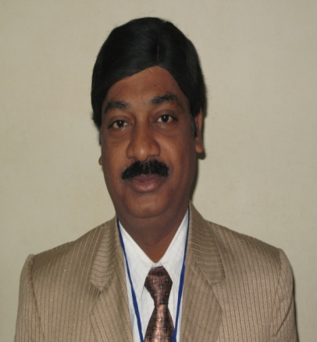
S. P. Puppalwar obtained M.Sc. degree in Physics from RTM Nagpur University, Nagpur, India. He did Ph.D. in Physics: Luminescence and TL Dosimetry in 2012. Dr. S. P. Puppalwar is presently working as Associate Professor in Department of Physics, Kamla Nehru Mahavidyalaya, Nagpur (NAAC accreditated with A+ grade). His research of interest is synthesis and characterization of Luminescent materials and development of TLD phosphors for radiation dosimetry. Around 32 papers are published in national and international reputed journals. He has completed one UGC project. He is a member of Luminescence Society of India and also a member of International Association of Advanced Materials, Sweden.

Email: suresh.puppalwar@gmail.com
Full name: Dr. Suresh P. Puppalwar
Contact number: +91 9881049243

