Abstract Title: Biorefining of turmeric rhizomes with the use of supercritical technology: obtaining of value-added products
Ádina L. Santana¹, M. Angela A. Meireles

¹ Food Innovation Center (University of Nebraska-Lincoln, USA).
²LASEFI/School of Food Engineering (University of Campinas, Brazil).
https://materialsscience.euroscicon.com/abstract-submission

Every year millions of tons of organic wastes are generated causing environmental problems. In this context, several investigations have been developed on the transformation of organic wastes into value-added products. Supercritical technology is an environmentally friendly alternative for the complete application of feedstocks to synthesize bioactive compounds, biofuels, and energy. The rhizomes of turmeric are traditionally processed to obtain volatile oil and curcuminoids, leading to the generation of a biowaste composed of carbohydrates and curcuminoids. This is the first work to propose the valorisation of turmeric wastes by the application of biorefinery concept with the use of supercritical technology to produce colorant, oil, sugars, microparticles and starch. Supercritical fluid extraction (SFE) was applied to produce essential oils (3.02%). The waste of SFE was extracted with pressurized liquid ethanol to obtain a concentrated curcuminoids extract (12.08%). The essential oils and curcuminoids ethanolic extracts were coprecipitated with polyethylene glycol and compressed carbon dioxide to provide microparticles to enhance the stability of these products. The overall coprecipitation yield ranged approximately 50-70%. Partial hydrolysis with pressurized hot water provided a liquid fraction source of curcuminoids and fermentable sugars (7%) which can be used as substrate for bioethanol production by fermentation or as a natural additive in food products. Besides, the pressurized hot water extraction increased the release of starch (from 26 to 32%) and modified the structure of turmeric waste, which enables its selling as combustion feedstock, fertilizer, or replacer/complement to conventional sources of starch (corn, and potato), besides adding colour and antioxidants on products. The Economic evaluation show that process integration for the obtaining of volatile oil and curcuminoids extracts resulted on higher COM values when compared to literature. Otherwise, pressurized hot water extraction showed feasibility on the biorefining of turmeric waste.

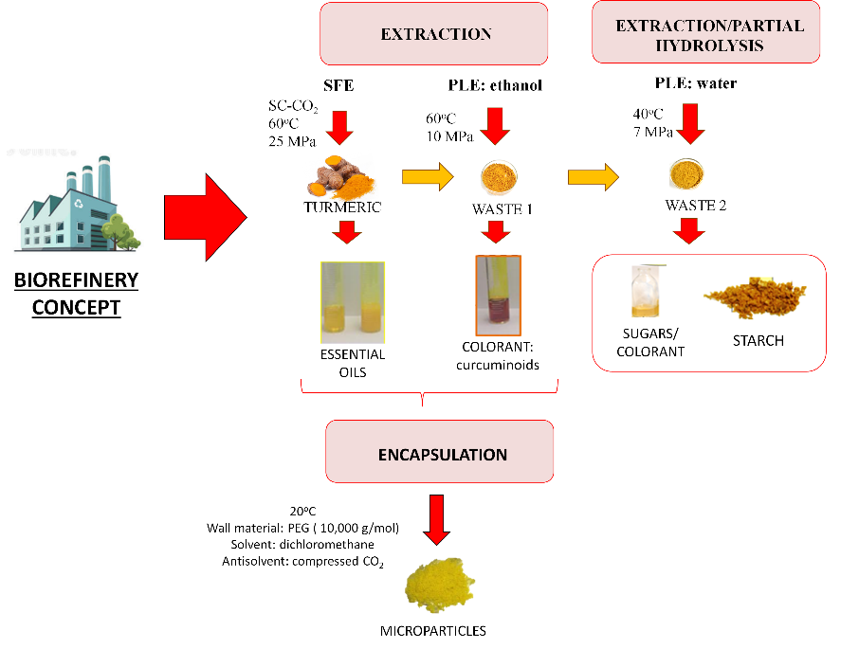

Keywords—Biopolymer, Biorefinery concept, Particle formation, Starch, Supercritical technology.

Professional Biography (100-150 words)

Ádina L. Santana
Ádina L. Santana completed her PhD at the age of 29 years at the Food Engineering Department from University of Campinas (2017) and postdoctoral studies at the Food and Nutrition Department from the Unicamp (2018-2019). Nowadays she is a Post-Doctoral Researcher Associate at the Food Innovation Center from University of Nebraska-Lincoln and serves as reviewer for 29 international journals. Dr. Santana contributed as an editor to the publication of one book recently published by Springer. She has also published 31 research papers in peer-reviewed journals, 17 book chapters and 19 works in scientific conferences. She has published research involving rheology of foods, starch chemistry, encapsulation, phase equilibrium, extraction, and purification of bioactive compounds with the use of supercritical fluids, pressurized liquids, enzymes, and ultrasound. Also, she collaborated as research on the anti-glycation effects of extracts derived from citrus wastes.

M. Angela A. Meireles
M. Angela A. Meireles holds a PhD in Chemical Engineering from Iowa State University, (USA, 1982) and the MSc and BS degrees in Food Engineering both from Unicamp (1979 and 1977). She is the director of the company Innovation of Bioativos Naturais, the Coordinator of food science of Capes (Coordination for the Improvement of Higher Education Personnel) and a Professor at the Food Engineering Department at Unicamp, where she began working in 1983 as an assistant professor. In 2016, she retired from Unicamp where she still holds the position of professor for the Post-Graduate program in Food Engineering and is the leading research of four technology transfer projects: i) Development of a Process to obtain an extract from Cannabis sativa (http://entouragelab.com/index.html) for entourage brasil; ii) Development of an Integrated process to produce bioactives to cosmetic industry (https://pt-br.facebook.com/scosmeticosdobem/) and iii) Assembling a Supercritical Fluid Pilot Plant to Process algae (http://www.cietec.org.br/project/bioativos/).

Email Id: adina.santana@gmail.com (Á.L. Santana)

Contact Number:1 402 429 7083 (Á.L. Santana)

