Delirium: Improving recognition in the acute setting

Joshua Soggi, North Manchester General Hospital, UK

Introduction: Delirium is often undiagnosed and associated with poor outcomes but can be prevented and treated if recognised early. We aimed to improve delirium recognition for patients in the acute setting when being admitted to hospital.

Method: A stage 1 retrospective analysis was done for patients being admitted through general medical wards who were aged 65+ years with risk factors for delirium. It was assessed whether these patients had a validated screening tool for delirium within 24 hours of presenting to hospital. If screening was done and positive, was a diagnosis of delirium documented and mentioned on their discharge summary. Presentation of results and area for improvement was done to the general medicinal clerking team. After implemented change and improvement to the trusts clerking pro-forma a stage 2 re-audit was done.

Results: A total of 126 patient were identified, of which 30 met the selection criteria in stage 1. It was found that 10% of patients were assessed with a validated tool within 24 hours of presenting to hospital. Of those 10%, 50% screened positive for delirium. Out of those screening positive, 10% had a diagnosis of delirium on their discharge summary. In stage 2 a total of 98 patients were identified of which 10 met the selection criteria. 100% of patients had a validated screening tool within 24 hours of admission. All 10% of patients screened positive for delirium which all had a diagnosis of delirium made. Of those screening positive, 0% had a diagnosis of delirium on their discharge summary.

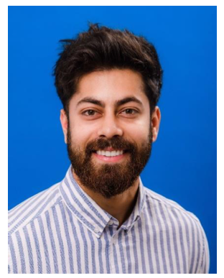
Conclusion: The audit demonstrates a significant improvement in delirium recognition in the acute hospital setting. The trusts clerking pro-forma went from endorsing CAM and AMTS to just the 4AT which had a higher compliance. Delirium diagnosis mentioned on discharge however still proves to be an area of improvement.

Biography
Joshua Soggi is a junior doctor currently working in elderly medicine at North Manchester General Hospital. He is an international graduate, who has an MD from Medical University Of Varna, Bulgaria.

