Case Report
GIANT CARDIAC HYDATID CYSTS: A CASE REPORT.

Sami Bouchenafa, A. Boukli Hacene, B. Hamouda, N. Draou, L. Zebirate, M. Atbi
Cardiac Surgery Departement, EHU Oran, Algeria

Ab s t r a c t:

A 55-year-old woman presented recently with dyspnea. The clinical examination was normal. Enlargement of the mediastinum with cardiomegaly was noted on the chest x-ray. Echocardiography showed the existence of 3 giant cardiac cysts which compressed the heart whose cavities are barely visible. A thoracic scanner revealed a giant hydatid cyst measuring 11 cm between the sternum and the right atrium. Another giant hydatid cyst, measuring 10 cm, was posterior and inferior behind the right inferior pulmonary vein and extended towards the right pleura. A 3rd giant hydatid cyst, measuring 10 cm, appeared to penetrate the wall of the left ventricle.
The surgery was performed under femoral cardiopulmonary bypass, which involved opening of the 3 cysts after aortic clamping and resecting the multiple cysts of different sizes and more than 40 vesicles and debris.
The patient left the hospital 10 days after undergoing surgery and Albendazole treatment.
An isolated cardiac hydatid cyst is rare, of incidental discovery or after cardiac signs of complications when it is of a giant size and/or multiple cysts are present.

Keywords: hydatid cyst, cardiac surgery, pericardectomy.

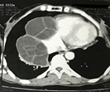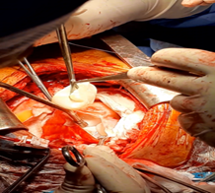
Fig 1: Giant hydatid cysts at the CT Fig 2: operative resection of the cyst

