Investing in Women’s Health in

Pakistan – Role of Mass Media:

Positive or Negative?
Dr. Ayesha Shahid
Obstetrics and Gynecology Department, Shaikh Zayed Hospital, Lahore, Pakistan

Biography:
I, Dr. Ayesha Shahid currently doing postgraduation residency in Shaikh Zayed Hospital, Lahore. I have keen interest in Women’s mental, psychical, psychological and reproductive health. Hence, done multiple researches on it along with studies including Covid and pregnancy. I believe on women empowerment in every field so that mortality and morbidity must be lessened in developing countries where many aspects of women’s health still need to be addressed

Abstract:
Investing in women’s health is still an island in this huge sea of knowledge. Hence, this research intends to focus on role of mass media on Pakistani women’s wellbeing. The scoping review synthesized data from PubMed and Google scholar databases reaped 17 eligible studies, of which 5 studies were on family planning/ contraception use and 3 studies on STD’s prevention, 3 studies on breast cancer and its screening, 3 studies on cervical cancer and its screening and 3 studies on social media exploitation among Pakistani women. Findings revealed that reliability and active participation in mass media has fetched many educational programs in improvement women psychological and physical health awareness. But at the same time excessive use of media caused troubles and negative impact on youth’s perception and attitude regarding women reproductive and sexual health resulting in obscenity leading to sexually transmitted diseases, unplanned pregnancy and miscarriages; which has inevitably affected women’s health. Therefore, effective strategies are need of an hour to ensure that mass media services should provide positive awareness and parents continual monitoring on their children networking websites will help community to refrain from occurrence of various adverse health consequences as well as from unwanted sexual and risky behaviors.
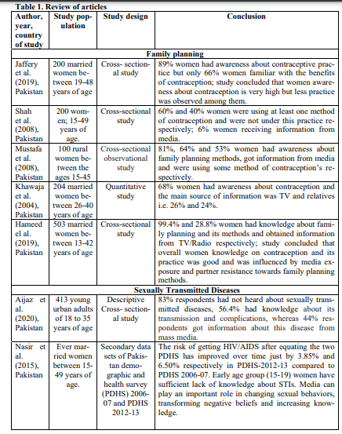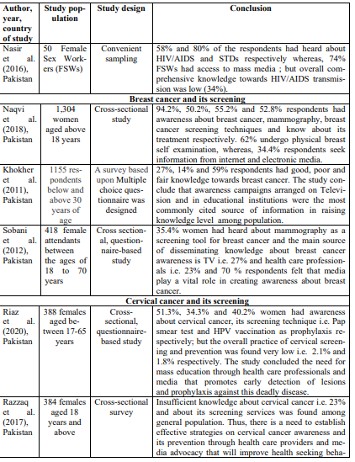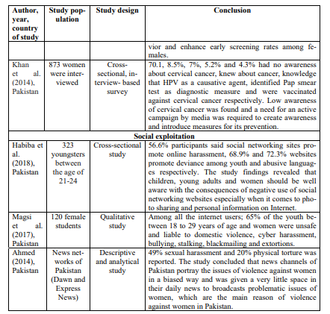
Importance of Research:
Mass media aims to capitalize women health on contraception use, family planning, STD’s prevention, breast and cervical cancer screening. To enable women combating grave unavoidable diseases and promote healthy environment, cybercrime must be checked in developing countries like Pakistan. This article aims to highlight role of mass media in awareness about women’s health and social media exploitation in Pakistan.
Media bids women to express their views, perceptions, resistance on societal constraints and source of information on reproductive and sexual health regarding contraception and planned/unplanned pregnancy, abortions, STD’s and HIV/AIDS; but increase socialization, visualization of sexually leaning genres such as operas, video games and music videos and fictional metaphors as veracity generates inappropriate attitudes towards serotypes, new relationships goals, masturbation, extra- marital activities, cyber bullying, humiliation, harassment, peer relationships, pornography, violence, sexting, social rejection, domestic violence, physical torture or rape and depression among women. It is important to develop content, stories and messages that will engage community towards positive knowledge on individual’s health and suggestions on how to handle social media exploitations. In this way we can improve the quality of women’s life and empower women to combat health issues.
About University:
I am currently doing residency in Shaikh Zayed Hospital, where multiple high-risk cases of obstetrics & gynecology are done under supervision. Department encourages researches and their publications and presentations.
References:
- Ahmed, S. (2014). Violence against women: media representation of violent issues in the perspective of Pakistan. Sci. Int., 26(1): 367-371.
- Aijaz, S, Mehraj, J.(2020). Awareness of sexually transmitted diseases among young adults of Karachi; a cross-sectional study. J Pak Med Assoc., 70(6): 1029-1035.
- Habiba, U, Farid, N, Saud, M.(2018). Social Networking Sites and Deviance among Youth in Islamabad, Pakistan. Eur J Behav Sci., 1 (1): 48-58.
- Hameed, S, Haq, N, Haque, N, Nasim, A, Riaz, S, Tahir, M et al. (2019). Knowledge, Attitude and Practices (KAP) Regarding Family Planning Services among Married Women of Quetta Pakistan. IJRRGY, 2(1): 1-12.
- Jaffery, HO, Tufail, S, Aslam, P, Qamar, S, Mushtaq, Q, Kanwal, R. (2019). Knowledge, attitude and practice of family planning among Pakistani women attending a tertiary care hospital. Pak Armed Forces Med J., 69: 329-333.
- Khan, GJ, Naeem, HS, Khan, S, Jamshaid, T, Sajid, MI, Bashir, I, Jamshaid, M. (2014). Understanding and responsiveness level about cervical cancer and its avoidance among young women of Pakistan. Asian Pac J Cancer Prev., 15(12):4877-83.
- Khawaja, NP, Tayyeb, R, Malik, N. (2004). Awareness and practices of contraception among Pakistani women attending a tertiary care hospital. J Obstet Gynaecol., 24:5, 564-567.
- Khokher, S, Qureshi, W, Mahmood, S, Saleem, A, Mahmud, S. (2011). Knowledge, Attitude and Preventive Practices of Women for Breast cancer in the Educational Institutions of Lahore, Pakistan. Asian Pacific journal of cancer prevention: APJCP, 12(9): 2419-2424.
- Magsi, H, Agha, N, Magsi, I. (2017). Understanding cyber bullying in Pakistani context: Causes and effects on young female university students in Sindh province. New Horizons., 11(1): 103- 110.
- Mustafa, R, Afreen, U, Hashmi, HA. (2008). Contraceptive Knowledge, Attitude and Practice among Rural Women. J Coll Phy Surg Pak., 18(9): 542-545.
- Naqvi, AA, Zehra, F, Ahmad, R, Ahmad, A, Yazdani, N, Usmani, S et al. (2018). Awareness, knowledge and attitude towards breast cancer, breast screening and early detection techniques among women in Pakistan. J Pak Med Assoc., 68(4):576-586.
- Nasir, JA, Imran, M, Chohan, AA, Zaidi, SAA. (2015). Sexually transmitted infections; Trends and differentials. Professional Med J., 22(10):1226-1231.

