Debate about Liver Haemangioma Management.
Wael Mansy¹ MD & Morsi Mohamed¹ MD
¹Assistant professor of general surgery, Hepato-Pancreatico-Biliary Consultant, Zagazig University (Egypt).
Abstract:

Background:
Management of patients with liver giant hemangiomas, carries a great debate. The debate is regarding indication of surgical intervention, and also the way of management either enucleation or resection. Although non-operative management in recent studies has a low complication rate, still operative management play a rule in large symptomizing haemangioma.
Patients and methods:
A retrospective study on 49 patients with giant haemangioma between 2014 and 2018 in Advanced Hepato-Pancreatico-Biliary Center, Zagazig University Hospital, Egypt.
Results:
From 49 patients, 27 patients managed conservatively. While 22 patients managed by surgery (13 by enucleation and 9 by liver resection). During the follow-up period; in the non-operative group; 5 had new onset of symptoms related to haemangioma. While in the operative group no recurrence occurred and the rate of postoperative complication was 24.49%.
Conclusion:
- Clinical observation is the role in management patients with giant haemangiomas, except patients with persistent sever symptoms or development of complication.
- Enucleation and liver resection are safe and effective for giant haemangiomas >10cm and complicated haemangiomas.
- No major differences in outcomes between enucleation and liver resection.
- Still clamp fracture may be used in surgical management, but hemostatic strategies including hepatic inflow occlusion decrease CVP and usage of hemostatic devices should be used to decrease the intra-operative bleeding.
Keywords: Clinical Observation, Enucleation, Haemangioma, Liver, Resection.

Professional Biography:

Wael Mansy has completed his PhD at the age of 34 years from Zagazig University and postdoctoral studies from Zagazig University and joined International Medical Center (IMC) in Egypt in Living Donor Liver Transplantation Program with Professor Koichi Tanaka and Professor Khalid Amer. I am now the head of Hepato-Pancreatico-Biliary Center in Zagazig Egypt. I has published more than 20 papers in reputed journals and has been serving as an editorial board member and reviewer of repute.

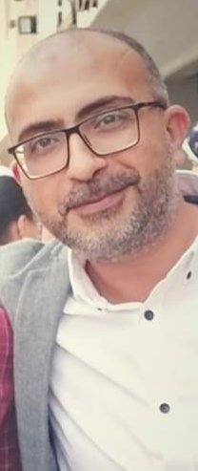

Email Id: drwaelmansy@hotmail.com

