Treatment of Car Wash Wastewater Using Crushed Glass as Granular Filter Media

Marie Rose Farah, Tonia Jabbour, Sophia Ghanimeh
Department of Civil and Environmental Engineering, Notre Dame University – Louaize, Lebanon

ABSTRACT

Considering the aggravating water scarcity and the high associated risks in developing countries, water resources diversification becomes a must for sustainable water supply. In this context, the proposed article seeks a viable low-cost low-tech treatment process suitable for car wash wastewater(CWW) with the purpose of generating a reusable effluent. The tested systemuses crushed glass waste to replace natural sand in the filtration process. The suggested CWW treatment process consists of four stages including, primary settling, coagulation and flocculation, secondary settling and filtration. The settling column test showed that a retention time of 70 minutes can be adopted, with expected43 % removal of suspended solids. The jar test showed that Ferric Chloride, at 90g/m³ dosage, is an efficient coagulant for this type of wastewater. The crushed glass bed particles ranged between 0.425 to 0.600 µm and provided efficient filtration leading to a drop of turbidity drop from 59.3 to 1.1 NTU. The overall BOD removal reached 64.7 %.
- IMAGE:
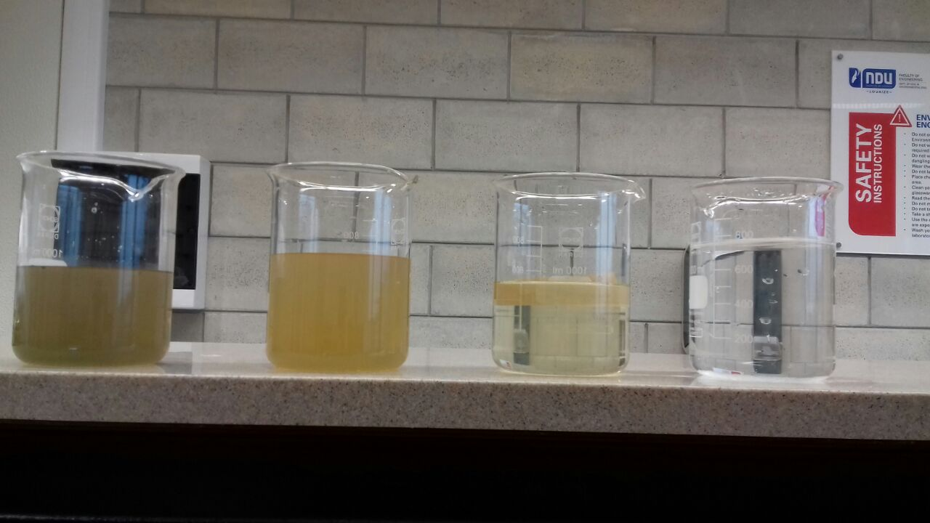

Figure 1: Physical appearance of CWW after each treatment stage

