Literature Review Abstract

Author: Mr. Mehrshad Sultani Tehrani, Dr. Steve Connor, Miss. Irumee Pai
Title:
Exploring the Prevalence of Vascular Loops in Patients with Suspected Pulsatile Tinnitus: A literature review analysing radiological findings significance

Background:
Tinnitus is a mostly unexplained phenomenon affecting approximately 10% of the general population (Marsot-Dupuch, 2001). It involves an auditory ringing or buzzing that may be pulsatile or continuous in character as well as unilateral or bilateral. Previous literature has pointed towards a parallel between the presence of vascular loops within the Internal Auditory Meatus (IAM) and Pulsatile Tinnitus (PT).
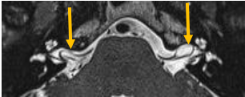

Objectives:
This literature review aims to analyse the current understanding of Vascular loop prevalence in the IAM as an incidental finding on MRI for patients with PT.

Methods:
Studies from PubMed, OVID, and EMBASE databases were used to search for relevant papers which were then cross-referenced. The search terms used included: “vascular loop,” “ear,” “auditory,” “tinnitus,” “pulsatile,” and “imaging.” This yielded 72 articles, but a total of 21 irrelevant articles were excluded as well as 8 case reports and 4 systemic reviews.

Results:
The majority of the studies reviewed did not find a significant correlation between the presence of vascular loops in the IAM and PT. These findings suggest that vascular loops may be only an anatomical variation and not causally linked to PT.
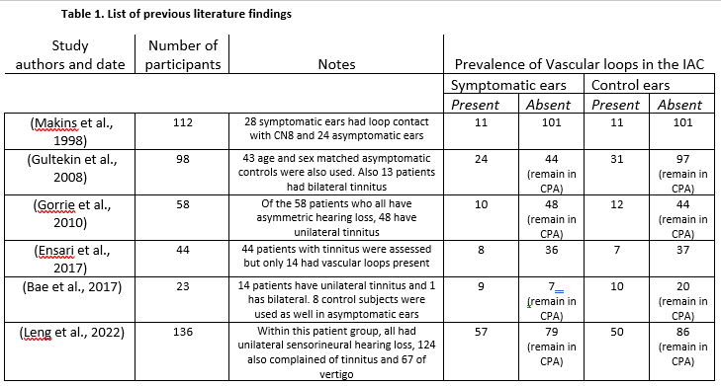

Discussion:
While no definitive causal relationship has been established, the presence of vascular loops in the IAM may play a role in PT. Research has shown that vascular compression syndrome may cause conditions such as hemifacial spasms and trigeminal neuralgia (Jannetta, 1975), which have been successfully treated with microvascular decompression. Similar advancements in treatment and diagnostic pathways could benefit patients with PT.

Conclusion:
The prevalence of vascular loops in the IAM as an incidental finding on MRI in patients with PT remains inconclusive. However, further research in this area may lead to novel treatment options and diagnostic approaches for patients, ultimately improving their quality of life.

Reference List
Jannetta, P.J. (1975). Neurovascular cross-compression in patients with hyperactive dysfunction symptoms of the eighth cranial nerve. Surg. Forum 26467-469.
Marsot-Dupuch, K. (2001). Pulsatile and nonpulsatile tinnitus: a systemic approach. Semin. Ultrasound CT MR 22(3), 250-270.

