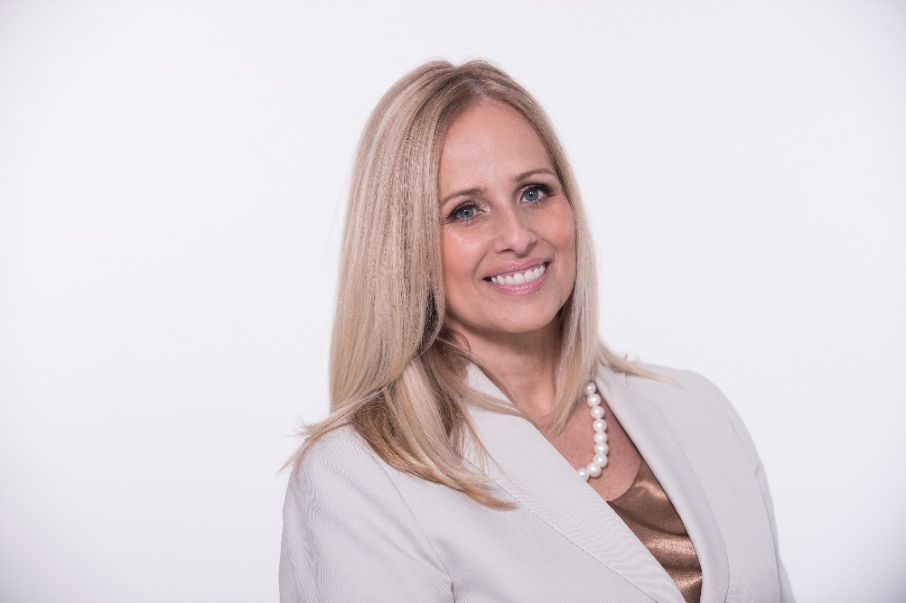
Manon Pilon, Author, Medical Spa Consultant, Medical Esthetician since 1982
Acne and Acne rosacea from a Medical-Aesthetic Perspective
-the Solution with proven results
by Manon Pilon Author
An in-depth class on how acne evolves in grades. Understand the difference between acne and acne rosacea. Learn tips and tricks on prevention, protocol, solutions targeting the pathogenic microbiome involved. Familiarize yourself with the terminology used to describe acne or rosacea. Learn safe and effective technology, ingredients and protocols that will replace prescription drugs in Acne Care and in acne rosacea care.
Provide your clients with optimum results!

How to Build Your Own Skincare Line: Do’s & Don’ts?
by Manon Pilon, Author
Have you ever considered having your own skin care line? If Private Labeling is a good fit for you, it might be the best business decision you will ever make. This class is an insight on the do's and don'ts when you consider launching your own private label skin care products. Learn how to get started, avoid costly mistakes and grow your business.

TOP 15 Marketing Strategies for Spa Management
By Author Manon Pilon

In this class you will learn from the leader in the industry, Manon Pilon, spa, medical spa consultant and operator, with 38+ years of experience in the spa and med spa industry,
Author of 2 books. Pilon will introduce new concept; strategies to marketing ideas; services and products to stay current in today’s competitive market; as well as easy tools to integrate for your success.
Learn different ways to increase revenue and credibility by offering latest medical spa approaches. Get top, easy, and effective marketing ideas. Learn the marketing strategies that have transformed spas around the world.

THE vaginal ph and the impact on your client’s wellness
By Author Manon Pilon
Learn the importance of the microbiota and its pH and its balance in woman health .The key microbiomes will be discusses. Menopauses symptoms will be addressed and how you can make a difference in the quality of life. The impact of unbalanced vaginal microbiome will be discussed and Learn how cosmetics for vaginal health can transform your practice.

New NECK LIFTING treatment! Micro needling (RF) & using Radio Frequency (RF).
by Manon Pilon Author
Learn and update your knowledge on the industry's latest technological advances. Ideal for the neck. The first of its kind for skin tightening for FACE, NECK and BODY using a bi-polar radio frequency (RF) and micro needling with radio frequency (RF) for optimal results! How to incorporate New & Innovative Services for your Success. Do not miss this class!!

HOW TO Increase your Retail Sales
By Manon Pilon, Author
Do you have a 50%-125% in retail sales ratio over your services? Get the secret to successful retail sales!
In this presentation, Manon Pilon will discuss the methods and benefits of home care. How you should integrate and convert your sales. Learn a new sales approach and how she sets the standard for professionals. Learn a step-by-step process on how to introduce your products to your clients and gain loyalty.

Vajacial…Tips for a Perfect Brazilian waxing service! Learn how to incorporate a new services and products to increase your BUSNESS! Are you an expert in Brazilian waxing and use best practices to better services your clients? Learn new innovative services to maximize your profits. New innovative personal and feminine hygiene products and service category that will transform your spa. The importance pf pH testing and why. Learn tips and tricks a client should know before and after waxing to make a difference. How to avoid ingrown hair. Discover how to provide a new professional waxing treatment combine VAJAFACIAL. Precautions and techniques for Brazilian waxing will also be discussed.

Business Start-Up for Spa & Medical-Spa
With Expert Manon Pilon
This class is a smart investment for future entrepreneurs in the medical spa industry. Learn about tips of what to do and not to do, on feasibility and strategies it takes to be successful in a medical spa business in today’s competitive market. The different steps to start a medical aesthetic practice will be discussed
and the 38 years of expertise to guide you through you’re a successful project.
Lear what equipment to purchase are profitable and where to start.
Join Manon Pilon world medical spa consultant and expert!!
Do not miss this class!!

Body Type
How morphology can improve your services and results!
In this presentation Mrs. Pilon will classify one by one the 4 body types based on Hippocrates methodology and easy method to implement in your practice using shape and colors based on her book Anti Aging the Cure.
This will help you discover an easy method to obtain maximum results. Personalized a program based on genetic predispositions, gain your patient loyalty by initiating a unique concept that everyone is talking about. This new method is making a mark in the medical and wellness/med spa industry!

