Abstract Title: Adoption and Incorporation of Artificial Intelligence in the Clinical Pathology practice during the COVID-19 pandemic: Overview of contemporary developments in the light of Evidence-Based Research

Ali Haider Bangash^{1,2}

¹Shifa College of Medicine, STMU, Islamabad, Pakistan
²Member, Working Group 3, COST Action Evidence-Based RESearch (EVBRES)

Abstract (not more than 300 words)

The SARS-CoV-2 struck everybody with surprise with the novelty of its genome along with accompanying mutations and the diverse extent of its clinical manifestations. Clinical pathologists suddenly found themselves at the forefront of the global efforts to curb the damaging effect of the COVID-19 pandemic. With conventional management protocols unable to mitigate the associated morbidity and mortality effectively, artificial intelligence was explored for its applications so that they may be incorporated, thus optimizing, the healthcare protocols designed to contain the effect of the novel causative agent. Artificial Intelligence, specifically its specialization of Machine Learning, was reconnoitred in a bid to predict SARS-CoV-2 carriers, prognosticate severe complications for risk stratification so as to optimally allocate healthcare resources, develop effective targeted anti-viral drugs as well as to optimize vaccination development and distribution— the list by no means is exhaustive.
In order to appreciate the applications of Artificial Intelligence, especially Machine Learning, in the fight against the COVID-19 pandemic, a scoping review is conducted of the relevant published literature. The findings are commented on in the light of the principles of Evidence-Based Research so as to inform on the quality of the respective applications of Artificial Intelligence against COVID-19. Knowledge gaps and lacunae are identified with constructive recommendations to address them.

Keywords— Artificial intelligence, Machine learning, Prognostication, Vascular injury

Professional Biography (100-150 words)

Ali Haider Bangash is pursuing Bachelors of Medicine, Bachelors of Surgery at STMU Shifa College of Medicine, Islamabad, Pakistan with an interest in hepatopancreaticobiliary surgical oncology, vascular surgery and gastrointestinal malignancies. His research focuses on the applications of machine learning and their incorporation into the management protocols to decrease the morbidity and mortality associated with medical conditions especially neoplastic conditions. He is a medical student member of the American Society of Clinical Oncology, a research member of the Taskforce on COVID-19 at the Confederation of Laboratories for Artificial Intelligence Research in Europe (CLAIRE) as well as a member of COST Action Evidence-Based RESearch (EVBRES). He is heading the Medical Research department as its National Head at SYNCH, Pakistan and is also the co-head of the Research department at InciSioN, Pakistan. He has contributed to multi-centre collaborative studies published in Anaesthesia and The British journal of surgery.

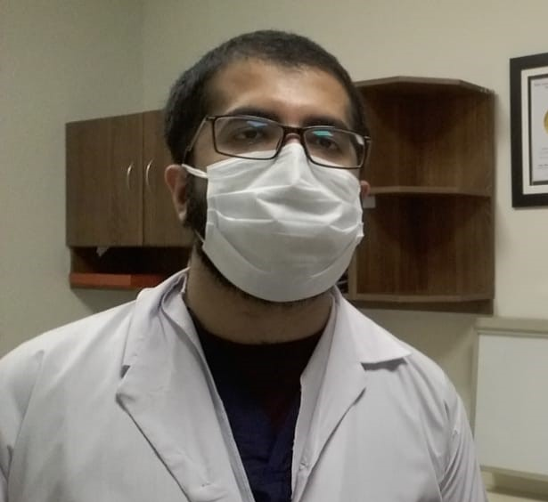

Email Id: hhaider4@gmail.com

Any Comments: Most humbly requesting a complete waiver of all associated fees as a one-time-only gesture and a token of leniency towards researchers from low-middle income countries.

