Abstract Template
Abstract Title: The leisure experience in nature as the foundation of building sense of place.
Ried, Andrés1
¹ First Author Affiliation (Pontificia Universidad Católica de Chile, Chile)

Abstract (not more than 300 words)

This presentation identifies and characterizes the links established between outdoor recreationists and protected areas. The text refers to the theoretical discussion of leisure experiences and constitutes a determinant of the relationship between subjects and parks. Through qualitative analysis of interviews, we identified and categorized the significance that outdoor enthusiasts place on a specific natural are: a sense of belonging and identity; the park as a place of privileged socialization; reservoirs of magic, cultural traditions and mythology. Leisure experiences based on contact with nature, provide experiences that transform the space into a place, building ties that tend to generate behaviours of admiration, commitment and care for the environment and nature.

Keywords— sense of place, leisure experiences, benefits

Professional Biography (100-150 words)

Ph. D. in Leisure and Human Potential from the University of Deusto, he is currently an academic at the Pontifical Catholic University of Chile, in his Villarrica Campus, there he teaches courses related to outdoor education and play as a pedagogical tool. He is a researcher at the Center for Studies for Local Development CEDEL-UC. His research interests have focused on the experience of outdoor recreation, its benefits and the senses of the place that are built from it in protected wild areas. He is a member of the Ibero-American Association of Leisure Studies OTIUM and the Society of Tourism Researchers of Chile (SOCIETUR).

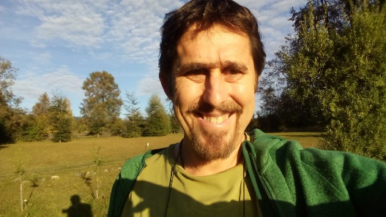
Email Id: rried@uc.cl

