Climate and Social Vulnerability in Alaska
Elena A. Grigorieva, ICARP FEB RAS, Birobidzhan, Russia

Abstract
Human health and well-being depend on the complex influence of many factors, one of which is the thermal state of the climatic environment. The thermal load on human body is an important indicator of climatic discomfort, especially in the extraordinary cold conditions of the Arctic, where extremely low temperatures are combined with strong winds. The purpose of the study is to evaluate social vulnerability to cold climates in Alaska as the northwestern-most state of the USA. Social vulnerability Index as a combination of climatic exposure, social sensitivity and adaptivity was estimated separately for seven Public health regions in Alaska. Climatic exposure was expressed by Universal Thermal Climatic Index (UTCI) in the categories of cold and very cold thermal stress. Social sensitivity was presented as a combination of indicators showing groups of population mostly vulnerable to cold temperature extremes. Adaptive capacity was assumed as the ability of society to couple with a cold environment and was represented by social infrastructure and socio-economic indicators. UTCI data for 30 locations in Alaska were based on historical reconstructions of ERE5-HEAT at the Copernicus Climate Data Store for the period 2014-2019. Social and economic data on the population of Alaska are available from the US Census data. Health data such as statistics for cardio-vascular and respiratory disease for the same period can be found on the state Department of Health website data and statistics page. The results show that Northern Alaska and Interior are exposed to the highest level of climatic discomfort, but Anchorage has the best conditions for adaptation to them. Conclusion & Significance: The results of the interdisciplinary research on estimation of social vulnerability are a useful tool in warning stakeholders and decision makers when developing appropriate intervention procedures in the field of the health monitoring, minimizing population losses and guaranteeing social security for the Arctic communities.
Recent Publications
Grigorieva E.A., Livenets A.S. Risks to the Health of Russian Population from Floods and Droughts in 2010‒2020: A Scoping Review. Climate 2022 10, 37. https://doi.org/10.3390/cli10030037

Sukhoveeva A.B., Grigorieva E.A. Reproductive health and environment at the Russian Far East: objective conditions and subjective assessments. IOP Conf. Ser.: Earth Environ. Sci. 2021 629, 012022. https://doi.org/10.1088/1755-1315/629/1/012022

Grigorieva E.A. Adventurous tourism: acclimatization problems and decisions in trans-boundary travels. Int J Biometeorol. 2021 65: 717-728. https://doi.org/10.1007/s00484-020-01875-3

Grigorieva E.A., Revich B.A. Health Risks to the Russian Population from Temperature Extremes at the Beginning of the XXI Century. Atmosphere 2021 12, 1331. https://doi.org/10.3390/atmos12101331

Grigorieva E., Lukyanets A. Combined Effect of Heat Waves and Outdoor Air Pollution on Respiratory Health: Literature Review. Atmosphere 2021 12, 790. https://doi.org/10.3390/atmos12060790.

Biography
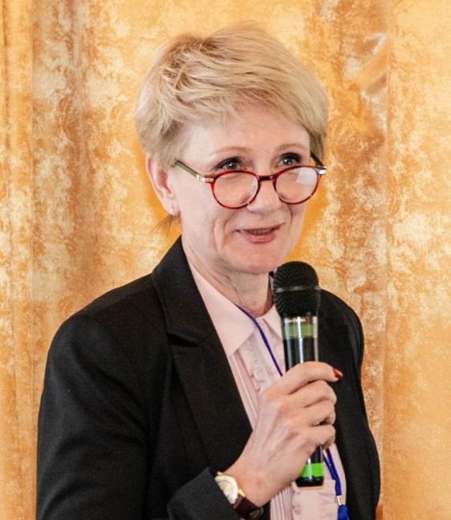
Dr. Elena A. Grigorieva is the leading researcher in the laboratory of regional social-economical systems, Institute for Complex Analysis of Regional Problems, Russian Academy of Sciences, Far Eastern Branch (ICARP FEB RAS), Birobidzhan, Russian Federation. Her research interests cover a number of themes in biometeorology, which include: Climate and human health, Environmental Health Threats by Climate, Human thermal acclimatization in extreme climates, Human bioclimatic indices, Urban climate, Climate and Tourism, Climate and Agriculture. Elena was Fulbright scholar in 2011–2012 (University of Miami), and member of Fulbright Arctic Initiative (2021–2022). Dr. Grigorieva is a well-known bioclimatologist, an active member and Vice President (2014–2023) of the International Society of Biometeorology (ISB), and member of ‘Climate, Tourism and Recreation Commission’, and ‘Climate and Human Health Commission’ in ISB. Elena is a member of ‘Women in Science and Engineering Committee’ in ‘Association of Academies and Scientific Societies in Asia’.

Email: eagrigor3000@gmail.com, eagrigor@yandex.ru

Notes/Comments:

