Pneumatic lighter: stimulating studies in Chemical Physics
Thiago de Cacio Luchese¹, Roger Matias Vogt², Rosália Andrighetto³

¹ Universidade Federal da Fronteira Sul, Brazil
² Universidade Federal da Fronteira Sul, Brazil
³ Universidade Federal da Fronteira Sul, Brazil

Abstract (not more than 300 words)

In early graduation, frequently it is observed a lack of motivation to study Thermodynamics or Chemical-Physics without a direct contact with in locus experiments that demonstrate the necessary understanding of these great themes. This perception and the finding that the burning of cotton or small pieces of paper in a transparent pneumatic lighter – witch, in turn, is a qualitative experiment of great simplicity and of rapid execution in classroom – calls attention of the students for these areas of knowledge, gives the basis for this work. So, we wish in this presentation to stimulate further contact between quantitative physical and qualitative chemical methods for investigation about the mater structure and the technical and technological applications of this. We want to give a so desired reason for students to pay attention in basics physics and chemistry.

Keywords — Tracker, adiabatic compression, modelling, mechanical energy

Professional Biography (100-150 words)

Thiago de Cacio Luchese has completed his doctorate degree at the age of 29 years from Universidade Federal de Santa Catarina and nowadays is teaching at Universidade Federal da Fronteira Sul.

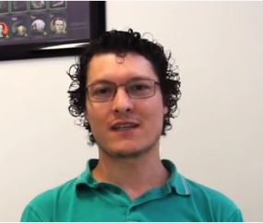
Email Id: thiago.luchese@uffs.edu.br

Roger Matias Vogt has completed his graduation degree at the age of 26 years from Universidade Federal da Fronteira Sul.

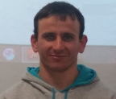
Email Id: rogervogt3@gmail.com
Rosália Andrighetto has completed his doctorate degree at the age of 26 years from Universidade Federal de Santa Maria and nowadays is teaching at Universidade Federal da Fronteira Sul.

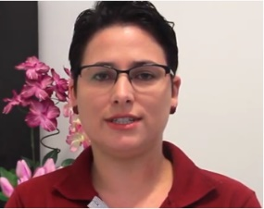
Email Id: rosalia.andrighetto@uffs.edu.br

