Variation in oxidative stress parameters after subchronic exposure to a lambda cyhalothrin pesticide in WISTAR rats

Mr AYACHI.A, University of tebessa, ALG

Abstract

Lambda cyhalothrin is a synthetic pyrethroid insecticide, which is increasingly used in agriculture and home pest control. Our experimental study was carried out on 18 male WISTAR rats (Rattus rattus) divided into three groups: group A (06 rats) control, group B (06 rats) treated with LCT (05 mg / kg / day), group C (06 rats) treated with LCT (10 mg / kg / day) administered orally for 90 days The present work involves the evaluation of the potential toxicity of LCT on the kidneys of rats and the variation of some on oxidative stress parameters. The results obtained after the administration of LCT show that it has caused a generally prooxidizing effect, this is revealed by the reduction of the reduced glutathione level GSH and the enzymatic activity of the glutathione peroxidase GPx and catalase CAT in the kidneys and also by increasing the enzymatic activity of glutathione-S-transferase GST and the level of MDA in treated rats with different doses compared to controls. All of these results are signs of possible nephrotoxicity.

Key words: pyrethroid, lambda cyhalothrin LCT, oxidative stress, GPx, CAT, Rattus rattus, nephrotoxicity.

Image

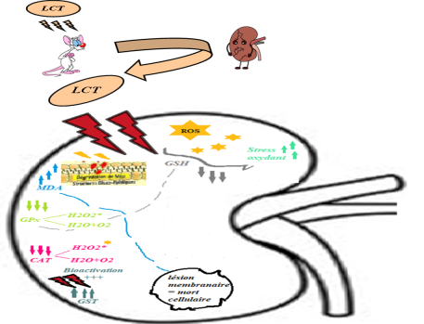
Figure. General presentation concludes the nephrotoxic effects of lambda cyhalothrin on rat kidneys.

Recent Publications

Fetoui, H., Makni, M., Garoui, M. et Zeghal, N. (2010). Toxic effects of lambda-cyhalothrin, a synthetic pyrethroid pesticide on the rat kidney: Involvement of oxidative stress and protective role of ascorbic acid. Experimental and Toxicologic Pathology,Volume 62(6), 593-599. doi : 10.1016/j.etp.2009.08.004.
- Leila, hocine. hafida, merzouk., Sid Ahmed, merzouk., hafeda, ghorzi., meriem, youbi., mechel, nacre. (2016). the effects of alpha-cypermethrin exposure on biochemical and redox parameters in pregnant rats and their nweborns, pesticides biochemistry and physiology, 134:49-54.

Lachref, Asma. Bouallaga, Imane. (2018). the antioxidant and antitoxic effect by bioactive substances of Coriandrum sativum L. in albino Wistar rats intoxicated by Lambda-cyhalothrin. End of study memory. Echahid Hamma Lakhdar University - ELOUED: Applied Biochemistry. from: http: //dspace.univ eloued.dz/handle/123456789/1061
- Moustafa, A.Abbassy., Mamdouh, A.Marzouk., Sameeh, A.Mansour., Hassan, A.Shaldam. And Abdel-Tawab, H.Mossa. (2014). Impact of Oxidative Stress and Lipid Peroxidation Induced by Lambdacyhalothrin on P450 in Male Rats: The Ameliorating Effect of Zinc, Environmental Analytical Toxicology:4:4.
- ShiddappaMallappa, Shivanoor. et Muniswamy, David. (2014). Protective role of turmeric against deltamethrin induced renal oxidative damage in rats, Biomedicine & Preventive Nutrition 4.2014 543–553.
- Heba, M.Abdou., Hend, M.Hussien. et Mokhtar, I.Yousef. (2012). Deleterious effects of cypermethrin on rat liver and kidney: Protective role of sesame oil, Journal of Environmental Science and Health, Part B: Pesticides, Food Contaminants, and Agricultural Wastes, 47:4, 306-314.

Biography
Mr AYACHI ABDERAOUF
I have a BA and MA in Applied Toxicology from the Faculty of Exact Sciences and Nature and Life Sciences, University of Tebessa, Algeria .as well as a Biologist in the Laboratory of the Mother and Child Hospital in Tebessa, Algeria. I have a great desire to develop my knowledge in the field of scientific research and gain more experience.
Email: raouf1794@gmail.com

