Abstract Title: Designing and Distribution of Dementia Resource Book to augment the capacities of their Caretakers
Dr. Avani MAniar, Ms Khyati Deesawala
¹ Department of Extension and Communication, The Maharaja Sayajirao University of Baroda, Vadodara, India
2. Department of Extension and Communication, The Maharaja Sayajirao University of Baroda, Vadodara, India

Abstract (not more than 300 words)
As Per the estimates of the WHO, aging Population is increasing in developing countries and dementia is going to be epidemic among elderly in the coming decades. This demands early action to prevent the disease and treatment of the affected persons, which is poorly existed in middle and low-income countries.

The need of the hour to tackle dementia in India is to estimate disease burden in the community, search for risk and protective factors and undertake measures to provide social benefits to the sufferers and those who are at risk. Raising awareness amongst the civil society is an important task ahead. Apart from that, family members and caregivers of Dementia sufferers have to be very sensitive and resourceful while handling them. If they are well equipped to deal with the issue, positive results can be seen in their efforts.

Without proper information about dementia, the person and the family may respond in different ways which may aggravate the problems in dealing with dementia patients. Hence, to prepare family members and caregivers of Dementia sufferers a resource book was designed in simple, non-medico language with a lot of illustrations and variety of information which will help them and seek support for various issues while dealing with them.

- Keywords— Dementia, Resource Book ,Caretakers ,Awareness

Professional Biography (100-150 words)

Dr. Avani Maniar is presently working as an Associate Professor in the Department of Extension and Communication, Faculty of Family and Community Sciences, The M. S. University of Baroda, Vadodara, India. She has 22 years of teaching experience. Her major contribution is in the field of ICT in education and development focusing on designing and implementing information technology in the formal and nonformal set–up for bringing quality changes in the lives of the people. The focus of her work is in community Development Programs Using Various Communication Strategies from Traditional to Modern media. Media blending techniques and behaviour communication strategies have been incorporated into all her projects for bringing change in the communities. Her expertise is in collaborative community development projects for outreach activities for community development work. Since last ten years, she is contributing her work towards senior citizens for improving their quality of life.

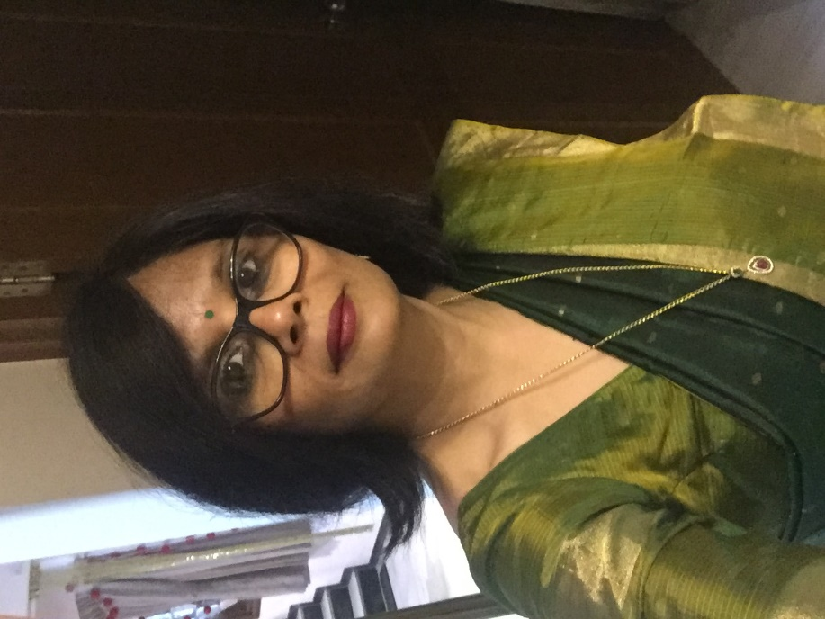
Paste your Photograph here

Email Id: avanimaniar@gmail.com

Any Comments:

