Abstract Template
Creation of doubled haploids lines of barley (Hordeum vulgare L.) drought tolerant through anther culture.
W. BRAHMI and A. LTIFI

Laboratory of biotechnology National Agricultural Institute of Tunisia (INRAT) –Tunis Hedi Karra Street, 2049 Ariana, Tunis

Abstract

Abstract:

Drought is one of the most important abiotic stresses that limits the growth and productivity of cultivated plants. We studied the physiological responses of barley plants under specific drought conditions. The goal was to evaluate the impact of water stress on thirteen varieties of barley. Rihane, Manel, Momtez, Faiz, Roho, Tej, Kounouz, Lamsi, Ardhaoui and Safra, Momtez*Roho and two doubled haploid lines Roho*Ardhaoui .The barley plants were grown in a greenhouse A full randomized test was conducted; a water deficit regime (50%) was used with a 100% control of the soil field capacity. The physiological parameters were collected using Scanalyzer 3D (LemnaTec, GmbH), a Platform. With this technology, it is possible to dynamically study the effects of water stress, on plant development in terms of early detection of physiological responses to plant stress.
In terms of the biomass produced and chlorophyll fluorescence, the analysis of different evaluated parameters shows diversity between lines, although often very close at the level of certain characters. By considering the descriptive parameters as a whole, it appears that the cultivar Roho and the doubled haploid lines Roho*Ardhaoui was performing on several levels.

Keywords: barley, drought, doubled haploid, Platform,physiological.

Professional Biography
My name is Wejden Brahmi, I m a 27-year-old student from Tunisia. I have an Agronomic Engineering degree .
Currently, I am a 4rd year doctoral student in Biological and Integrated control in agriculture I enrolled at INAT ‘Institut National Agronomique de Tunis’ and I am doing my research at INRAT ‘ National Institute of Agronomical Research in Tunisia’. The title of my thesis is «Production of drought-tolerant barley-doubled haploid by culture of anthers in vitro »My thesis advisor is Dr Ltifi Ali. My research centers around the selection of drought-tolerant lines.
I did a three-month research internship at the biotechnology laboratory Agrobios in metaponto Italy when i characterize the response to drought stress induced in barley plants by collecting information regarding the physiological and molecular changes induced by the stress and the potential positive effects, in terms oftolerance, due to the treatment. The physiological mechanisms were evaluated by image analysis (Scanalyzer 3D System, LemnaTec), using visible light (RGB), florescence, and near infra-red (NIR) chambers.

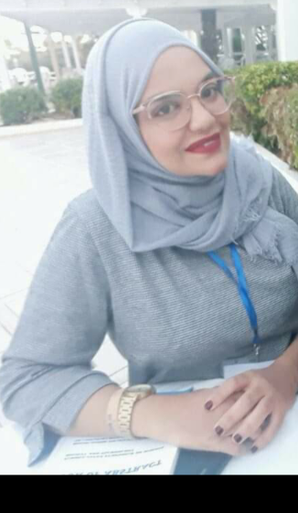

Email Id:
brahmiwejden90@outlook.fr

