Significance of mineral elements characterization for anaerobic digestion substrates: The case of avocado oil processing by-products
Charles Rashama*, MSc, IDEAS, University of South (UNISA), CSET.
Grace Ijoma, PhD, IDEAS, UNISA, CSET
Tonderayi Matambo, PhD, IDEAS, UNISA, CSET

Abstract
Statement of the Problem: Biodegradability effects of varying metal profiles in different anaerobic digestion substrates’ is poorly understood and hence merely included in substrate evaluation experiments. Researchers have reported that some metals in substrates can stimulate biological activity which improves biomethanation while other metals are known to be toxic to methane producing microorganisms. However, the metal species and ranges in other substrates are not known. Different metal concentration ranges for microbial activity enhancement or intoxication levels in digesters are reported by different Researchers. This motivates for independent investigations when one encounters new or potential substrates for biogas production. Methodology & Theoretical Orientation: Mineral elements in avocado oil processing by-products (potential biogas substrates) were measured using ICP-OES methods. The analytical results were compared to literature based findings on microbial toxicity and/or activation then inferences about these byproducts’ biodegradability to biogas were made. Findings: Of the 21 mineral elements identified in avocado oil processing byproducts only zinc is high enough in concentration to present potential biodegradation inhibition/toxicity challenges. Six minerals seem to fall within optimal ranges for biodigestion while the rest (14 elements) require supplementation to optimize these substrates’ biodigestion to biogas. Besides concentration as measured by ICP-EOS methods, metal bioavailability plays a critical role in determination of effects towards biogasification. Conclusion & Significance: It is always important to evaluate mineral element profiles of new substrates so that optimal digester designs can be done from the onset and avoid expensive reworks. It is recommended that mineral evaluation be incorporated into internationally recognized standard biogas substrate evaluation protocols as a mandatory requirement and this should include metal bioavailability studies.

Image
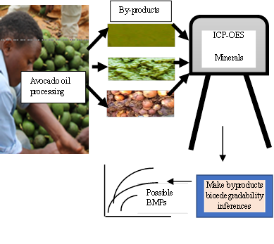
Figure 1: Mineral elements characterization in biogas substrates
Recent Publications
- Rashama C, Ijoma GN, Matambo TS (2021) The effects of phytochemicals on methanogenesis: insights from ruminant digestion and implications for industrial biogas digesters management, Phytochemistry Reviews, https://doi.org/10.1007/s11101-021-09744-6.
- Rashama C, Ijoma GN, Matambo TS (2020) Determination of theoretical biomethane potentials for avocado oil processing byproducts, Journal of Material Cycles and Waste Management, 23:409–415.
- Rashama C, Ijoma GN, Matambo TS (2019) Biogas generation from by-products of edible oil processing: a review of opportunities, challenges and strategies: Biomass Conv. Bioref; https://doi.org/10.1007/s13399-019-00385-6.
- Rashama C, Matambo TS (2018) Investigating the fermentability of synthetic medium-density fiberboard wastewater to alcohol and effects of cofermenting the wastewater with sucrose: Biofuels; https://doi.org/10.1080/17597269.2018.1475712.
5. Rashama C, Matambo TS (2018 (2016) Ethanolic fermentation kinetics and efficiency using medium density fibreboard wastewater as substrate; Eco-Bio Conference 2016 – Netherlands, Rotterdam. – Poster presentation.

 Biography
Charles Rashama is Renewable Energy Researcher at the Institute for the Development of Energy for African Sustainability based at the University of South Africa. Prof Matambo and Dr Ijoma are also based at the same institute and their researches are focused on application of biotechnology to biofuels and environmental bioremediation strategies respectively. All the Authors have extensive teaching and industrial experience in their areas of research.

Email: c.rashama@gmail.com

